Liberty Glen Campground
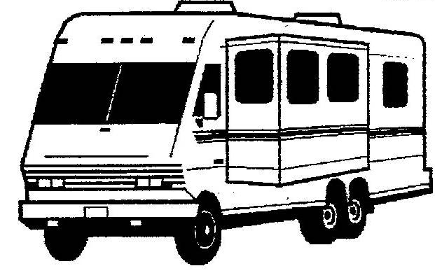
At Lake Sonoma

3288 Skaggs Springs Road

Geyserville, CA 95441

(707) 431-4533

Liberty Glen is the only campground at Lake Sonoma with drive-in access. Liberty Glen offers campsites for tents and RV’s as well as single-family sites, larger double sites and a group area. No electrical hook ups are available. Liberty Glen provides excellent access to our hiking trails. Access to the shoreline of the lake is by trail or by car. In order to maintain a family friendly and safe environment, we ask that you follow these simple guidelines:

Important Car Camping/RV Access Update
The dump station at Liberty Glen is currently out of service due to limited output of our water wells. However, flush toilets and showers are available along with portable restrooms. Reservations must be made at least two days in advance, and we no longer accept any “first come, first served” campers.

Refunds
Lake Sonoma does not give immediate cash refunds back to the customer. Family emergencies do occur and the National Recreation Reservation Service will process refund requests if you have to cancel or leave early. Refunds are generally not granted for changes in weather, insects or other natural phenomenon. Contact park staff immediately if you have a problem with your campsite.

Extra Vehicles
Your camping permit includes entry for a maximum of two “vehicle units” and 8 people for a single-family site. Thus a single campsite may contain two autos, an auto with a trailer, or one large recreational vehicle. Please call the Visitor Center if you need to arrange for extra parking; additional fees may apply.

Gate Closure
The campground gates are open from 7:00 AM to 10:00 PM during the summer. After 10:00 PM the gate closes. Cars will be able to exit Liberty Glen but not enter until the following morning.
Double Site.....................................................................................................................$30.00/night
Group Sites...................................................................................................................$80.00/night
Extra Vehicle Fee (for each vehicle above the first two).................................................$3.00/vehicle
Camping Cabin (reserved through Visitor Center)..……………………………………….....$60.00/night

Single Site.......................................................................................................................$15.00/night

No person under 18 years of age is allowed to register for a campsite. Minor(s) under 18 years of age while camping on Lake Sonoma/Warm Springs Dam Project premises must, at all times, be accompanied and supervised by a parent or legal guardian. For age verification purposes, anyone appearing to be under 25 years of age must be in possession of valid photo identification, showing date of birth. Anyone under 21 years of age is prohibited from possessing or consuming alcoholic beverages while on Lake Sonoma/Warm Springs Dam Project premises.
Juveniles
Fires
Campfires are permitted only inside the fire-ring at designated campsites. Tiki torches are not allowed. Campers may gather DEAD and DOWNED wood only. Firewood is available for sale at the front entrance booth.
All campers are required to check-in at the Liberty Glen entrance booth. If the booth is not staffed, campers should follow the instructions posted on the bulletin board by the entrance booth. Extra vehicle fees can be paid by deposit envelope. Checkout time is 12:00 noon of the final day of your visit. Failure to vacate the site may result in additional camping fees and/or a citation, unless prior arrangements have been made. For information about the camping cabin, please call (707) 431-4533.
www.spn.usace.army.mil

Check-in/Check-out
Cell phones do not have clear communication in all regions of the park. In addition, dialing 9-1-1 by cell phone routes the call through the CHP in Benicia. If calling by cell phone in an emergency; call the Sonoma County Sheriff’s Office Dispatch at (707) 565-2121. If calling by pay phone dial 9-1-1.
Emergency Access

All generators, radios, and other noise producing equipment must be turned off between the hours of 10:00 PM and 6:00 AM. Disturbing the peace at any hour may be grounds for removal from the park and loss of fees paid.

Pets
Pets must be on a maximum 6-ft. leash at all times. Pets must not remain unsupervised in a campsite at any time. Campers are responsible for cleaning up after their pets.

Quiet Hours

