

Juvenile salmonid outmigration and green sturgeon distribution in the San Francisco Estuary

Draft
Annual Report
2009

Chapman ED, AR Hearn, M Buckhorn, AP Klimley, PE LaCivita, WN Brostoff & AM Bremner

To cite this document:

Chapman ED, AR Hearn, M Buckhorn, AP Klimley, PE Lacivita, WN Brostoff & AM Bremner (2009) Juvenile salmonid outmigration and green sturgeon distribution in the San Francisco Estuary: 2008-2009. University of California Davis and US Army Corp of Engineers. 90p.

EXECUTIVE SUMMARY

To reduce the impacts of dredging and in-bay placement of dredged materials the Long Term Management Strategy (LTMS) established environmental work windows (windows) for dredging. A Science Assessment and Data Gaps Work Group (Science Group) was created to coordinate scientific research that would provide better information to endangered species specialists at the National Marine Fisheries Service (NMFS). The purpose was to identify projects that would address data gaps and/or issues of concern so as to facilitate consultation under section 7 of the Endangered Species Act (ESA). The windows permit dredging in most areas from June through November when the majority of fish species of concern are not present. The windows were based on the best available science at the time but it was determined that the duration and/or locations of restrictions needed to be assessed by further research to decrease the potential for adverse affects on fish, mammal and bird species. It was determined that the original focus should be on fish which stimulated plans for this study on out-migrating juvenile (smolt) Late Fall Chinook salmon (Oncorhyrnchus tshawytscha) and steelhead trout (Oncorhyrnchus mykiss). These might be used as surrogates for more vulnerable salmonid runs, for which there is little available data on their migration pattern, although surrogacy should always be applied with caution.

The objective of this study is to determine whether salmonid smolts may be exposed to dredged sites or dredged material placement sites during their outmigration through the San Francisco Bay Estuary. The study: 1) estimated transit times through various reaches of the San Francisco Estuary, 2) measured exposure times at dredged sites, and 3) identified the pathways of smolts as they migrate to the ocean. The first two years of the study (2006-2008) were performed by the San Francisco District of the United States Army Corps of Engineers (USACE) with oversight provided by the Science Group. During these two years the study closely matched the efforts of the California Fish Tracking Consortium (CAFTC) to study the migrations of smolts from the upper reaches of the Sacramento River. The first year served as a pilot study and the second improved study design and field methods. The third year of study, which this report is based on, was carried out by researchers in the Biotelemetry Laboratory at UC Davis.

Five hundred juvenile Late Fall Chinook salmon and five hundred juvenile steelhead were released at the end of February 2009 at Elkhorn Landing at the northern end of the city of Sacramento, above any influence of the tides (river kilometer 209). The fish were tagged with individually coded ultrasonic beacons which can be detected by a watershed-wide array of underwater receivers. The receivers, placed at narrow stretches (bridges) to provide nearly complete coverage of the channel, made it possible to characterize both large scale movements through the estuary and migration trends related to water depths. Additional information from similar fish released in the river system in other concurrent studies is also presented.

The overall success rate of the smolts from the release site to the start of the study area (Benicia Bridge) was 48% for steelhead and 62% for Late Fall Chinook salmon. Of these, approximately one third survived to the Golden Gate. The overall transit time, from Benicia bridge to the last detection for those individuals which passed the Golden Gate (a distance of 50.69 km) varied from 1.14 to 11.6 days for Chinook salmon (median: 2.2 days) and from 1.0 to 17.7 days for steelhead (median: 1.9 days). We observed two general strategies – fish which migrated through river reaches at rates >1 ms-¹ and those which transited at slower rates (around 0.5 ms-¹ or less). We found that the same individuals might adopt different strategies at different times. These rates may be related to tidal current direction and velocity. Analysis of transit through the Benicia-Carquinez river reach suggested that fish tend to move on peak flows for both flood and ebb tides.

Some individuals of both species displayed repeated upstream and downstream movements, which we related to the tidal state. We estimated the instantaneous rate of transit through the San Pablo receiver arrays and found that they were in general higher than the overall rates for that river reach, indicating that fish were not remaining to forage or undertake other activities at these sites. Analysis of residency showed that fish do not reside at any of the sites, and that the term “exposure time” should be used instead. Exposure of smolts at marinas and dredged sites near shoals was low (only a few minutes for up to 5 fish), whereas a higher proportion of fish were detected at the channel sites. Analysis of time elapsed between detections at the different Arrays in San Pablo Bay gave conservative estimates of up to 200 minutes exposure time through these sites. Several fish from both species were detected at the Bay Bridge (potentially entering the South Bay), yet this did not appear to affect their survival rate to the Golden Gate. The analyses from both study years show a substantial proportion of both species utilized deeper dredged channels and/or passed at least one dredged material placement site. \

Ten green sturgeon tagged in other studies were also detected at several of the study sites, out of forty tagged individuals known to be in the SF Estuary at that time. Eight of these fish were detected at Martinez Marina for periods ranging between 7-252 minutes, yet only two individuals transited through the SF 10 Placement Site. Both individuals appeared to move randomly in and around the site, rather than a directional movement such as that shown by salmonid smolts. Further work will be carried out on adult and subadult green sturgeon in future years, given their importance as a threatened species.

Contents
1 Background 5
1.1 Study Objectives 5
1.2 Geography of San Francisco Bay Estuary 5
1.3 Dredging activities in the San Francisco Bay Region 6
1.4 Study Species 8
1.5 Biotelemetry and salmonids 9
1.6 The California Fish Tracking Consortium 11
1.7 Prior work 11
2 Methods & Materials 13
2.1 Receiver locations 13
2.2 Receiver Deployment 16
2.3 Range Testing 17
2.4 Tagging procedure 18
2.5 Release site and procedure 20
2.6 Environmental data 21
2.7 Data Analysis 21
2.7.1 Minimum Survival Rates 21
2.7.2 Transit Times and Rates 21
2.7.3 Residency and exposure times 23
2.7.4 Migratory pathways 24
2.7.4 Interannual variations 25
2.7.5 Green sturgeon analyses 25
3 Results 26
3.1 Survival 26
3.2 Transit time 26
3.4 Migratory Pathways 46
3.5 Inter-annual variation 51
3.6 Other Species 52
3.7 Green Sturgeon exposure 53
4 Discussion 55
Acknowledgements 59
References 60
Appendices 63
Appendix 1. Repeated upstream-downstream behavior displayed by Chinook salmon in San Pablo Bay 64
Appendix 2. Repeated upstream-downstream behavior displayed by selected steelhead in San Pablo Bay. 71
Appendix 3. Exposure time of Steelhead at Dredge Sites 76
Appendix 4. Exposure time of Chinook salmon at Dredge Sites 79
Appendix 6. Other Chinook salmon detected on ACE receivers 86

1 Background

  - Study Objectives

The goals of the study are to determine the potential exposure of outmigrating salmonid smolts and green surgeon to sites in the San Francisco Bay Estuary where dredging or dredged material placement occurs. This report addresses the following questions:

- What are the transit rates of LFC and STH through particular reaches of the San Francisco Bay estuary and through sites of interest (dredging and placement sites)?
- Do LFC and STH display residency or exposure times at particular sites of interest (dredging and placement sites) in the San Francisco Bay estuary, and if so, how long do they reside at these sites?
- What are the general migratory routes of LFC and STH in San Francisco Bay estuary, and how do these relate to the location of dredge and dredged material placement sites?
- Do green sturgeon interact with sites where dredging or dredged material placement occur?

It is important to note that dredging operations did not generally take place during the periods when salmonids were migrating through San Francisco Bay. The intent of this study is to determine hypothetical rather than actual exposures.

  - Geography of San Francisco Bay Estuary

The San Francisco Bay Estuary (the Bay) is commonly divided into four different sub-regions: Suisun Bay, North Bay/San Pablo Bay, Central Bay, and South Bay (Fig. 1). It is the largest estuary on the west coast, and covers more than 1,500 square miles of central California. The San Joaquin and Sacramento Rivers are the largest sources of fresh water and flow into Suisun Bay in the northeastern portion of the Bay. Other sources of fresh water reach the Bay via the Petaluma, and Napa Rivers, as well as Sonoma Creek. The Bay drains almost one-half of the land area of California (60,000 square miles). San Francisco Bay estuary contains 90 percent of California's remaining coastal wetlands. The estuary's aquatic and wetland habitats range from the brackish water of the lower delta and Suisun Bay to the dilute salt water of San Pablo Bay, and the highly saline waters of South San Francisco Bay. The region supports a variety of natural wetland habitats as well as a diverse wildlife population. It is a prime nursery and foraging habitat for many fish species including green sturgeon.

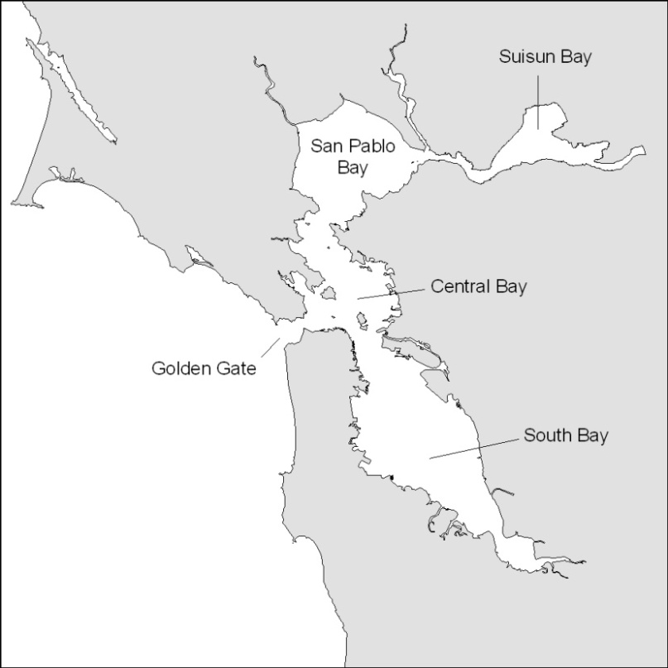

Figure 1. Aerial view of San Francisco Estuary.

There are 4 islands in the central part of the Bay: Alcatraz Island, Angel Island, Yerba Buena Island and the artificial Treasure Island. The depth profile for the San Francisco Bay has changed significantly through anthropogenic disturbance in the last 200 years. Beginning in the 1800s, sedimentation from mining practices in the upper Sacramento, American and Cosumnes rivers began to build up and fill in the bay. Dredging for navigational purposes, under the charge of the U.S. Army Corps of Engineers, began in the late 1800s and has continued non-stop, except for a brief interruption in the late 1980s (Dwinnell et al., 2003). Before 1850, the region sustained 1400 square kilometers of freshwater wetlands and 800 square kilometers of salt marshes; today, only 125 square kilometers of un-diked marshes remain of the original 2,200 square kilometers. This equates to a 95 percent loss of crucial habitat, the majority due to human activity. By the 1960s, one-third of the Bay was lost to filling and diking, and more than 80 percent of its tidal wetlands were converted to other uses. Dredged material has been used to reclaim wetlands and build Treasure Island or has been disposed of in the bay. San Francisco Bay depths range from 1 m (nearshore) to 53 m in the central part of the Bay and eventually to 115 meters depth just outside the Golden Gate Bridge (Chin et al., 2004).

  - Dredging activities in the San Francisco Bay Region

The first dredged waterway in San Francisco Bay was created in 1868 and has been periodically dredged ever since. Today dredging is carried out by federal and non-federal entities and results in 2–10 million cubic yards of dredge material per year (USACE et al.,1998). There are two types of dredging that occur in the San Francisco Bay Estuary – maintenance dredging (the removal of new sediments that have recently been deposited) and new work construction (dredging of sediments in their natural condition). Maintenance dredging is carried out by federal and private entities, new work is carried out mostly by private companies such as sand mining for construction material. Dredged materials were first placed at the Alcatraz Disposal site in 1894 because of a great depth that reached 50m (U.S. Environmental Protection Agency, 1996) and it was believed that strong tidal currents would disperse the dredged material from the site. In 1982 it was realized that the material was accumulating and resulting in a potential hazard to navigation. Subsequently, other placement sites were created to decrease the buildup of dredged materials at the Alcatraz site. Material is currently placed at three types of locations: 1) other in-Bay sites; 2) upland/wetland re-use placement sites; and in the ocean. The Long Term Management Strategy (LTMS) was launched in January 1990 and established 3 major work groups: 1) ocean disposal led by the EPA; 2) in-Bay disposal led by SG Bay Regional Water Quality Control Board; and 3) upland/re-use led by the Bay Conservation and Development Commission, with oversight provided by the COW and the State Water Resources Control Board. Based on the final EIR/EIS, completed in December 1998, the long term disposal regime that would provide beneficial re-use of dredged material and decreases in disposal within the Estuary was determined. It was decided that low disposal volumes would be placed at in-Bay sites (~20%), medium disposal volumes in the Ocean (~40%), and medium disposal volumes of upland/wetland reuse placement sites (~40%).

The excavation process commonly referred to as “dredging” involves the removal of sediment in its natural or recently deposited condition, using either mechanical or hydraulic equipment. After the sediment has been excavated, it is transported from the dredging site to the placement site or disposal area. This transport operation, in many cases, is accomplished by the dredge itself or by using additional equipment such as barges, scows, and pipelines with booster pumps.

Mechanical dredging
Mechanical dredges remove bottom sediment through the direct application of mechanical force to dislodge and excavate the material at almost in situ densities. Backhoe, bucket (such as clamshell, orange-peel, and dragline), bucket ladder, bucket wheel, and dipper dredges are types of mechanical dredges. Sediments excavated with a mechanical dredge are generally placed into a barge or scow for transport to the placement site.

Hydraulic dredging
The hydraulic dredge uses water to remove and transport the material. This system has a pump for moving the water. The pump creates a vacuum or a pressure head, which moves water rapidly through the pipe. This system always has at least three components: dredging device, pump, and discharge system. There are many common hydraulic dredging systems: hopper dredges, sidecast dredges, cutterhead dredges, and dustpan dredges. Hydraulic dredges remove and transport sediment in liquid slurry form. They are usually barge-mounted and carry diesel or electric-powered centrifugal pumps with discharge pipes ranging in diameter from 6 to 48 inches. The pump produces a vacuum on its intake side, which forces water and sediments through the suction pipe. The slurry is transported by pipeline to a placement area.

Dredging impacts on fish in the Bay
Potential impacts of dredging on fish in the Bay were described in the LFR 2004 report, which cited both the NMFS biological opinion (Whitlock 1999) and the LTMS EIS/EIR report (USACE et al.,1998).

NMFS Biological Opinion Chinook and steelhead:
- Redistribution of pollutants and/or release of contaminants which may result in chronic or acute toxicity, particularly those that rear for prolonged periods in affected areas, burial of bottom-dwelling organisms which may reduce feeding opportunities for rearing juvenile salmon.
- Re-suspension of sediment particles which could interfere with visual foraging, abrade gill tissues, or interfere with migration.
- Increased turbidity may also interfere with primary productivity
- Sediment alterations associated with in-Bay disposal.
EIS/EIR Chinook salmon and steelhead:
- Water quality degradation
- Direct habitat loss or degradation
- Interference with foraging or food resources
- Entrainment by the dredge
  - Study Species

Chinook salmon were formerly abundant and widely distributed throughout rivers and streams of California’s Central Valley. Chinook salmon occur in four distinct subpopulations, differentiated by timing of the spawning run, timing of the spawn itself, former spawning habitat, and the emergence, freshwater residency and ocean entry of juveniles (Fisher, 1994). The names of these Chinook salmon subpopulations are drawn from the seasons when most adults return to freshwater to spawn: winter, spring, fall, and late-fall (Stone, 1874; Fry, 1961). Of the four salmon runs, the fall run is the most abundant, and heavily supplemented by hatchery production (Fisher, 1994). Currently, Sacramento River Winter Run Chinook salmon are listed under the state and federal Endangered Species Act as an endangered species. Central Valley Spring Run Chinook salmon are listed under the state and federal Endangered Species Act as a Threatened species. The late fall and spring runs exhibit two types of juvenile life-history strategies: ocean-type and stream-type. The ocean-type juveniles spend relatively little time in streams and enter the ocean at a small size [80 mm fork length (FL)]. In contrast, the stream-type juveniles spend several months to over a year in streams and enter the ocean at a large size (120-180 mm FL). These larger stream-type smolts are also called yearlings. For this study Late Fall Chinook salmon (Fig. 2) were tagged because of their size and availability.

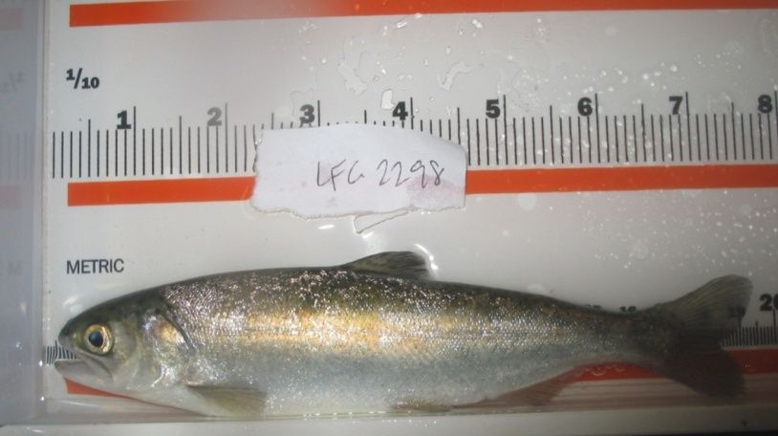

Figure 2. Chinook salmon smolt (note scale loss during smoltification) fork length=175mm, 60.8g.
Steelhead (Fig. 3) are a salmonid species indigenous to the Pacific coast of Asia and western North America and the anadromous form of rainbow trout (Oncorhynchus mykiss). Recent allozyme data show that samples of steelhead from Deer and Mill Creeks and Coleman National Fish Hatchery on the Sacramento River are well differentiated from all other samples of steelhead from California. The distance from the ocean to spawning streams can exceed 300 km, providing unique potential for reproductive isolation among steelhead in California (Busby et al., 1996). Only a winter run of Central Valley steelhead are currently recognized, although in the past there may have been a summer run of steelhead as well (Needham, 1941).Central valley steelhead were listed as threatened under the Endangered Species Act in 1998 and the status was reaffirmed in 2006. The central valley Evolutionary Significant Unit (ESU) occupies the Sacramento and San Joaquin Rivers and their tributaries. Steelhead in the Central Valley have been almost completely extirpated from their historical range mainly due to habitat loss by the construction of dams. There may have been more than one million adults returning to the Sacramento and San Joaquin drainages but by the 1960s that number had dwindled to 40,000.

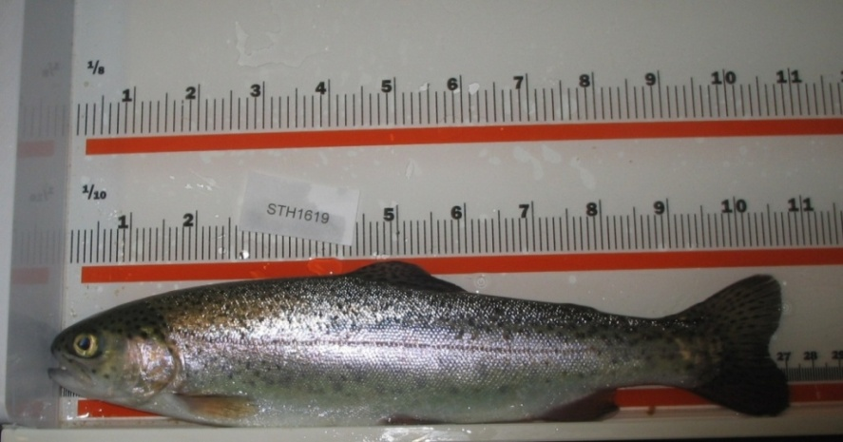

Figure 3. Steelhead trout smolt, fork length=263mm, 185.4g.

Green sturgeon (Acipenser medirostris) have been recorded from the coastal waters of Mexico, the United States, and Canada. In North America, the green sturgeon’s range in the ocean extends from the Bering Sea to Ensenada, Mexico. This range includes the entire coast of California. They have been found in rivers from British Columbia south to the Sacramento River in California. The Southern Distinct Population Segment (DPS) of green sturgeon has been listed as threatened by the National Marine Fisheries Service (NMFS 2006). This DPS utilizes the San Francisco Bay estuary and migrates up the Sacramento River to spawn. Adults migrate into rivers to spawn from April to July with a May to
June peak. Eggs are spawned among rocky bottom substrates and juveniles spend 1 to 4 years in
fresh water before moving offshore (Adams et al., 2002).

1.5 Biotelemetry and salmonids

With the advent of small, inexpensive, ultrasonic tags (Fig. 4), mass marking of salmonid smolts has become a cost-effective method of tracking their migrations from upper reaches of river systems to the ocean. VEMCO Ltd. (Halifax, Canada) designed transmitters which emit a unique coded signal at 69 KHz. These are small enough so that they may be inserted into the peritoneal cavity of juvenile salmonids without affecting their swimming behavior. Several studies have examined the effect of radio or ultrasonic tags implanted within the body on swimming performance, growth, and vulnerability to predation of juvenile salmonids. Implanted tags weighing less than 8% of the fish’s weight did not produce any significant difference in swimming performance of tagged fish from those having an operation but not carrying a tag, and those individuals that did not undergo an operation (Moore et al., 1990; Peake et al., 1997; Adams et al., 1998; Brown et al., 1999; Robertson et al., 2003; Anglea et al., 2004; Lacroix et al., 2004).

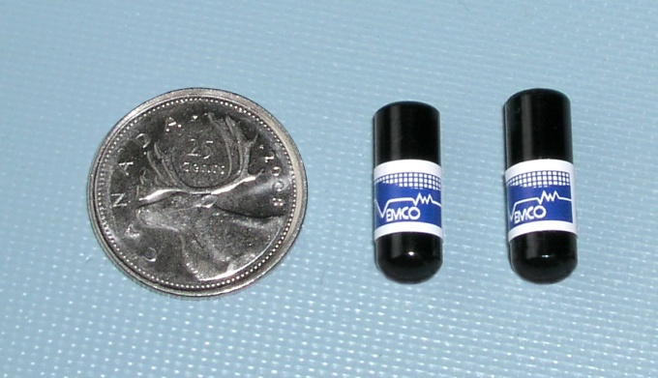

Figure 4. Comparison of the VEMCO V-2L (left) and V7-4L (right) transmitter tags.

V7-2L tags were implanted in Chinook salmon and V7-4L in steelhead. The tags emit pulse bursts that can be detected by a hydrophone connected to a mobile unit or an underwater receiver/listening station (Fig. 5). Each Chinook salmon tag is programmed with a random delay of 15-45 seconds and each steelhead tag a random delay of 30-90 seconds. This ensures that signal collisions of two or more tags (which result in either false or no detections) do not occur repeatedly. The tag delays were also chosen to maximize the number of detections of a fish swimming past a stationary receiver.

Listening stations can be deployed in arrays such as curtains, which might cover an entire cross-section of a channel, or to provide coverage at particular interest sites. Two receiver types are currently in use: VR2 and VR2W. The difference between the two receiver types lies in their communications systems – the latter uses Bluetooth technology to communicate with and transfer data to a computer, whereas the former uses a more traditional USB port. Both receivers use lithium batteries which must be replaced every 12 months, and passively record the code number, time and date of up to 300,000 tag pulses, whenever a tag comes within range. The detection range of a VR2 varies greatly depending on water turbidity, riverbed bathymetry, weather conditions, and ambient noise levels. VEMCO state that the detection range has a radius of 500 meters, but recommend that range testing be carried out for each individual study. Both types of receivers must be brought to the surface for data download.

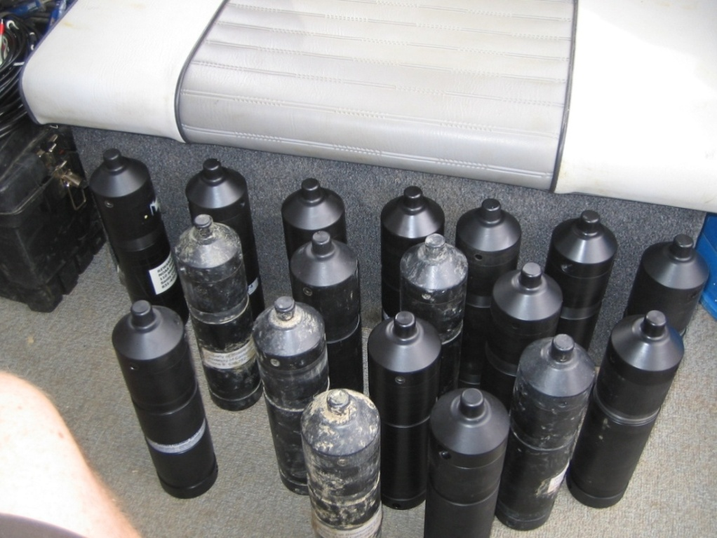

Figure 5. Automated, tag-detecting receivers (VEMCO VR2 and VR2W).

1.6 The California Fish Tracking Consortium

The California Fish Tracking Consortium (CAFTC) was established in 2006, and maintains an array of receivers throughout the Sacramento River watershed, from the upper river (above Red Bluff Dam) to the ocean, including the delta and bay areas (www.californiafishtracking.ucdavis.edu/). The Consortium is made up of a number of private and public institutions, such as the Biotelemetry Laboratory at the University of California, Davis, NOAA/UC Santa Cruz, the US Army Corps of Engineers, US Fish & Wildlife Service, California Department of Fish & Game, Bay Planning Coalition and others. Each institution carries out a series of research projects which utilize the receiver array. These include studies of the spawning migrations of green sturgeon (eg. see Heublein et al., 2008), site fidelity of sevengill sharks (see Buckhorn et al., in prep), and several studies related to salmonid smolt movement patterns and survival in different river reaches, and comparisons between hatchery-reared and wild fish (eg. see Johnson et al., 2008).

1.7 Prior work

The first two years of a proposed three-year study were carried out by the San Francisco District of the United States Army Corps of Engineers (USACE) with oversight by the LTMS Science and Data Gaps Work Group (Science Group) from late summer of 2006 to summer of 2008 (Klimley et al., 2009). USACE coordinated its effort with members of the California Fish Tracking Consortium to maximize the efficiency of data collection, analysis, and interpretation. The 2006-2007 study season served as a pilot study, to determine the suitability of equipment and logistics, as well as the feasibility of addressing study questions. Improvements in field methods to more accurately record salmonid movements throughout the San Francisco Bay were reflected in subsequent years including the 2007-2008 study year.

Juvenile late-fall run Chinook salmon and steelhead smolts were released into the lower Sacramento River, near the Rio Vista Bridge. USACE released 49 Chinook salmon and 49 steelhead in 2006-2007 and 50 of each species in 2007-2008. Individuals tagged with coded ultrasonic beacons were detected by an estuary-wide array of hydroacoustic receivers. Each receiver records fish passage and the associated date and time for every successful tag detection. The receivers, placed at “choke points” and arranged in curtain arrays with overlapping ranges, made it possible to characterize both large scale movements through the estuary and migration trends related to water depths. Transit times were calculated between Rio Vista (the USACE release point) and the Richmond San Rafael Bridge as well as from the Richmond San Rafael Bridge to the Golden Gate Bridge. Migratory pathway trends were analyzed using data acquired from the Richmond San Rafael curtain array and its associated cross sectional depth profile.

This study passively detected salmonids to describe large-scale movements in and around dredge activity sites within the estuary. Based on tag-detection records for 2007-2008, the mean travel time between Rio Vista and Golden Gate bridges was 10.2 days for Chinook salmon and 8.5 days for steelhead. The median residence time at SF10, the designated in-bay placement site for dredged material in San Pablo Bay, was 6.5 min for Chinook salmon and steelhead. Both species tended to use mid-channel waters around the Richmond San Rafael Bridge rather than the shallow flats on either side of the channel. Each exhibited a positive linear relationship, up to 11.3 m, between depth and frequency of detection. The analyses from both study years show a substantial proportion of both species utilized deeper dredged channels and/or passed at least one dredged material placement site. The interim analysis suggests that adjustments to this study are necessary to better obtain quantitative confirmation of the study objectives. Recommendations for the third year of study include: 1) a larger number of tagged fish, 2) a release location farther upstream, 3) spacing receivers based on current range tests, and 4) new receiver locations to better cover dredged material placement sites.

2 Methods & Materials

2.1 Receiver locations

Receivers were placed at dredge and dredge placement sites throughout the San Francisco Bay Estuary (Table 1). Some were placed on bridges as arrays in order to detect passage through particular river reaches. Bridges are situated at narrow passes where fewer receivers are required to fully cover the expanse of the channel, and also provide the ease of attachment and highly successful recovery rates (receivers attached to bridges are far less likely to be lost and are easily interrogated by boat). We also placed receivers in marinas and channels throughout San Pablo and San Francisco Bay. These receivers were attached to US Coast Guard aids to navigation, marina docks, and other private and public channel markers. These were chosen so as to detect fish that ventured out of the main channels and into other dredged areas. The bridges are also situated at the logical beginning and end of each of the commonly referred to reaches of the San Francisco Bay Estuary: Suisun Bay, San Pablo Bay, Central Bay and South Bay (Fig. 6).

Table 1. Name and location of underwater ultrasonic receiver stations used to detect migrating salmonid juveniles.

Location | Lat | Long | Location | Lat | Long
Benicia_Bridge_01 | 38.043767 | -122.12595 | GoldenGate7.0 | 37.83025 | -122.46376
Benicia_Bridge_02 | 38.042433 | -122.12502 | GoldenGate7.2 | 37.82794 | -122.46168
Benicia_Bridge_03 | 38.041233 | -122.12382 | GoldenGate7.5 | 37.82542 | -122.45993
Benicia_Bridge_04 | 38.03896 | -122.12192 | GoldenGate7.7 | 37.8221 | -122.45841
Benicia_Bridge_05 | 38.037617 | -122.12108 | GoldenGate8.0 | 37.81856 | -122.45764
Benicia_Bridge_06 | 38.03645 | -122.1201 | GoldenGate8.4 | 37.81696 | -122.45953
Benicia_Bridge_Center | 38.03994 | -122.12301 | GoldenGate8.5 | 37.8159 | -122.45675
Carquinez_Bridge_01 | 38.063833 | -122.22697 | GoldenGate9.0 | 37.81305 | -122.45598
Carquinez_Bridge_02 | 38.062333 | -122.22525 | GoldenGate9.5 | 37.8094 | -122.45549
Carquinez_Bridge_03 | 38.060583 | -122.22497 | RSRB_1_2009 | 37.93348 | -122.41925
Carquinez_Bridge_04 | 38.058667 | -122.2251 | RSRB_2_2009 | 37.93361 | -122.42132
Carquinez_Bridge_05 | 38.05795 | -122.22455 | RSRB_3_2009 | 37.93376 | -122.42332
SP_Bouy7_2009 | 38.03137 | -122.37343 | RSRB_4_2009 | 37.93392 | -122.42501
SP_Bouy8_2009 | 38.02899 | -122.37149 | RSRB_East_Channel_2009 | 37.9339 | -122.42706
SP_Buoy9_2009 | 38.04207 | -122.35325 | RSRB_5_2009 | 37.93418 | -122.42887
SP_Buoy10_2009 | 38.03919 | -122.35075 | RSRB_6_2009 | 37.93425 | -122.43074
SP_Array_1A_2009 | 38.01482 | -122.41307 | RSRB_7_2009 | 37.93439 | -122.43282
SP_Array_1B_2009 | 38.01393 | -122.41171 | RSRB_8_2009 | 37.93449 | -122.43492
SP_Array_1C_2009 | 38.01297 | -122.41043 | RSRB_9_2009 | 37.93458 | -122.43699
SP_Array_1D_2009 | 38.01233 | -122.40899 | RSRB_10_2009 | 37.93481 | -122.43895
SP_Array_1E_2009 | 38.011 | -122.4081 | RSRB_11_2009 | 37.93494 | -122.44098
SP_Array_1F_2009 | 38.01053 | -122.40653 | RSRB_12_2009 | 37.9353 | -122.4428
SP_Array_1G_2009 | 38.00991 | -122.40483 | RSRB_West_Channel_2009 | 37.9352 | -122.44465
SP_Array_1H_2009 | 38.00867 | -122.40402 | RSRB_13_2009 | 37.93495 | -122.44659
SP_Array_2A_2009 | 38.0053 | -122.42673 | RSRB_14_2009 | 37.93522 | -122.4484
Table 1 cont.
SP_Array_2B_2009 | 38.00461 | -122.42513 | RSRB_15_2009 | 37.93553 | -122.45043
SP_Array_2C_2009 | 38.00276 | -122.42491 | RSRB_16_2009 | 37.9359 | -122.45251
SP_Array_2D_2009 | 38.00193 | -122.42368 | RSRB_17_2009 | 37.9364 | 122.45444
SP_Array_2E_2009 | 38.00064 | -122.42265 | RSRB_18_2009 | 37.937 | -122.4564
SP_Array_2F_2009 | 37.99958 | -122.42108 | RSRB_19_2009 | 37.93753 | -122.45813
SP_Array_2G_2009 | 37.99849 | -122.42007 | Bay_Bridge_E2_2009 | 37.81415 | -122.35849
SP_Array_2H_2009 | 37.99739 | -122.41928 | Bay_Bridge_E3_2009 | 37.815571 | -122.35385
SP_Control_1_2009 | 38.02457 | -122.4009 | Bay_Bridge_E5_2009 | 37.816679 | -122.35067
SP_Control_2_2009 | 38.02371 | -122.3993 | Bay_Bridge_E7_2009 | 37.817746 | -122.34744
SP_Control_3_2009 | 38.02233 | -122.39851 | Bay_Bridge_E9_2009 | 37.81884 | -122.34412
SP_Control_4_2009 | 38.02114 | -122.39788 | Bay_Bridge_E12_2009 | 37.819443 | -122.34116
SP_Control_5_2009 | 38.02024 | -122.3966 | Bay_Bridge_E15_2009 | 37.819907 | -122.33819
SP_Control_6_2009 | 38.0195 | -122.39581 | Bay_Bridge_18_2009 | 37.820376 | -121.33522
SP_Control_7_2009 | 38.0179 | -122.39468 | Bay_Bridge_W1_2009 | 37.790891 | -122.38563
SP_Control_8_2009 | 38.01682 | -122.3937 | Bay_Bridge_1.5_2009 | 37.79316 | -122.38319
Aclatraz_SE_2009 | 37.82082 | -122.42106 | Bay_Bridge_W2A_2009 | 37.795616 | -122.38091
Alcatraz_NE_2009 | 37.82385 | -122.42153 | Bay_Bridge_W2B_2009 | 37.795534 | -122.38033
Alcatraz_NW_2009 | 37.82385 | -122.42474 | Bay_Bridge_2.5_2009 | 37.79682 | -122.37914
Alcatraz_SW_2009 | 37.82087 | -122.42477 | Bay_Bridge_W3A_2009 | 37.798045 | -122.37823
Alcatraz_Control_1_2009 | 37.8313 | -122.44522 | Bay_Bridge_W3B_2009 | 37.798341 | -122.37742
Alcatraz_Control_2_2009 | 37.83457 | -122.44535 | Bay_Bridge_3.5_2009 | 37.79949 | -122.37656
Alcatraz_Control_3_2009 | 37.83449 | -122.44876 | Bay_Bridge_W4A_2009 | 37.800855 | -122.37531
Alcatraz_Control_4_2009 | 37.83143 | -122.44846 | Bay_Bridge_W4B_2009 | 37.800717 | -122.37471
Racoon_Tiburon_2009 | 37.87456 | -122.44261 | Bay_Bridge_4.5_2009 | 37.80299 | -122.37252
Racoon_Middle_1_2009 | 37.87323 | -122.44148 | Bay_Bridge_W5_2009 | 37.805514 | -122.36955
Racoon_Middle_2_2009 | 37.8715 | -122.441 | Berkeley_Marina_2009 | 37.86649 | -122.31712
Racoon_Lome_2009 | 37.86974 | -122.44033 | Emeryville_A_2009 | 37.8391 | -122.3111
GoldenGate1.0 | 37.82898 | -122.4741 | Emeryville_B_2009 | 37.84355 | -122.31609
GoldenGate1.5 | 37.82737 | -122.47266 | Vallejo_Marina_2009 | 38.11023 | -122.27147
GoldenGate2.0 | 37.82561 | -122.47125 | Suisun_City_Marina_2009 | 38.2345 | -122.03764
GoldenGate2.5 | 37.82344 | -122.47022 | Martinez_Marina_2009 | 38.02779 | -122.13839
GoldenGate3.0 | 37.82126 | -122.46918 | Petaluma_RR_Bridge_2009 | 38.11248 | -122.50219
GoldenGate3.5 | 37.81877 | -122.46816 | Port_Sonoma_Marina_2009 | 38.11558 | -122.50263
GoldenGate3.6 | 37.81958 | -122.46544 | SP_G3_2009 | 38.05814 | -122.42967
GoldenGate4.0 | 37.81615 | -122.46799 | SP_G5_2009 | 38.07095 | -122.42856
GoldenGate4.1 | 37.81681 | -122.46422 | Montezuma West | 38.17073 | -122.03894
GoldenGate4.5 | 37.81375 | -122.46766 | Montetuma East | 38.07187 | -121.87507
GoldenGate5.0 | 37.8112 | -122.46778 | SanRafael_Canal_6_2009 | 37.96862 | -122.48948
GoldenGate5.5 | 37.83478 | -122.46967 | Larkspur_Ferry_2009 | 37.94238 | -122.50448
GoldenGate6.0 | 37.83393 | -122.46794 | Point_Richmond_6_2009 | 37.90573 | -122.3938
GoldenGate6.5 | 37.83218 | -122.4659

Ninety-five receivers were deployed in the San Francisco Estuary (Fig. 6). The study area was split into four reaches based on the bridge deployments. It was assumed that the arrays expanding the entire channel should detect the majority of tagged fish passing each bridge. The first reach includes all receivers at Benicia Bridge and those deployed above Benicia, including the Delta and Sacramento River. The second reach consists of the receivers below Benicia Bridge and those at Carquinez Bridge. The third reach consists of receivers below Carquinez Bridge and the receivers attached to the Richmond-San Rafael Bridge, which includes all of the San Pablo Bay receivers. The fourth and final reach includes all of the receivers below the Richmond-San Rafael Bridge and the receivers at the Golden Gate Bridge, which includes Racoon Strait and the entire San Francisco Bay and the Bay Bridge receivers.

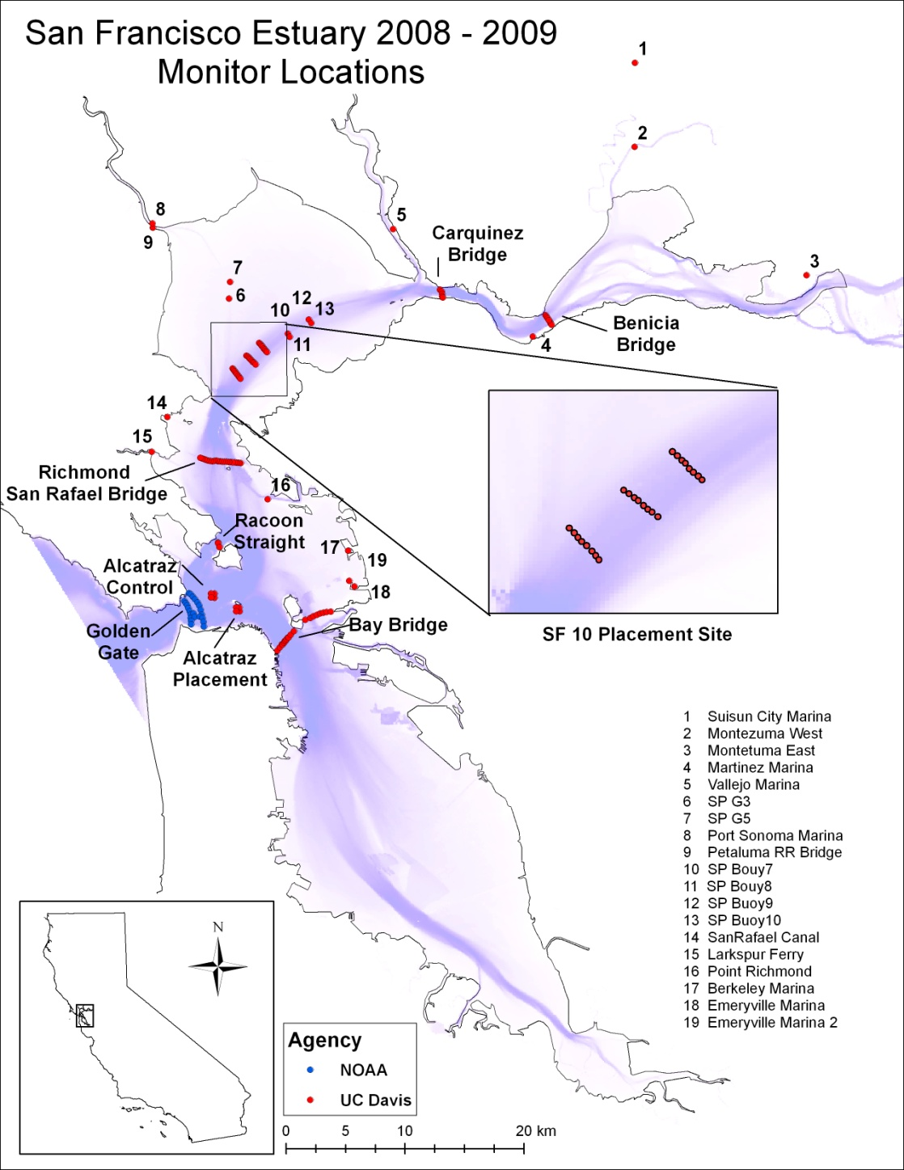

Figure 6. Map of study area, showing main channels in purple.

2.2 Receiver Deployment

The underwater receivers were deployed in two fashions, depending on the deployment site. Receivers deployed at bridges were attached to steel cables by means of two stainless steel clamps and one heavy duty cable tie. The steel cable was weighted with up to 30 lb of iron plates, and attached to one of the bridge supports, so that the receiver was always below the surface but never touched the riverbed. To retrieve the receivers, each site was visited every three months by boat, the steel cable was hauled by hand, and the receiver interrogated. Receiver batteries were changed after 12 months.

For open water deployments, the receiver was fitted with an acoustic release system. Originally, the moorings consisted of two biodegradable canvas sand bags weighing 140 lbs in air. These proved to be inadequate to withstand the conditions in San Francisco and San Pablo Bays. Holes developed in some of the sand bags, the sand emptied and the acoustic release system floated to the surface. The receivers were recovered and returned to the UC Davis research team. As a result, the UC Davis research team contacted the BCDC for permission to use a more robust mooring design. The second deployment of the acoustical release system was weighted with 90 lb of iron plates and is working as designed. This is the system that is currently used for all acoustical release configurations in the Bays (Fig. 7).

A vessel (belonging to the Aquarium of the Bay) was used to transport and deploy the receivers at predetermined coordinates that were programmed into GPS units. As each GPS point was reached, the receivers were dropped overboard, the weight dragging them to the bottom. Deployment was assisted by use of a hydraulic winch and ramp. In order to retrieve the receivers, each site was visited every three months. Each acoustic release responded to a unique acoustic pulse generated at the surface by an acoustic release interrogator which triggers the release to send an electrical current over the release mechanism. The mechanism is a small wire that corrodes when the current is sent through salt water, releasing the receiver, acoustic release and floats. The system was then retrieved when the floats surfaced with the receiver and acoustical release attached. The receiver was then interrogated and placed back in the same location to resume listening for acoustical tags.

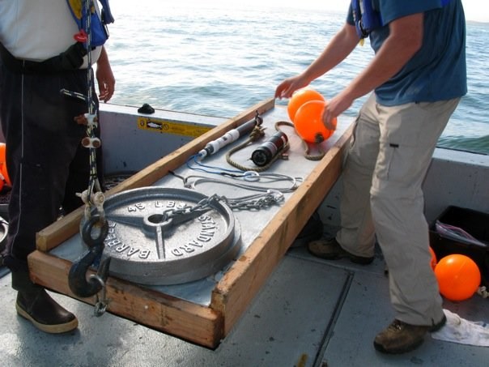

Figure 7. Deployment of VR2/VR2W ultrasonic receiver array in San Francisco Bay. Photo: M. Buckhorn.

2.3 Range Testing

Although VEMCO specify a detection range of 500 m for their tags, this varies depending on the physical conditions of the system to be studied, and may also vary throughout the study as these conditions (water turbidity, temperature, interference) change. We performed a standard range test by placing 12 receivers, spaced 30 meters apart, in a string at the SF10 placement site in San Pablo Bay. Two range testing tags, with the same power output as the tags used in the study, were placed 30 meters away from the first receiver and allowed to ping over a period of 24 hours (Fig. 8). Upon return the receivers were recovered and downloaded for analysis of the range of detection of V7 tags.

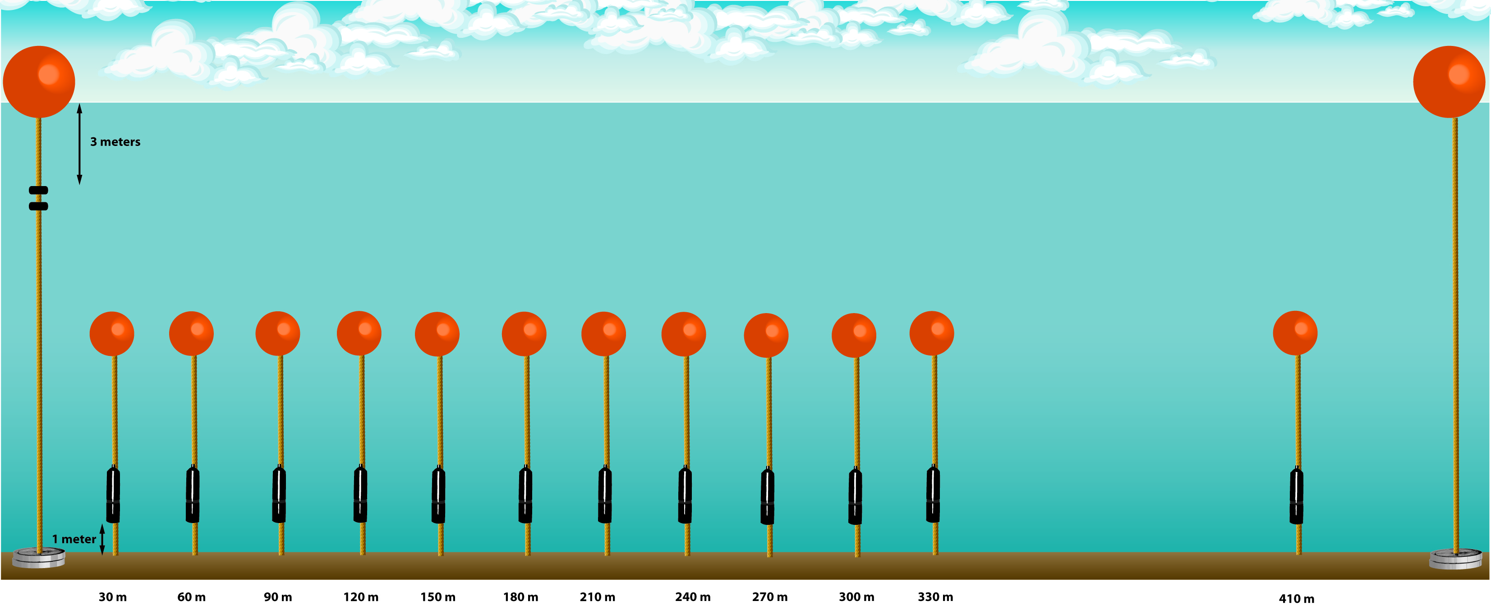

Figure 8. Cartoon of range test experimental design at SF10 placement site. Receivers are attached to moorings that are weighted down with 2-45 lb. weight plates. Receivers spaced every 30 meters up to 330 meters and then a last receiver at 410 meters. Not to scale.

As a result of range testing the receiver spacing was determined to be 150 meters (Fig. 9). A detection efficiency of 75% was achieved at a distance of 70-75 meters from the location of the tester tags. The receiver placed at 150 meters malfunctioned and produced no data, indicated by the dashed line. The receivers were spaced every 30 meters extending to 330 meters and one was placed at 410 meters.

By placing single lines of receivers across the channel with a spacing of 150 m, we optimized the cross-section detection range. However, the detection efficiency would still not be 100%, as Late fall Chinook travelling at speeds greater than 3.3 ms⁻¹, and steelhead travelling at speeds greater than 1.7ms⁻¹ may go through the entire detection range during the interval between tag transmissions. Additionally, where several fish passed through simultaneously, tag signal collisions may become an issue and require a longer period within receiver range for a successful detection.To estimate a reach-specific successful migration percentage we overcame this by using all detections to each cross array and below.
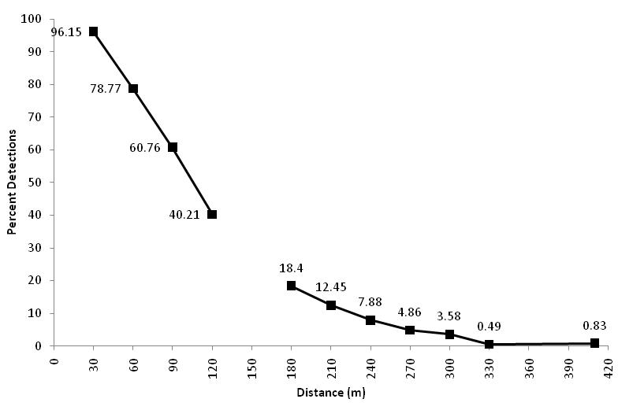

Figure 9. Detection efficiency of VR2W receivers during range tests in San Pablo Bay, November 2008.

2.4 Tagging procedure

A sample size of 500 individuals for each species was determined by using the program MARK to simulate the mortality of batches of fish released at different sites along the Sacramento River, with the objective of obtaining a success rate of 75-100 fish arriving at the Golden Gate. Inputs to the model were based on studies of hatchery released smolts from Coleman National Fish Hatchery (P. Sandstrom, UC Davis, pers.comm.).

We chose to conservatively tag fish whose tag-to-body weight was 5% or less, so a cut-off weight was imposed for each species based on the weight of the tag (V7-2L = 1.6 g, V7-4L = 1.84 g), implying that only Chinook salmon greater than 32 g, and steelhead greater than 94 g were tagged. To remain under the 5% body weight we could have tagged steelhead weighing as little as 36 g but chose to tag fish that were of similar size to those in previous years. The cut-off weight in previous years was based on the V9 tag weighing 4.7 g. The V7-4L tag was chosen this year due to tag losses observed in an unpublished tag retention study of V9 tags implanted in steelhead at UC Davis. The average tag-to-body weight of Chinook salmon smolts was 2.7% and less than 1% for steelhead in the tagging efforts of 2009. Fig. 10 shows the size distribution of the salmonids tagged during this study.

The surgeries averaged 136 seconds for Chinook salmon and ranged from 62 to 188 seconds. The average surgery time for steelhead was 121 seconds and ranged from 55 to 247 seconds. These times were recorded from the time the fish was removed from the anesthetic to placement in the recovery tanks (Table 2). This procedure was repeated so that a total of five hundred late-fall run Chinook salmon smolts and five hundred steelhead smolts were tagged over a period of two weeks. The vital statistics for each fish such as time and date of tagging and its body mass and fork length were provided to researchers at the Southwest Fisheries Science Center of NMFS in Santa Cruz, California for entry into the CAFTC database.

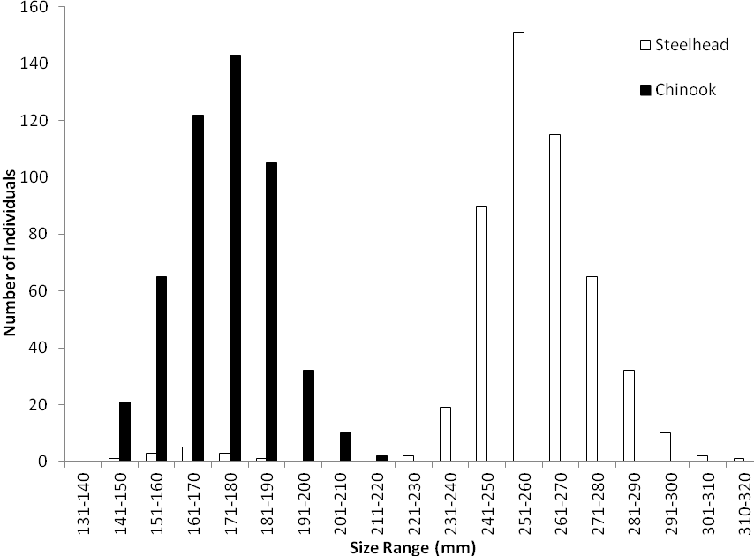
Figure 10. Size frequency distribution (fork length, in mm) of late fall Chinook salmon and steelhead smolts tagged in spring 2009.

Table 2. Summary of tagging information for salmonid smolts tagged during spring 2009 (for complete datasets see Appendix 1).

 | Species |  | Number of Fish  Tagged |  | Ave. Weight  (g) |  | Ave. Length  (mm) |  | Ave. Surgery Time  (minutes) |  | Ave. Tag to Body Weight (%)
Chinook salmon |  | 500 |  | 62.8 |  | 173 |  | 02:16 |  | 2.67
Steelhead |  | 500 |  | 192.0 |  | 259 |  | 02:01 |  | 0.96

Salmonid smolts were placed in a large round tub containing a 90 mg/L solution of the anesthetic, tricaine methanesulfonate (MS222). Once anesthetized, each individual was removed from the solution, photographed, and length, weight and condition were recorded. Fish were then placed ventral-side up on a surgery cradle and kept sedated by flushing a lower concentration of MS222 (30 mg/L) over the gills. A 10-mm incision was made beside the mid-ventral line, ending 3 mm anterior to the pelvic girdle. A sterilized, individually-coded, cylindrical ultrasonic tag was inserted into the peritoneal cavity of the fish and positioned so as to lay just under the incision. The incision was then closed using two simple interrupted sutures (Supramid, 3-0 extra nylon cable). All fish were placed into a 75-gallon tank to recover from the anesthetic before being moved outside to larger holding tanks (Fig. 11).

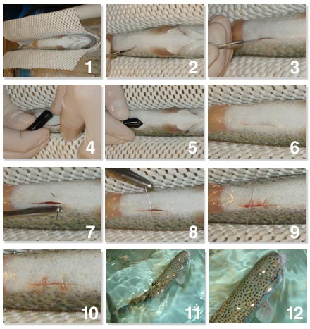

Figure 11. Stages during surgical implantation of tags in salmonid smolts.

2.5 Release site and procedure

Releases occurred on two occasions, one on 27 February 2009 and the second on 6 March 2009. 250 Chinook salmon and 250 steelhead, were released on each occasion. Two fish hauling tanks, one for each species, were used for transport from UC Davis to the release site at Elkhorn Landing on the river above Sacramento. Oxygen was pumped from tanks mounted on the truck through hoses to oxygen diffusers placed in the bottom of each tank. Dissolved oxygen and temperature were recorded throughout transport to ensure the fish were healthy upon release. Upon arrival at the release site, the river temperature was taken to ensure the fish were not stressed by a large temperature fluctuation. On both occasions the river temperature was within two degrees (Celsius) of the hauling tanks. The fish were then released into the river after dark to provide relief from predators within the first few hours of acclimatization.

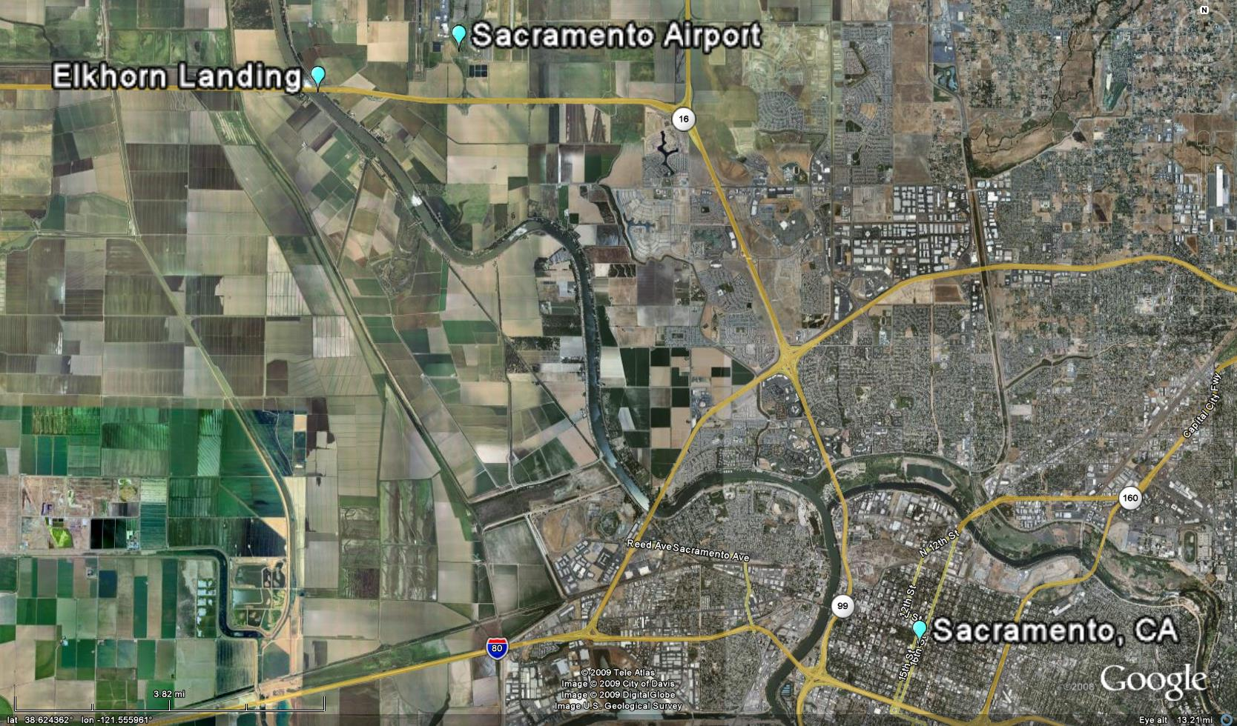

Figure 12. Elkhorn release site in relation to Sacramento Latitude: 36.62266 Longitude:-121.62479 (Image from Google Earth).

2.6 Environmental data

We obtained river discharge data (in cubic feet per second [cfs]) at Rio Vista from the California Data Exchange Center website (http://cdec.water.ca.gov/cgi-progs/staSearch). We obtained tidal height (in meters) data at Richmond Station (37.9283, -122.4) in one-hour intervals, from the NOAA website http://tidesandcurrents.noaa.gov/geo.shtml?location=9414863.

2.7 Data Analysis

2.7.1 Minimum Survival Rates
We determined the minimum survival rates through each of the four reaches and detection probabilities for each cross channel array. The actual detections at each bridge do not accurately describe successful migration to that site. Some tags were not detected at the bridge but were subsequently detected at other receivers below. The actual detections were added to the detections at other receivers in lower reaches to determine the minimum number of fish that successfully migrated to each bridge. This was also the method for determining the detection probability at each cross channel array/bridge. These are minimum estimates because there may have been fish that successfully migrated through a reach and were never detected again. Reach specific survival is the percentage of fish that were detected at the start of a reach which were then detected at the next bridge or in the next reach.

2.7.2 Transit Times and Rates
The “transit time” of a particular fish was defined as the time elapsed between the last detection at a particular listening station or site, and the first detection at a subsequent receiver or site. This can be converted into a value for rate of movement (in meters per second [ms⁻¹]) by dividing the distance travelled by the time elapsed. For all the following analyses, distances between locations were obtained from the NMFS Tracking Consortium shared database, where available, or estimated using Google Earth maps.

We considered the time taken from Elkhorn Boating Launch (release site) to Benicia Bridge to represent an acclimatization period, and therefore did not analyze movements in this section. To determine the overall transit time through the area, we used those individuals from each species which were detected at both Benicia Bridge and the Golden Gate. As the distribution of transit times was non-normal in both cases, for each species, we plotted the frequency distribution and calculated the median..

Two complementary methods were used to determine reach-specific transit time. Firstly, for each species, we selected all individuals which were detected at each of the four gateway arrays (Benicia, Carquinez, Richmond, and Golden Gate). We calculated the overall transit time for each individual as the time elapsed between the last detection at Benicia Bridge and the first detection at the Golden Gate. We then repeated the calculation for each section of the river: from Benicia to Carquinez, from Carquinez to Richmond, and from Richmond to Golden Gate. (It is important to note that the sum of the transit times through each reach may not equal the overall transit time, because individual fish may have resided at one of the bridges for several minutes, or made movements back upstream to previous reaches).

The transit rate is the overall rate of movement through the river section, assuming a constant speed and path distance. We converted transit times to transit rates using the following estimated shortest distances between bridges:

- Benicia to Carquinez: 10.6 km
- Carquinez to Richmond: 26.6 km
- Richmond to Golden Gate: 17.72 km

We used a MANOVA repeated measures test to determine whether significant differences existed between transit times and rates for each species and river section. These might correspond to different swimming speeds, resting phases, current velocity and direction, or pathways through the section.

Secondly, we analyzed each river section independently, using all individuals detected at both the entrance and the exit arrays for each section, to increase the sample size (several fish were detected at some but not all of the gateway arrays). Where data were not normally distributed, medians and quartiles are shown. We used non parametric statistics (Kruskal-Wallis) to test for differences between transit rates by species and river reach. In order to analyze a bimodal distribution found in the transit rates, for each species we grouped individuals as ‘fast’ or ‘slow’, using the cutoff rates apparent in the frequency graphs. We plotted individual fish weight against transit rates to ascertain whether these were correlated. As the bimodal distribution appeared strongest in the upper reach, we compared the transit rate of fish through the Benicia-Carquinez reach with the river discharge volume at Rio Vista (the closest point for which this information was available), to determine whether transit rate depended on the river flow. We also overlaid the time and date of detections of both fast and slow fish as they moved past Decker Island (the closest underwater receiver to Rio Vista) with the river discharge at Rio Vista.

At the main dredge placement site in San Pablo Bay (Fig. 6), we compared the instantaneous rate of transport between SP Control and SP Array 1(immediately upstream of the placement site), and between SP Array 1 and SP Array 2 (which denote the start and end of the placement site respectively), and used a non-parametric test to compare these rates with the overall rate of fishes through this river section. In the case Chinook salmon, a significant proportion of individuals made multiple trips through the array, in both upstream and downstream directions, so that determination of transit rates was not applicable. In these cases, we plotted the position of each individual over time, and estimated transit rates for each movement. We also overlaid tide height at Richmond Station (the closest tide and current station to the SP Arrays), and correlated the number of upstream and downstream movements with the tidal state. In the case of steelhead, where none of the individuals detected at both gateway arrays (Carquinez and Richmond) displayed this upstream/downstream movement, we performed a similar analysis on all fish which did display this behavior.

2.7.3 Residency and exposure times
‘Residency’ refers to the amount of time spent by a particular fish at a given listening station or site. However, in the case of salmonids smolts, which are for the most part migrating downstream towards the sea, it may be more appropriate to use the term ‘exposure time’ as the time spent at particular sites of interest in the river system, such as dredged areas (marinas and shipping channels) or dredge material placement sites (such as the Alcatraz or San Pablo Bay placement sites).

In order to determine exposure time at any given site characterized by one receiver, the number of individual detections at that site for each individual must be transformed to a period of time. This is calculated as the interval between one detection and the next. However, it is necessary to assign a cut-off time interval beyond which the subsequent detection must be considered a new visit, and not a continuation of the previous visit to the site. This cutoff point will depend on the blanking interval of the tag, the detection efficiency of the receiver (which may change over time, as it in turn depends on changing environmental conditions) and on the particular behavior of the species. One way of estimating the cut-off time interval is to carry out a log-survivorship analysis.

We used a method developed by Fagan & Young (1978) whereby the intervals between detections are grouped per unit of time (in this case: minutes). For each species, data from all receivers at the dredged sites were pooled for this analysis, with the assumption that behavior between these sites does not vary. A length frequency graph was plotted initially, from which the logarithm of the frequency of detections greater than each time interval were plotted. This distribution is described by a negative exponential distribution where intervals between detections, when plotted, form a curve whose slope is proportional to the probability of a detection occurring at any given time after the last detection (Colgan 1978). The inflexion point of the curve usually corresponds to a change in behavior. Any time interval smaller than the inflexion point therefore corresponds to two detections in the same visit. Missed detections may have many causes – clashes between tags, signal decay at the range extremes, external noise/interference. Intervals between detections which are greater than the inflexion interval cannot be explained by missed detections but rather by an absence from the site. The inflexion point is often obvious and can be determined visually (eg: Klimley & Holloway, 1984).

Once a cutoff interval was determined for each species, we determined the length of time for each visit at every site, and assigned an arbitrary value equal to the mean blanking interval for visits which lasted for only one detection – in the case of Chinook salmon – 30 seconds, in the case of steelhead – one minute. It is important to note that the results presented in this report show the total exposure time at each site for the area covered by the receiver (if we assume the detection distance to be 75m, this implies an area of roughly 17,620 m². Therefore, when considering exposure to an entire site, the time should be scaled up appropriately depending on the area in question.

We calculated the proportion of the fish which crossed Benicia Bridge (into the start of the study area) that were detected at each dredged site, and the range of potential exposure times.

Due to data constraints, we carried out different analyses for the two main dredge material placement sites. None of the fish from this study were detected at the Alcatraz placement receivers, and the receiver from Alcatraz Control 1 was lost, so it was not possible to make meaningful comparisons at this site. We therefore estimated exposure time for each individual in the same way as for the dredged sites.

At the San Pablo dredge material placement site, we compared the exposure time of fish over the area potentially influenced by dredged material placement activities with that of an adjacent control area (Fig. 13). We grouped all the detections of fish at SP Array 1 and 2, receivers A-D into one site (Disposal Site) and all the detections of fish at SP Array 1 and 2, receivers E-H into another site (Control Site). As the sites of interest in this case are surrounded by receivers rather than being point sites (see prior analysis of dredge sites), we calculated exposure time as the sum of consecutive detections at each of the two sites, regardless of the interval between successive detections. This was based on the precautionary assumption that any period of time between consecutive detections was spent within the area of influence of the Disposal or Control site. Where single detections occurred, we assigned a value equal to the mean blanking interval for the tag in question (for Chinook salmon: 30 seconds; for steelhead: one minute). We used a test of matched pairs to determine whether the salmonid smolts spent more time at one of the sites.

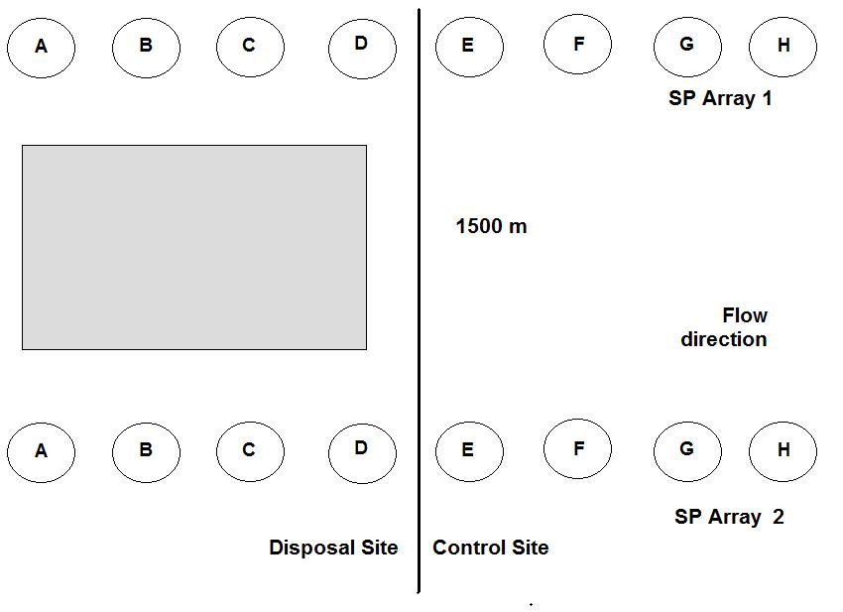
Figure 13. Receivers used to determine exposure time of salmonids smolts to San Pablo Bay Disposal Site (SP Array 1 & 2, receivers A-D) and adjacent control site (SP Array 1 & 2, receivers E-H).

2.7.4 Migratory pathways
Receivers that were deployed across several channels in the upper and lower bay were analyzed for potential depth preferences of smolts during their outmigration. The following arrays were used: Benicia Bridge, Carquinez Bridge, San Pablo Arrays (Control, 1, and 2), San Pablo/Richmond Bridge, and Golden Gate Arrays (west and east line). Detections by species and channel depth profile were graphed of each cross-section array. Regressions of overall depths (all sites combined) were run for each species as well as regressions of individual site depths by species.

Comparisons were also made of Chinook salmon and steelhead detections between areas designated as shoals and channels (dredged areas). The data had equal variances but a non-normal distribution so a non-parametric Wilcoxon test was performed.

2.7.4 Interannual variations
We compared the origin of the salmonid smolts used in the data analyses of previous years with that of the current year. In order to standardize transit times and rates with analyses from previous years, we calculated the transit time and rates, as described in section 2.7.2, for Chinook salmon and steelhead between Richmond Bridge and the Golden Gate.

Due to changing receiver locations and experimental design, it was not possible to provide a detailed comparison of the exposure time of smolts at the SP and Alcatraz arrays. We compared the number of individuals detected and mean exposure time at comparable sites (either where the receiver location was the same, or where a close proxy was available).

2.7.5 Green sturgeon analyses
The California Fish Tracking Consortium database provided information on the presence of green sturgeon throughout the Bay Area in 2008/9 and for the period of time coinciding with the movement of the salmonid smolts from this study through the area (March to June 2009). We calculated the proportion of these which were detected at dredged sites and dredge placement sites, and estimated the exposure time at these sites using the same methods outlined in section 2.7.3.

3 Results

3.1 Survival

Of the 500 Chinook salmon tagged and released at Elkhorn Landing on the Sacramento River, 309 (61.8 %) reached the beginning of the study area at the bottom of Suisun Bay (Benicia Bridge). 238 of the 500 tagged steelhead (47.6 %) survived to the same location. A total of 12.8% of tagged steelhead and 17.8 % of Chinook salmon successfully migrated to the Golden Gate. Detection efficiencies at the Bridges ranged from 47-94 %, except in the case of the Golden Gate, which is an overestimation as only the Point Reyes array was consulted to determine which fish had survived to the ocean and yet not been detected as they passed through the Gate (Table 3). There were 64 tagged steelhead and 89 Chinook salmon that migrated to the Golden Gate array. Of these fish, 52% and 62% respectively, migrated through the SF 10 dredge placement site in San Pablo Bay.
Table 3. Numbers of salmonid smolts detected at each bridge array and estimated detection efficiencies. Figures for Golden Gate in italics are estimates based on fish detected at Point Reyes.

 | Success to Site | Actual Detections |  |  | From Benicia % |  | From Release Site % | Reach Specific % |  |  | Detection Prob.  %
Steelhead
Benicia | 237 |  | 163 |  |  | 47.6 |  |  | 47.4 | 68.8
Carquinez | 212 |  | 101 | 89.5 |  | 42.4 |  |  | 89.5 | 47.6
Richmond | 152 |  | 86 | 64.1 |  | 30.4 |  |  | 71.7 | 56.6
Golden Gate | 64 |  | 62 | 27.0 |  | 12.8 |  |  | 42.1 | 96.9
Chinook salmon
Benicia | 309 |  | 233 |  |  | 61.8 |  |  | 61.8 | 75.4
Carquinez | 265 |  | 161 | 85.8 |  | 53.0 |  |  | 85.8 | 60.8
Richmond | 164 |  | 106 | 53.1 |  | 32.8 |  |  | 61.9 | 64.6
Golden Gate | 89 |  | 85 | 28.8 |  | 17.8 |  |  | 54.3 | 95.5

3.2 Transit time

The release site at Elkhorn Boating Facility is situated at a distance of 204.92 km from the Golden Gate. We considered the river section from the release site to Benicia Bridge to be acclimatization habitat, such that analysis of transit time and residency began once individuals were detected at Benicia. The overall transit time, from Benicia bridge to the last detection for those individuals which passed the Golden Gate (a distance of 50.69 km) varied from 1.14 to 11.6 days for Chinook salmon (median: 2.2 days) and from 1.0 to 17.7 days for steelhead (median: 1.9 days) (Fig. 14).

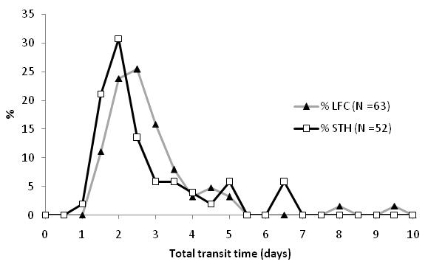
Figure 14. Total transit time (in days) for Chinook salmon (LFC) and steelhead (STH) from Benicia Bridge to the Golden Gate in 2009.

Of the 500 individuals of each species released, 85 Chinook salmon (17 %) and 62 steelhead (12.4 %) were detected at the Golden Gate. However, of these, only 20 (23.5 %) of the former and 10 (16.1 %) of the latter were detected at all four bridges used to separate river sections: Benicia, Carquinez, Richmond and the Golden Gate. Steelhead transited on average faster than Chinook salmon, at the river reaches between Benicia and Carquinez and between Richmond and the Golden Gate, while rates were similar for both species through San Pablo Bay, from Carquinez to Richmond (Table 4). Overall, there was no a significant difference in rates between species (MANOVA; p=0.0608) but there was a significant difference in transit rates between reaches (MANOVA; p=0.0009) in that steelhead transited more slowly through the Carquinez to Richmond reach.

For all fish detected at each river reach, the overall transit time through the study area (Benicia Bridge to the Golden Gate) did not vary between species (Welch’s test, p=0.722). There were no significant differences in transit rate by river stretch or species (Kruskal-Wallis, p = 0.67) [Fig. 15].

Table 4. Transit time (h:mm:ss) and rate (ms⁻¹) of Chinook salmon and steelhead which were detected through each section of the river system.

 |  | Benicia to Carquinez  10.4 km |  | Carquinez to Richmond  26.6 km |  | Richmond to Golden Gate  17.72 km
Species | Tag ID | Time | Rate (ms⁻¹) | Time | Rate (ms⁻¹) | Time | Rate (ms⁻¹)
Steelhead | 31698 | 35:51:49 | 0.08 | 39:34:37 | 0.19 | 15:59:54 | 0.31
 | 31704 | 2:00:11 | 1.44 | 19:53:09 | 0.37 | 3:53:49 | 1.26
 | 31711 | 8:22:19 | 0.35 | 10:15:44 | 0.72 | 15:07:58 | 0.33
 | 31738 | 2:39:46 | 1.08 | 13:16:02 | 0.56 | 22:24:43 | 0.22
 | 31770 | 12:18:30 | 0.23 | 32:35:31 | 0.23 | 6:41:21 | 0.74
 | 31859 | 2:14:09 | 1.29 | 72:02:29 | 0.10 | 5:21:00 | 0.92
 | 31864 | 2:53:21 | 1.00 | 17:34:42 | 0.42 | 77:07:26 | 0.06
 | 32005 | 3:35:59 | 0.80 | 31:51:20 | 0.23 | 2:57:22 | 1.67
 | 32118 | 1:53:16 | 1.53 | 125:07:24 | 0.06 | 8:20:13 | 0.59
 | 32129 | 2:44:55 | 1.05 | 20:31:49 | 0.36 | 2:52:40 | 1.71
Mean |  | 7:27:26 | 0.89 | 38:16:17 | 0.32 | 16:04:39 | 0.78
95 % CI |  | 6:32:02 | 0.316 | 21:54:45 | 0.127 | 13:53:54 | 0.369
Chinook | 31272 | 11:40:42 | 0.25 | 14:14:56 | 0.52 | 11:41:22 | 0.42
salmon | 31284 | 3:28:52 | 0.83 | 19:12:12 | 0.38 | 75:09:03 | 0.07
 | 31307 | 2:33:00 | 1.13 | 29:18:36 | 0.25 | 12:44:12 | 0.39
 | 31342 | 12:44:35 | 0.23 | 14:27:19 | 0.51 | 23:18:10 | 0.21
 | 31354 | 1:59:16 | 1.45 | 22:16:39 | 0.33 | 26:06:19 | 0.19
 | 31376 | 4:26:39 | 0.65 | 20:57:39 | 0.35 | 11:43:56 | 0.42
 | 31393 | 8:49:46 | 0.33 | 44:17:49 | 0.17 | 10:26:45 | 0.47
 | 31403 | 2:53:14 | 1.00 | 35:49:33 | 0.21 | 13:32:33 | 0.36
 | 31448 | 10:30:14 | 0.28 | 26:24:33 | 0.28 | 3:13:42 | 1.52
 | 31493 | 2:41:37 | 1.07 | 16:44:10 | 0.44 | 25:54:47 | 0.19
 | 31494 | 18:13:42 | 0.16 | 37:16:34 | 0.20 | 8:58:38 | 0.55
 | 31500 | 1:52:57 | 1.53 | 13:20:18 | 0.55 | 9:31:45 | 0.52
 | 31501 | 3:03:04 | 0.95 | 12:00:55 | 0.61 | 22:28:43 | 0.22
 | 31570 | 12:17:15 | 0.24 | 15:09:12 | 0.49 | 18:53:21 | 0.26
 | 31571 | 1:59:00 | 1.46 | 23:16:19 | 0.32 | 10:31:07 | 0.47
 | 31578 | 10:44:02 | 0.27 | 12:12:12 | 0.61 | 10:02:28 | 0.49
 | 31589 | 12:34:46 | 0.23 | 19:46:05 | 0.37 | 3:30:14 | 1.40
 | 31597 | 10:28:28 | 0.28 | 53:07:31 | 0.14 | 4:28:46 | 1.10
 | 31619 | 13:56:06 | 0.21 | 13:53:58 | 0.53 | 60:57:33 | 0.08
 | 31628 | 11:51:54 | 0.24 | 15:13:35 | 0.49 | 11:29:38 | 0.43
Mean |  | 7:56:27 | 0.64 | 22:57:00 | 0.39 | 18:44:09 | 0.49
95 % CI |  | 2:15:10 | 0.21 | 5:03:43 | 0.07 | 8:02:09 | 0.18

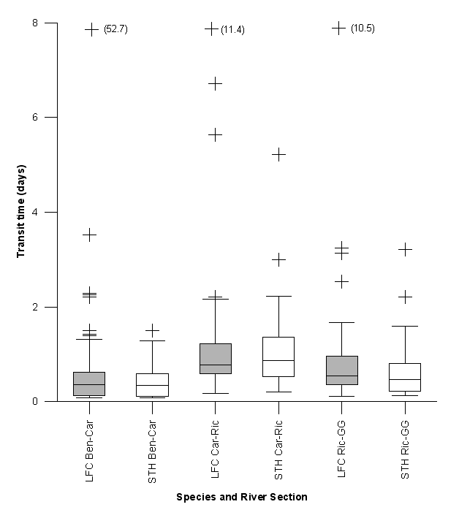
N: 118 65 58 43 48 31
Figure 15. Transit time of Chinook salmon (LFC, grey) and steelhead (STH, white) in three sections of the Sacramento River system: Benicia (BEN) –Carquinez (CAR), Carquinez (CAR)–Richmond (RIC), Richmond (RIC) –Golden Gate (GG). The boxes display the upper and lower quartiles, the line denotes the median, caps at each end of the box delimit extreme values; outliers are displayed as “+”. Sample size for each group is displayed above in bold.

The overall transit rates for each stretch of river, calculated as the distance between bridge arrays over the time taken for each individual, displayed a clear bimodal distribution for both species between Benicia and Carquinez (Fig. 16). One group of fish migrated through this reach relatively slowly – at a modal speed of around 0.25 ms⁻¹, while another group migrated rapidly, often at speeds > 1 ms⁻¹. Very few fish migrated through this reach at rates between 0.5-0.9 ms⁻¹. This is less apparent in the other river reaches (Figs. 17 and 18).
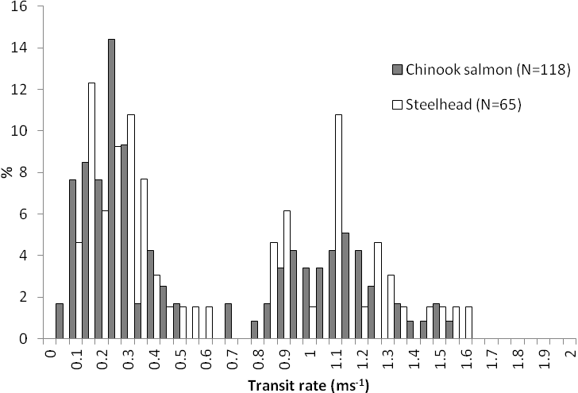
Figure 16. Transit rates (ms-1) for Chinook salmon (filled bars) and steelhead (white bars) from Benicia Bridge to Carquinez Bridge, 2009.

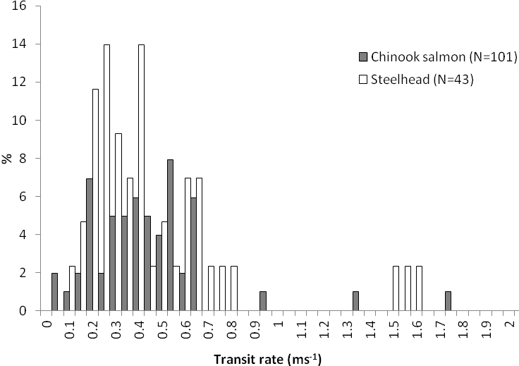

Figure 17. Transit rates (ms-1) for Chinook salmon (filled bars) and steelhead (white bars) from Carquinez Bridge to Richmond Bridge, 2009.

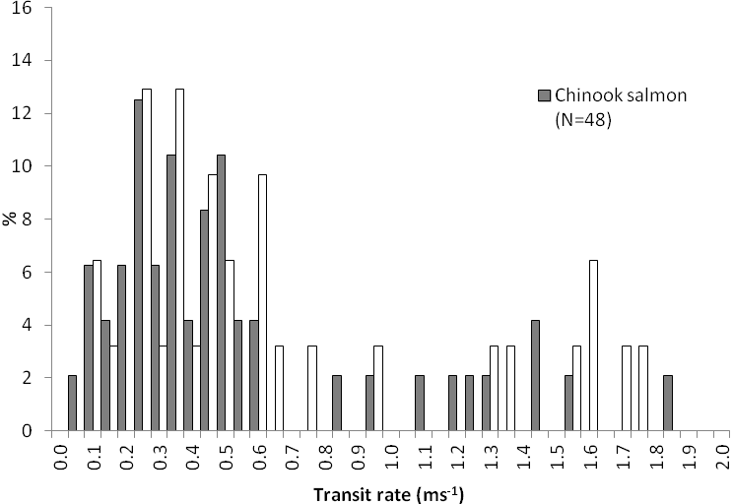
Figure 18. Transit rates (ms-1) for Chinook salmon (filled bars) and steelhead (white bars) from Richmond Bridge to the Golden Gate, 2009.

The size of the fish (represented as its wet weight, in grams) did not display any significant relationship with the transit speed, for either species (Figs 19 and 20).

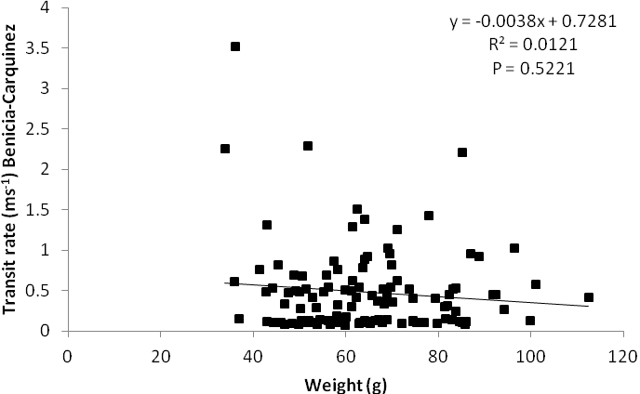
Figure 19. Relationship between fish weight (g) and transit rate (ms⁻¹) of Chinook salmon through river section from Benicia to Carquinez.

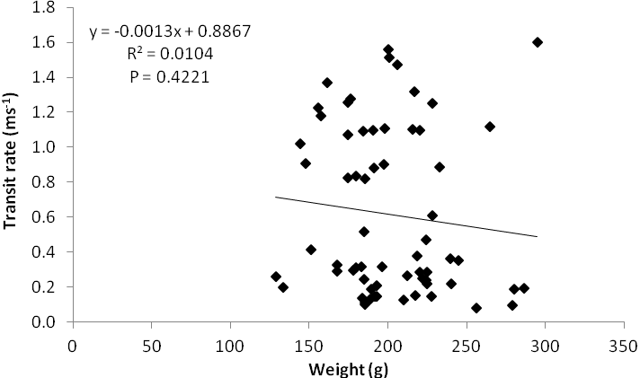

Figure 20. Relationship between fish weight (g) and transit rate (ms⁻¹) of steelhead through river section from Benicia to Carquinez.

The two groups of Chinook salmon – those which migrated through the Benicia-Carquinez river section at an overall rate faster than 0.6 ms⁻¹, and those slower – appeared to move mostly with peak flows (Fig 21). Only three individuals were recorded as transiting during slack tide, yet ironically, all three belonged to the group of fish which transited rapidly. There was no significant difference between the river discharge volumes at the time of passage for either fast or slow fish (Fig. 22).

Steelhead generally transited through the reach on peak ebb tides, although in this case some of the slow individuals moved during slack or flood tides (Fig. 23). For this species, the downstream flow appeared to explain some of the transit rate (Fig. 24).

The overall transit rate through the Benicia-Carquinez river stretch did not appear to be determined by whether the fish moved back upstream and did not seem to affect whether the fish eventually reached the Golden Gate (Table 5).

Table 5. Proportion of fish which transited at ‘fast’ or ‘slow’ rates through Benicia-Carquinez river stretch and whether they displayed upstream-downstream movements and reached the Golden Gate.

Fish | Speed Category | Transit rates (m/s) | N | # at Golden Gate (GG) | % | # upstream-downstream  (U-D) | % | # U-D detected at GG | % | % U-D of GG detected
Chinook | Fast | 0.69-1.56 | 48 | 12 | 25 | 30 | 62.5 | 7 | 23.3 | 58.3
Chinook | Slow | 0.06-0.47 | 70 | 23 | 33 | 33 | 47.1 | 11 | 33.3 | 47.8
steelhead | Fast | 0.82-1.60 | 26 | 15 | 58 | 12 | 46.2 | 9 | 75.0 | 60.0
steelhead | Slow | 0.08-0.52 | 38 | 8 | 21 | 18 | 47.4 | 7 | 38.8 | 87.5

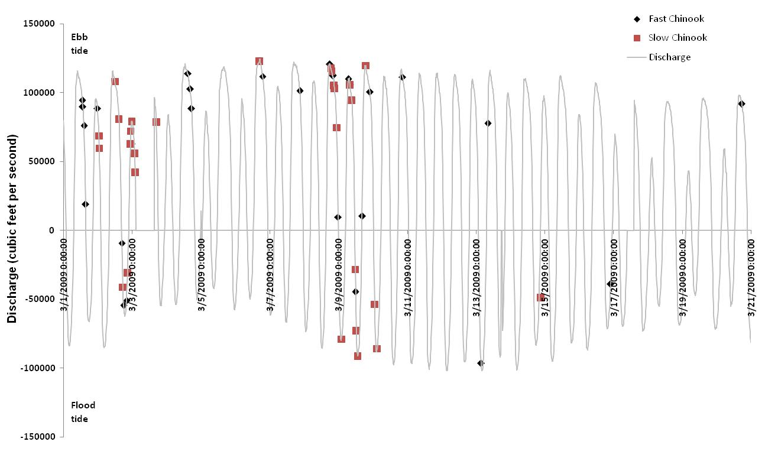
Figure 21. River discharge volume (from Rio Vista c-dec) at first detection of Chinook salmon through Decker Island.

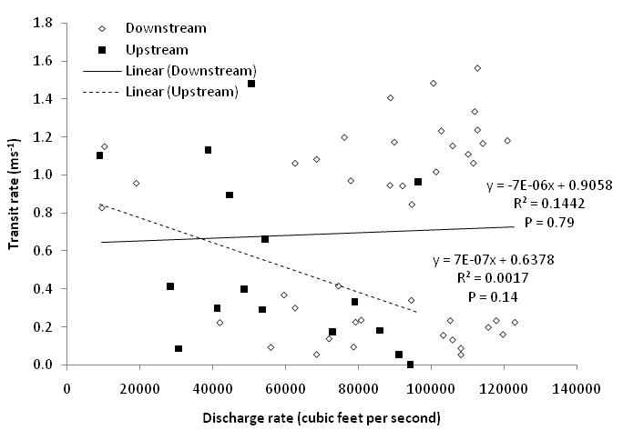

Figure 22. Correlation of transit rates (ms⁻¹) of Chinook salmon through river section Benicia-Carquinez, with corresponding river discharge volume (from Rio Vista C-dec) at first detection at Decker Island.

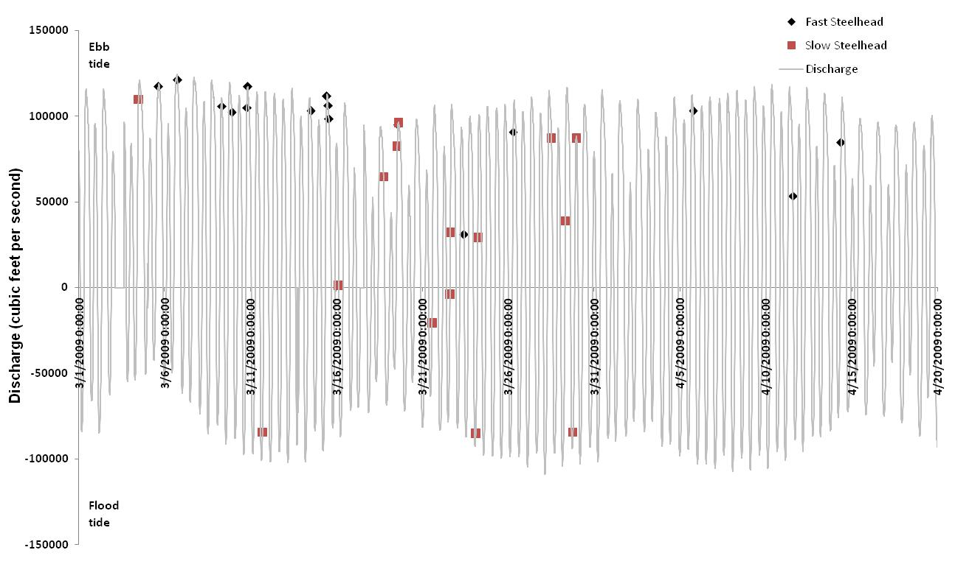
Figure 23. River discharge volume (from Rio Vista) at first detection of steelhead through Decker Island.

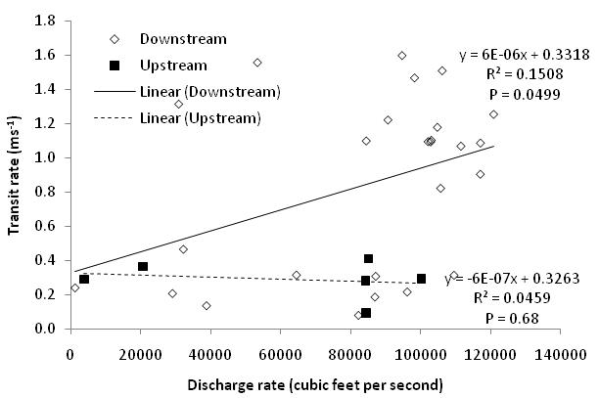

Figure 24. Correlation of transit rates (ms⁻¹) of Chinook salmon through river section Benicia-Carquinez, with corresponding river discharge volume (from Rio Vista C-dec) at first detection at Decker Island.

A total of 36 Chinook salmon were detected at both Carquinez and Richmond bridges and at least two of the SP Arrays. Out of these, 22 fish migrated through the array once (Table 6), whereas 14 (39%) displayed movements back upstream at least once (Appendix 1). Table 6 displays the instantaneous rate of transit for each of the 22 fish as they moved between SP Control and SP Array 1 and between SP Array 1 and SP Array 2, and compares these rates with those displayed by the same fish over the entire river section. The mean rates between both arrays are very fast – greater than 1 ms⁻¹ in both cases, compared with overall rates of 0.44 ms-1 on average, but significant differences exist both between the entire stretch and SP Control-SP Array 1 (Paired T-test,, p <0.001), the entire stretch and SP Array 1 – SP Array 2 (Paired T-test, p<0.001), and between the two sections of the array : SP Control-SP Array 1 and SP Array 1-SP Array 2, with fish transiting at a faster rate through the former section (Paired T-test, p<0.001).

Table 6. Instantaneous transit rates (ms⁻¹) of Chinook salmon through sections of the San Pablo Array compared with overall transit times from Carquinez to Richmond Bridge.

Tag ID | Carquinez-Richmond | SP Control - SP Array 1 | SP Array 1- SP Array 2
31284 | 0.38 | 2.05 | 1.90
31289 | 0.45 | 1.82 | 1.84
31376 | 0.35 | 2.53 | 0.09
31386 | 0.44 | 1.81 | 1.50
31389 | 0.41 | 1.68 | 0.12
31496 | 0.17 | 1.24 | 1.00
31578 | 0.61 | 1.31 | 0.06
31589 | 0.43 | 0.88 | 0.06
31618 | 0.39 | 1.40 | 1.41
31628 | 0.49 | 1.38 | 1.26
31636 | 0.47 | 1.70 | 1.22
31260 | 0.47 | 1.76
31392 | 0.36 | 1.37
31426 | 0.54 | 1.30
31454 | 0.44 | 1.21
31466 | 0.29 | 1.55
31500 | 0.55 | 2.42
31501 | 0.61 | 1.95
31570 | 0.49 | 1.93
31579 | 0.39 | 1.31
31619 | 0.53 | 1.22
31415 | 0.32 |  | 1.93
Average transit rate | 0.44 | 1.61 | 1.03

Chinook salmon #31142 (191 mm fork length, 85.2 g) was released on February 27th and reached Carquinez Bridge (the entry to San Pablo Bay) at 23:06 on March 7th (Fig. 25). It was detected at the bridge on several occasions throughout the night until 10:20 am the next morning, when it began to move downstream, at slack high tide. It was detected at SP Control eight hours later - implying a downstream transit rate of 0.53 ms⁻¹, undertaken almost entirely during the ebb tide. The next movement detected by the array occurred at the next ebb tide, as the fish moved downstream through SP Arrays 1 (at 0.9 ms⁻¹) and 2 (at 0.5 ms⁻¹), and then back upstream to SP Control (at 0.9 ms⁻¹ through SP Array 1, then 0.54 ms⁻¹ to SP Control) as the tide turned. During the following ebb tide (on 9 March at 16:00), the fish repeated the same movement through the Arrays, but ended further upstream, at SP Buoy 10, where it held position for the next 12 hours (a full tidal cycle), then moved further upstream back to Carquinez (transit rate: 1.28 ms⁻¹) on the flood tide. It travelled back downstream to SP Control on the next ebb tide (transit rate: 0.8 ms⁻¹) and then back up to Carquinez yet again on the following flood tide (transit rate: 0.58 ms⁻¹). It then transited the entire length of the bay, arriving at Richmond bridge at 19:21(transit rate: 0.5 ms⁻¹). It then returned once more to SP Array 2 on the next flood tide, after which it was not detected further.

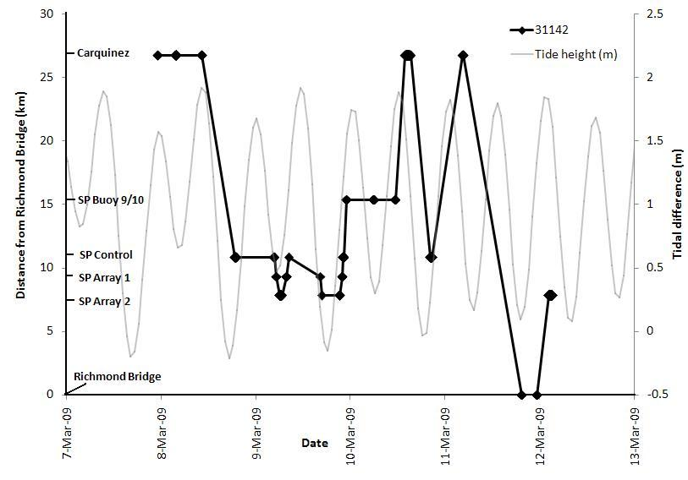
Figure 25. Movement of Chinook salmon #31142 from Carquinez to Richmond Bridge, related to tidal state.

Chinook salmon #31494 (166 mm fork length, 58.2 g) was released on March 6th and reached Carquinez Bridge at 20:16 on March 14th (Fig. 26), where it was detected only once. At 9:52 am the next morning, it was detected at the SP Channel (transit rate 0.23 ms⁻¹). From the SP Channel buoy, it moved downstream through SP Control (but not SP Array 1) to SP Array 2 (transit rate: 1.4 ms⁻¹), where it was detected once, before returning to SP Channel on the flood tide (transit rate: 0.26 ms⁻¹). The fish remained at the SP Channel buoy for 3 minutes and was next detected over 6 hours later (at 22:21) back downstream at SP Array 1, where it resided for one hour. It made one final move back upstream to SP Control, for three minutes, then moved through SP Array 1 (but not SP Array 2) to Richmond Bridge (transit rate: 1.4 ms⁻¹) and from there out of San Pablo Bay to the Golden Gate (transit rate: 0.46 ms⁻¹).

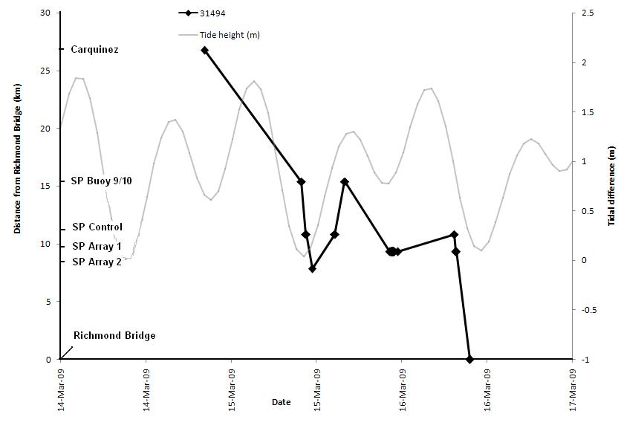
Figure 26. Movement of Chinook salmon #31494 from Carquinez to Richmond Bridge, related to tidal state.

Overall, the upstream and downstream movements of these Chinook salmon appeared to coincide with upstream and downstream current flows, as shown in Fig. 27. The upstream movement of four individuals coincides with the peak flood tide, whereas the downstream movement of five individuals coincides with a peak ebb tide. Similarly, one or two individuals make upstream or downstream movements with the tide throughout the study period.
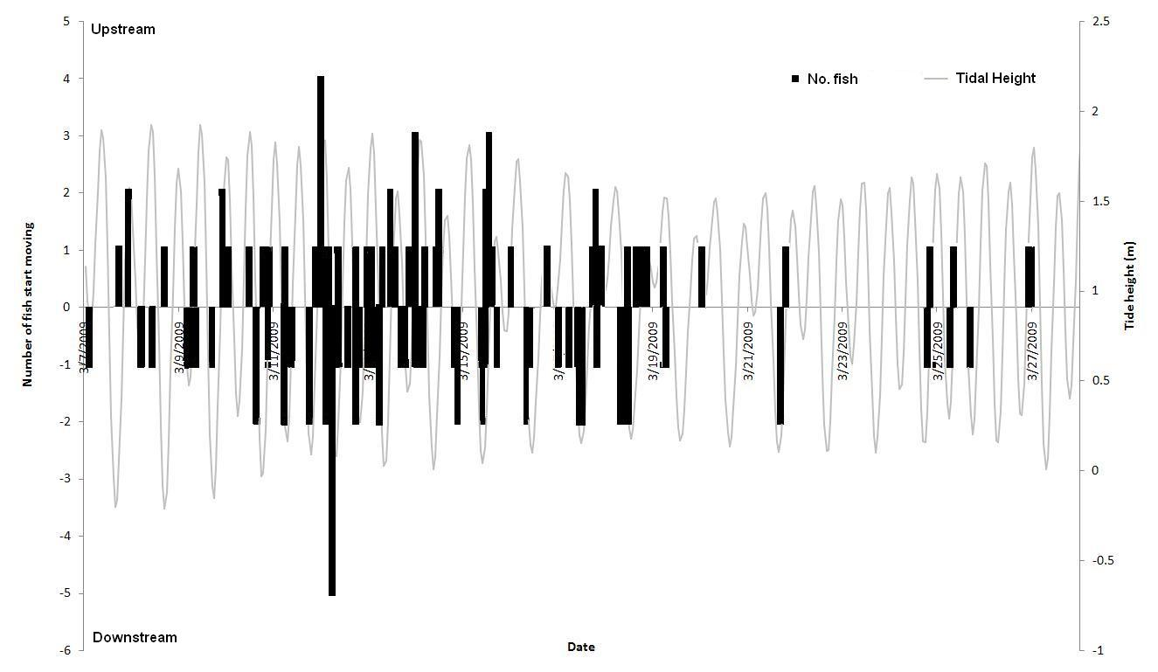

Figure 27. Number of Chinook salmon moving upstream or downstream through San Pablo Bay in relation to tidal height.

Seventeen steelhead were detected at both Carquinez and Richmond Bridges, none of which moved through the arrays more than once (Table 7). However, several steelhead which escaped detection at one or other of the bridges displayed upstream movements and transited the array on more than one occasion (Appendix 2). As with the Chinook salmon, steelhead transited the array sections at high instantaneous rates – greater than 1 ms⁻¹ on average for each part of the Array, in comparison to an average of only half this value for the entire river section (entire stretch vs. SP Control-SP Array 1: Paired T-test, p <0.001; entire stretch vs. SP Array 1-SP Array 2: Paired T-test, p < 0.001), but there were no differences in transit rates between SP Control–SP Array 1 and SP Array 1–SP Array 2 (Paired T-test, p = 0.22).

Table 7. Instantaneous transit rates (ms⁻¹) of steelhead through sections of the San Pablo Array compared with overall transit times from Carquinez to Richmond Bridge.

Tag ID | Carquinez-Richmond | SP Control - SP Array 1 | SP Array 1- SP Array 2 | SP Control - SP Array 2
31720 | 0.40 | 1.71 | 1.52 | 1.61
31827 | 0.78 | 1.32 | 1.19 | 1.25
31848 | 1.57 | 2.43 | 1.77 | 2.05
31867 | 0.23 | 1.13 | 0.61 | 0.80
31940 | 1.47 | 1.06 | 1.39 | 1.20
32101 | 0.25 | 0.74 | 0.87 | 0.80
32133 | 0.64 | 1.76 | 1.56 | 1.65
31983 | 0.23 | 0.02
 |  |  |  | Table 7 Cont.
32005 | 0.23 | 1.09
32052 | 0.16 | 1.18
32064 | 0.19 | 1.52
32070 | 0.24 | 2.24
32078 | 0.31 | 0.59
32084 | 0.58 | 1.15
32137 | 0.39 | 1.67
31859 | 0.10 |  |  | 0.10
32104 | 1.50 |  |  | 2.04
Average transit rate | 0.55 | 1.31 | 1.27 | 1.28

Steelhead #31754 (254 mm fork length, 155.9 g) was released on February 27th and reached Benicia Bridge on March 28th, where it was detected for approximately 10 minutes just before 04:00 (Fig. 28). It passed through Carquinez (although was not detected), and arrived at SP Control (at an overall transit rate of 0.014 ms⁻¹) at 9:45for five minutes, and was then detected once again at the same site 2 hours later, for a further 7 minutes, probably moving upstream, as the subsequent detection was at 15:00, at SP Buoy 9 (coinciding with the slack high tide). At 17:00 it then returned downstream to SP Array 1(at a rate of 1.12 ms⁻¹) for a few minutes and was not detected again until 02:30 the next morning, slightly upstream in SP Control, where it remained for one hour and was then detected at the Golden Gate at 08:30, moving out of the system at an overall rate of 1.37 ms⁻¹.

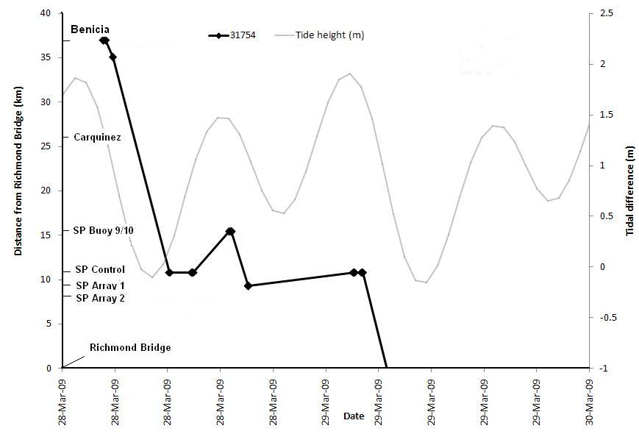
Figure 28. Movement of steelhead #31754 through Carquinez to Richmond Bridge, related to tidal state.
Steelhead #31773 (263 mm fork length, 199.2 g) was released on February 27th and reached Carquinez Bridge on March 29th at 21:10 for three minutes, after which it transited to SP Control, at a rate of 0.34 ms⁻¹, arriving at 10:16 the next morning (Fig. 29). After a single detection at SP Control, it was detected once at SP Array 1 and then for 5 minutes at SP Array 2 (transiting at 1.13 ms⁻¹ and then 0.46 ms⁻¹ respectively). It then moved back upstream, coinciding with the flood tide (Fig. 29) back to SP Array 1 (at a rate 0f 0.18 ms⁻¹) and then to SP Channel by the evening (at an overall rate of 0.24 ms⁻¹) after which it was not detected again.

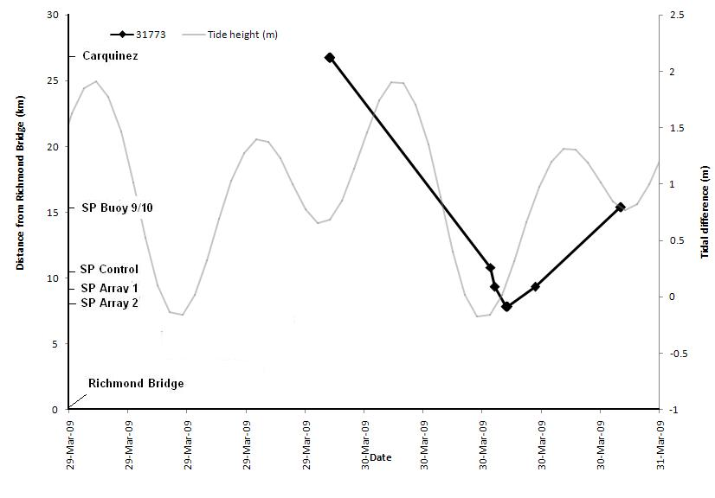
Figure 29. Movement of steelhead #31773 through Carquinez into San Pablo Bay, related to tidal state.

Overall, the upstream and downstream movements of the steelhead appeared to coincide with upstream and downstream current flows, as shown in Fig. 30.

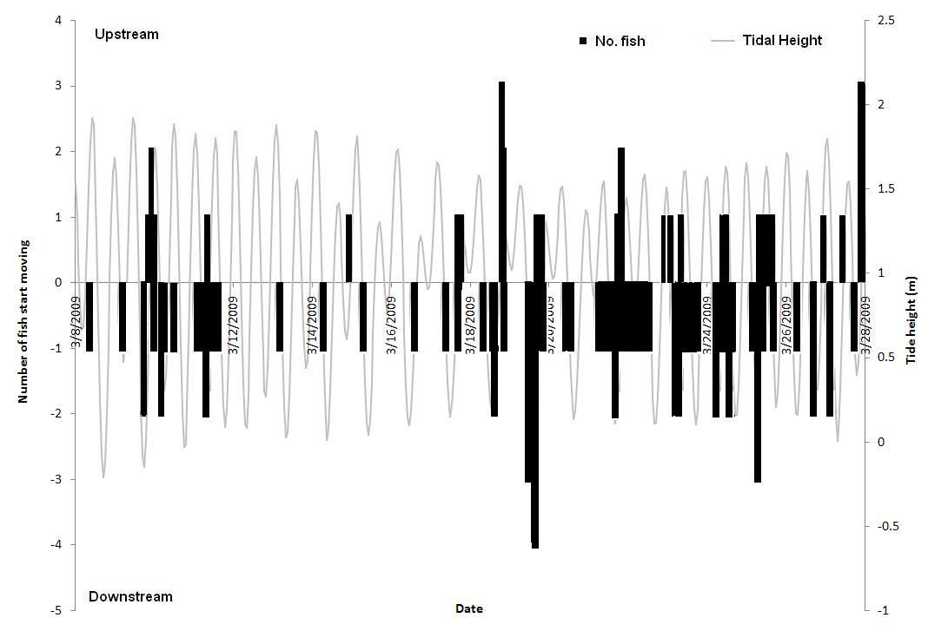
Figure 30. Number of steelhead moving upstream or downstream through San Pablo Bay in relation to tidal height.

3.3 Residency and exposure times

Of the 265 Chinook salmon which entered San Pablo Bay, 94 % (249 individuals) were detected at either a dredge site (Table 8) or a disposal/control site (SP Control and Arrays 1 & 2, Alcatraz Control and Array). Similarly, of 213 steelhead which entered San Pablo Bay, 77.5% (165 individuals) were detected at one or more of these sites. For both species, Martinez Marina detected the largest number of individuals (156 Chinook salmon and 64 steelhead), whereas several sites (Berkley Marina, Emeryville A, San Rafael Can6, Suisun City Marina) were not visited by any individual of either species.

Table 8. Number of fish detected at marinas and channel sites (where dredging occurs).

 |  | Chinook salmon |  | Steelhead
Station Type | Station Name | # Fish | # Detections | # Fish | # Detections
Marina/Shoal | Berkley Marina
 | EmeryvilleA
 | EmeryvilleB | 1 | 2
 | G3 | 5 | 160 | 2 | 22
 | G5 |  |  | 1 | 1
 | Larkspur Ferry 15 |  |  | 5 | 112
 | MartinezMarina | 156 | 1152 | 64 | 162
 | MontezumaEast | 4 | 308 | 4 | 149
 | MontezumaWest | 4 | 103 | 2 | 22
 | PetalumaRRBridge | 5 | 192 | 5 | 206
 |  |  |  |  | Table 8 Cont.
 | Point Richmond |  |  | 2 | 30
 | PortSonomaMarina | 4 | 50 | 3 | 7
 | San Rafael Can 6
 | Suisun City Marina
 | Vallejo Marina C | 12 | 36
 | Total | 168 | 2003 | 77 | 711
Channel | SPBuoy7 |  |  | 1 | 1
 | SPBuoy8 | 50 | 331 | 38 | 163
 | SPBuoy10 | 38 | 240 | 2 | 5
 | SPBuoy10b | 3 | 7
 | Total | 80 | 578 | 39 | 169

Log survivorship analysis of intervals between detections at these sites did not show a clear break for Chinook salmon (Fig. 31), and showed only a small break at 4.5 minutes for steelhead (Fig. 32). For both species, time-frequency graphs displayed a gap corresponding to the random delay of the tags – shorter for Chinook salmon, which had a shorter delay. The time-frequency graphs displayed a large peak at around 0.5 minutes for Chinook salmon, and 1 minute for steelhead, coinciding with the tag emission frequency. Two smaller peaks might be resolved at time intervals which correspond to one or two detection failures. We assigned an interval of 5 minutes based on the assumption that three consecutive detection failures are unlikely, as can be observed on the graphs.

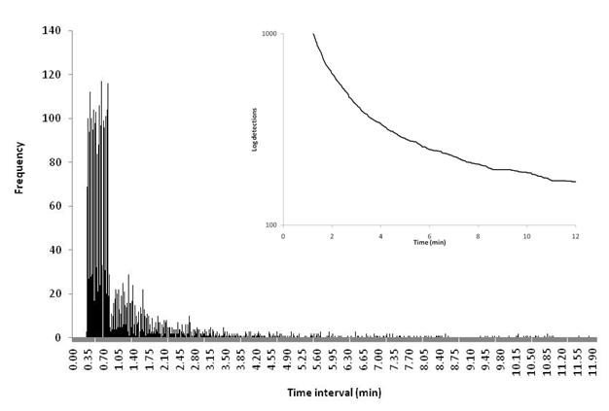
Figure 31. Frequency of time intervals between detections for Chinook salmon at all dredging sites. Inset: log survivorship analysis showing logarithmic scale of frequency of intervals greater than x. Note that there is no clear cutoff.
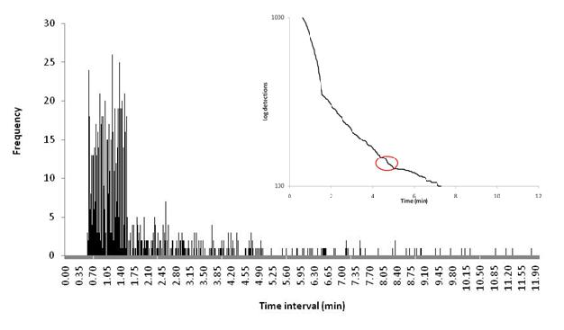
Figure 32. Frequency of time intervals between detections for steelhead at all dredging sites. Inset: log survivorship analysis showing logarithmic scale of frequency of intervals greater than x. Note cutoff at about 4.5 minutes.

The exposure time for both Chinook salmon and steelhead at the dredged sites can be expressed in terms of minutes rather than hours or days, with 75 % of steelhead spending less than 6 minutes overall at a dredge site, and 75% of Chinook salmon spending less than 8 minutes at these sites (Fig. 33).

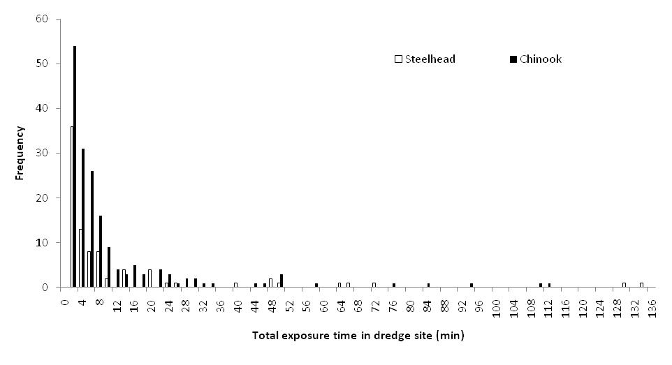
Figure 33. Total exposure time at a dredged site (marina or channel) by salmonid smolts in San Francisco Bay estuary.

Martinez Marina was the site which recorded the highest number of both Chinook salmon and steelhead, whereas several individuals were recorded at the SP Buoys, in the main channel. At the other sites, only a small number of fish were detected (Table 9). Appendices 3 and 4 show time spent by each individual at each site for Chinook salmon and steelhead respectively.

Table 9. Total and mean exposure time (in minutes) for salmonids smolts per site where dredging potentially occurs. Also shown are the number of individuals recorded at each site.

Data | Sp. | EmeryvilleB | G3 | G5 | Larkspur Ferry 15 | MartinezMarina | MontezumaEast | MontezumaWest | PetalumaRRBridge | Point Richmond | PortSonomaMarina | SPBuoy10 | SPBuoy10b | SPBuoy7 | SPBuoy8 | Vallejo Marina C
Total time (min) | STH |  | 26 | 1 | 125 | 158 | 194 | 19 | 254 | 36 | 6 | 4 |  | 1 | 175
Mean time (m) |  |  | 13 | 1 | 25 | 3 | 48 | 19 | 50 | 18 | 2 | 2 |  | 1 | 4
# Individuals |  |  | 2 | 1 | 5 | 48 | 4 | 1 | 5 | 2 | 3 | 2 |  | 1 | 38
Total time (min) | LFC | 1 | 176 |  |  | 1028 | 362 | 87 | 139 |  | 32 | 188 | 7 |  | 220 | 24
Mean time (m) | LFC | 1 | 35 |  |  | 7 | 90 | 21 | 27 |  | 8 | 5 | 2 |  | 4 | 2
# Individuals |  | 1 | 5 |  |  | 138 | 4 | 4 | 5 |  | 4 | 37 | 3 |  | 50 | 12

At the San Pablo Array site, there was no significant difference (Matched pairs, Chinook salmon p=0.25; steelhead, p = 0.91) between the time spent at either the control or placement sites for both species (Figs 34 & 35). Exposure time was mostly under 200 minutes (78 % for the control site and 90% for the disposal site in the case of Chinook salmon, and 88% for the control site and 91% for the disposal site in the case of steelhead).

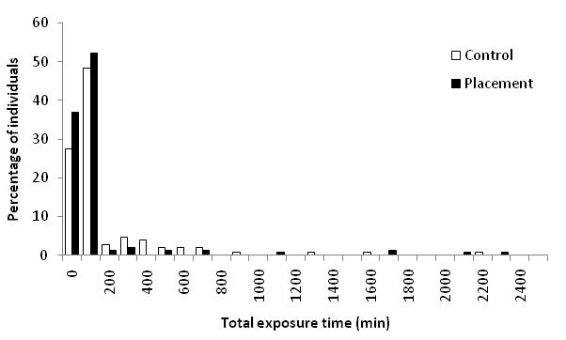
Figure 34. Total exposure time of Chinook salmon at the San Pablo Array placement site in comparison with adjacent control site.

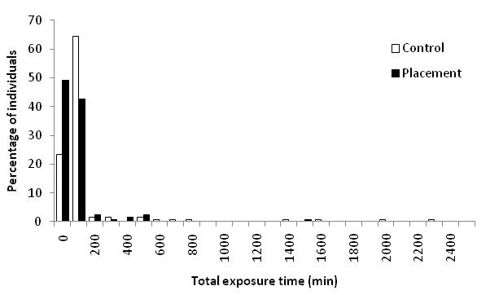
Figure 35. Total exposure time of steelhead at the San Pablo Array placement site in comparison with adjacent control site.

No salmonid smolts from this study were detected at the Alcatraz dredge material placement site, although the partial early release of the array may partially account for this. The total exposure time at the receivers in the Alcatraz Control site did not exceed 2 minutes for steelhead, and only exceeded 5 minutes for three Chinook salmon (Table 10).

Table 10. Total exposure time (minutes) of salmonid smolts at Alcatraz Control site.

Chinook salmon |  |  |  | Steelhead
Tag ID | Exposure (min) | Tag ID | Exposure (min) | Tag ID | Exposure (min)
31167 | 1.4 | 31501 | 2.1 | 31709 | 2
31237 | 9.7 | 31509 | 1.9 | 31822 | 1
31327 | 1 | 31519 | 1 | 31835 | 1
31339 | 0.5 | 31560 | 0.5 | 31858 | 1
31355 | 10.9 | 31586 | 2.4 | 31990 | 1
31417 | 2.7 | 31591 | 0.9 | 32005 | 1.6
31440 | 0.9 | 31602 | 0.5 | 32009 | 1.6
31443 | 0.5 | 31612 | 4.3 | 32034 | 0.7
31477 | 0.5 | 31626 | 0.8 | 32037 | 2
31480 | 0.5 | 31628 | 2.4 | 32053 | 1
31481 | 0.5 | 31630 | 0.5 | 32084 | 1
31489 | 16

3.4 Migratory Pathways

Graphs of smolt detections and channel depth profiles are shown in Figure 36. Each graph shows the individual receivers on the X-axis, number of individuals detected (bars) on left Y-axis, channel depth (line) on the right Y-axis. The cross-section graph for the Richmond Bridge arrays excludes Fish I.D. number 31917, a steelhead smolt. This particular fish crossed the Richmond Bridge array on March 13, 2009, was then detected at the Golden Gate Array on March 14, 2009 and then was detected again continuously until April 21, 2009 at the Richmond Bridge array (Figure 37). This may indicate a predation event and skewed the number of detections at that site.

Chinook salmon were detected more frequently (total detections and individual tag detections) at all the bridges and San Pablo array than steelhead smolts (Tables 11 and 12). The linear dependence between the frequency of detection of migrating salmonids and the full range of water depths is significant, but very low (Figure 38). At some sites (Figure 39 a to h), Chinook salmon and steelhead followed a similar pattern with respect to depth profile, such as either having an effect (Golden Gate Bridge) or no effect (Benicia and Carquinez Bridges) on migratory pathways, while at other sites Chinook salmon and steelhead diverged from each other with respect to channel depth profile and migratory pathways (San Pablo Bay and Richmond Bridge).

Table 11. Total detections for each bridge or cross-section array

Locations | Chinook salmon |  | Steelhead
Benicia Bridge | 5575 | 1650
Carquinez Bridge | 3506 | 1506
San Pablo Control | 3273 | 533
San Pablo Array 2 | 1309 | 404
San Pablo Array 1 | 1405 | 439
Richmond Bridge | 952 | 445
Golden Gate Bridge | 853 | 278

Table 12. Individual transmitter detections for each bridge or cross-section array

Locations | Chinook salmon |  | Steelhead
Benicia Bridge | 233 | 163
Carquinez Bridge | 161 | 101
San Pablo Control | 144 | 103
San Pablo Array 2 | 99 | 72
San Pablo Array 1 | 129 | 104
Richmond Bridge | 102 | 83
Golden Gate Bridge | 115 | 78

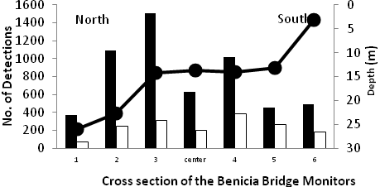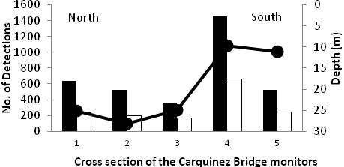
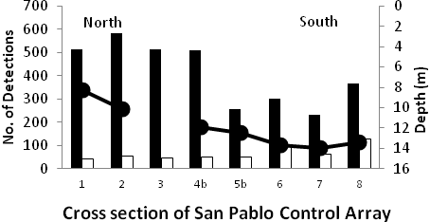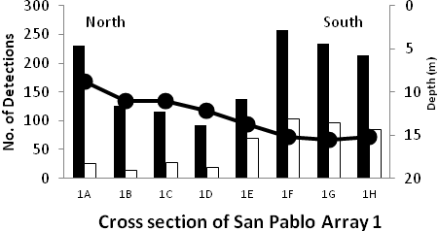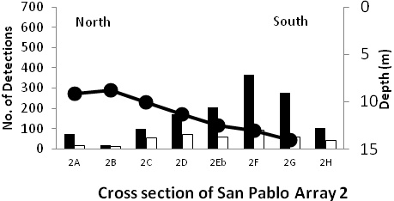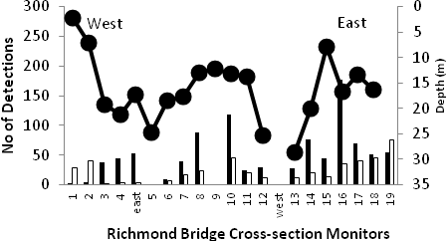
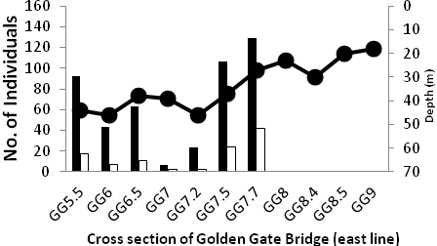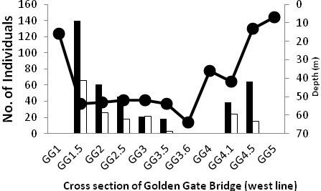

Figure 36. Graphs of smolt detections at cross channel receivers and channel depth profiles. Graphs are presented top left to right in the order that smolts would travel through them as they outmigrate through the upper and lower Bay systems. White bars represent steelhead smolts; black bars represent Chinook salmon smolts; black lines with dots represent channel depth.

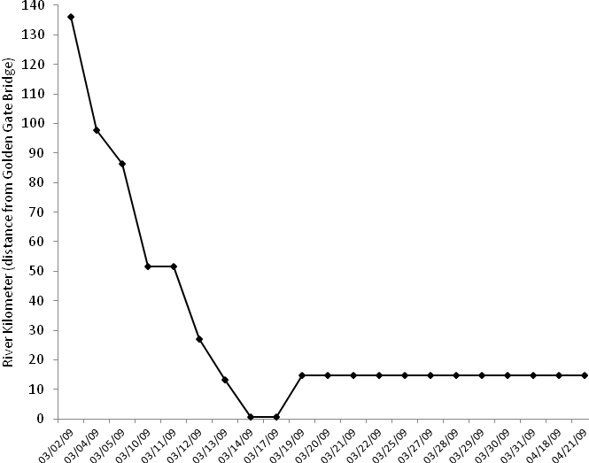
Figure 37. Graph of Fish I.D. number 31917 movement from release to Golden Gate Bridge array and then back again to San Pablo/Richmond Bridge array.

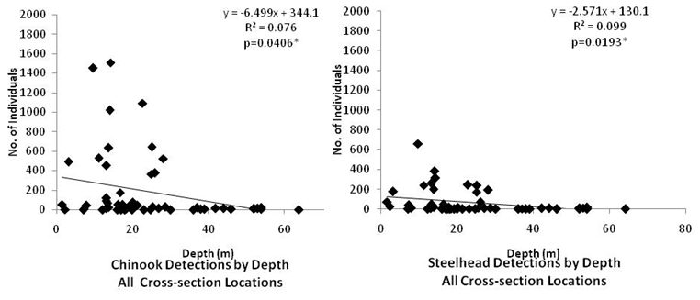

Figure 38. Chinook salmon and steelhead detections by depth at all cross-section locations. Smolts overall have higher detections in shallower depths, although a very small effect.

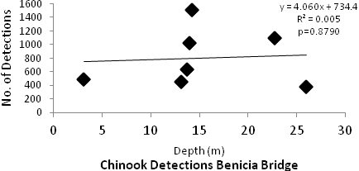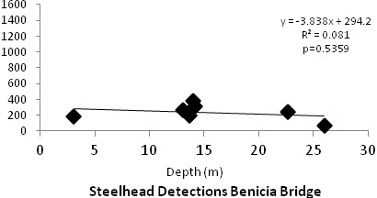
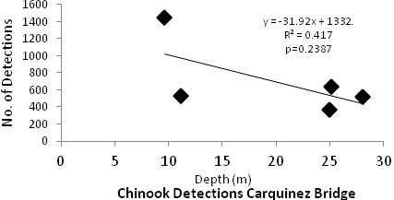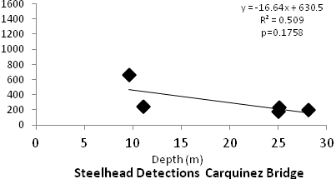
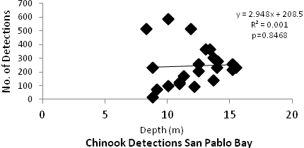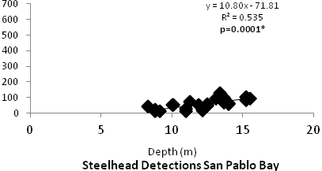
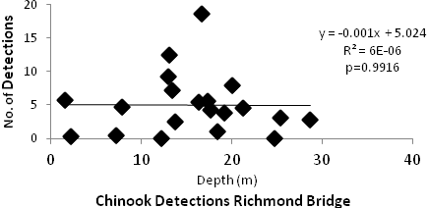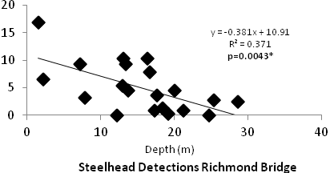
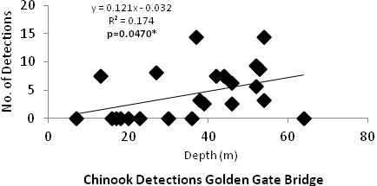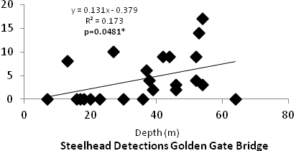
Figure 39. Chinook salmon (left column) and steelhead (right column) detections by depth at each cross-section array. Number of detections on y-axis; depth in meters on the x-axis. Depth had a significant relationship with steelhead detections at San Pablo Bay, Richmond Bridge and Golden Gate Bridge arrays. Chinook salmon detections had a significant relationship with depth at the Golden Gate Bridge arrays only.

Chinook salmon smolts and steelhead also passed through the Bay Bridge receivers to the south bay (Figure 40). Although this would indicate animals leaving the outmigration path, detections by depth were analyzed and found to have a small effect on Chinook salmon migratory pathways, but no effect on steelhead (Figure 41). Of the 43 Chinook salmon and 39 steelhead smolts that were detected at the Bay Bridge, 24 and 9, respectively, were later detected at the Golden Gate array.

There were no significant differences between detections between shoals and channels for both Chinook salmon (Wilcoxon, p=0.3486) and steelhead (Wilcoxon, p=0.8771).

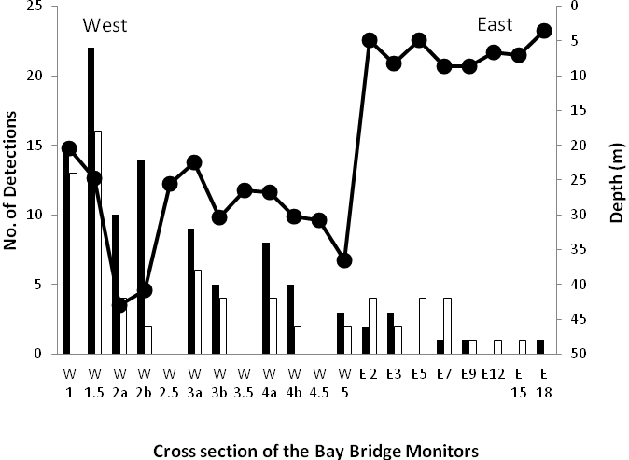
Figure 40. Detections of Chinook salmon (black bars) and steelhead (white bars) at Bay Bridge 2009.

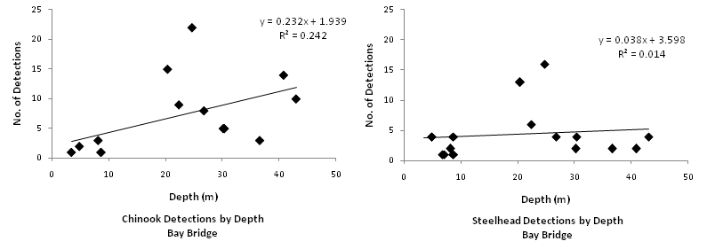

Figure 41. Relationship between channel depth and number of detections of salmonid smolts at the Bay Bridge 2009.

3.5 Inter-annual variation

Comparison of the results between study years requires an awareness of the number and origin of the fish used in each analysis. In the first two study years, only about 50 fish of each species were tagged as part of the USACE study, which was in a pilot phase, so that analysis depended greatly on fish tagged as part of a CALFED study, and on Chinook salmon tagged by USFWS and steelhead tagged by East Bay Mud (Fig. 42). However, the use of different batches of fish, released at different times and places, should be done with caution.

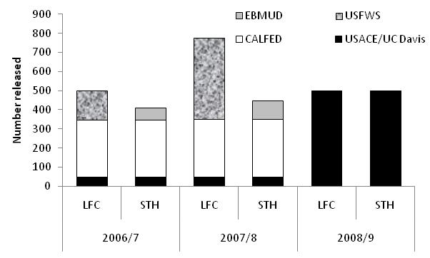

Figure 42. Number of tagged late fall Chinook salmon (LFC) and steelhead (STH) smolts released by different agencies 2006-9, used in analysis of results.

The transit times and rates of both species from Carquinez to the Golden Gate were similar in each year (Table 13), except that in 2008/9 the Chinook salmon moved through at a slightly faster rate than the steelhead, in contrast to the previous two years. For the two pilot study years, the total number of individuals reaching the Golden Gate was not separated by species.

Table 13. Transit time and rate of salmonid smolts from Carquinez to the Golden Gate over three year study period 2006-9.

Year /  Species | 2006/7 |  | 2007/8 |  | 2008/9
Year /  Species | LFC | STH | LFC | STH | LFC | STH
Number to Golden Gate | 135 |  | 194 |  | 64 | 89
Transit time (days) Carquinez-Golden Gate | 2.6 | 1.9 | 2.7 | 2.5 | 1.8 | 2.2
Transit rate (ms-1) Carquinez-Golden Gate | 0.22 | 0.28 | 0.21 | 0.31 | 0.34 | 0.3

The distribution of receivers throughout San Pablo Bay varied between years, so comparisons at key sites such as the San Pablo dredge material placement site were not possible. However, it was apparent that only a few individuals from each species migrated up Petaluma river in each year, although the mean time spent here by steelhead in 2007/8 is worthy of note (Table 14).

Table 14. Number of Chinook salmon and steelhead detected at sites in San Pablo Bay (with mean exposure times [in minutes] in brackets), for 2006/7, 2007/8 and 2008/9.

 | Chinook salmon |  |  | Steelhead
Site | 2006/7 | 2007/8 | 2008/9 | 2006/7 | 2007/8 | 2008/9
Petaluma River | 1 (4.1) |  | 5 (27) | 2 (230.2) | 3 (851.4) | 5 (50)
SP Channel Buoy 7 |  | 21 (3.7) |  |  | 17 (14.6) | 1 (1)
SP Channel South or 8 |  |  | 50 (4) |  | 25 (19.2) | 38 (4)
SP Channel Buoy 9 | 19 (6.5) |  |  | 11 (15.9) | 18 (8.3)
SP Channel East or 10 |  |  | 40 (5) |  | 20 (6.7) | 2 (2)

3.6 Other Species

There were detections of green sturgeon and sevengill sharks on the receivers throughout the San Francisco Bay Estuary (Table 15) Appendices 5 and 6 respectively, include detections of Chinook salmon and steelhead from other studies. There were no sevengill sharks detected above the Richmond San Rafael Bridge although two were detected at the Emeryville Marina. Green sturgeon were detected throughout San Francisco and San Pablo Bays as well as on receivers in the Delta, Sacramento River and San Joaquin River. There were eight green sturgeon detected at the SF 10 disposal site.

Table 15. Number of detections of green sturgeon and sevengill sharks at receivers in the San Francisco Bay Estuary 2008-9.

 |  |  |  |  | Receiver Stations
Species/  Tag ID | Alcatraz Control | Alcatraz Disposal | Emeryville Marina | Martinez Marina | Pt. Richmond(Rich Harbor) | Raccoon Straits | SP Array 1 (SF10) |  | SP Array 2 (SF10) |  | SP Channel (Buoy 7,8,9, &10) |  | SP CONTROL |  | Vallejo Marina |  | Grand Total
Sevengill Shark (AOB Study)
14289 | 285 | 116 |  |  |  |  |  |  |  |  |  |  |  |  |  |  | 401
16231 | 1 |  |  |  |  |  |  |  |  |  |  |  |  |  |  |  | 1
16232 | 836 |  |  |  |  |  |  |  |  |  |  |  |  |  |  |  | 836
16233 | 3501 | 129 |  |  |  |  |  |  |  |  |  |  |  |  |  |  | 3630
 |  |  |  |  |  |  |  |  |  |  |  |  | Table 12 cont.
16234 | 231 | 36 |  |  |  |  |  |  |  |  |  |  |  |  |  |  | 267
52071 | 54 | 14 |  |  |  |  |  |  |  |  |  |  |  |  |  |  | 68
52072 | 5 | 3 |  |  |  |  |  |  |  |  |  |  |  |  |  |  | 8
52073 | 33 |  |  |  |  |  |  |  |  |  |  |  |  |  |  |  | 33
52075 | 481 | 138 | 66 |  |  | 311 |  |  |  |  |  |  |  |  |  |  | 996
52077 | 823 | 7 |  |  |  | 139 |  |  |  |  |  |  |  |  |  |  | 969
52078 |  | 27 |  |  |  |  |  |  |  |  |  |  |  |  |  |  | 27
52079 |  | 158 |  |  |  | 107 |  |  |  |  |  |  |  |  |  |  | 265
52080 | 442 | 1 |  |  |  | 11 |  |  |  |  |  |  |  |  |  |  | 454
52081 | 1297 |  |  |  |  |  |  |  |  |  |  |  |  |  |  |  | 1297
52082 | 584 | 1 | 2 |  |  | 3 |  |  |  |  |  |  |  |  |  |  | 590
52083 | 267 | 97 |  |  |  | 221 |  |  |  |  |  |  |  |  |  |  | 585
Green sturgeon (UCD/BOR Study)
5447 | 64 |  |  | 164 |  |  | 145 |  | 49 |  | 192 |  | 369 |  | 71 |  | 1054
5449 | 8 |  |  | 37 |  |  | 300 |  | 126 |  |  |  | 128 |  |  |  | 599
5450 | 97 |  |  | 19 |  |  | 449 |  | 682 |  | 469 |  | 1160 |  |  |  | 2876
10816 | 108 |  |  | 101 |  |  | 161 |  | 269 |  | 25 |  | 18 |  |  |  | 682
2204 | 3 |  |  | 13 |  |  | 26 |  | 8 |  | 27 |  | 64 |  |  |  | 141
2237 | 34 | 9 |  | 4 |  |  |  |  |  |  | 12 |  | 16 |  |  |  | 75
2242 | 2 |  |  |  | 10 |  | 18 |  | 19 |  |  |  | 16 |  |  |  | 65
Green sturgeon (Vogel Study)
217 |  | 10 |  | 16 | 8 |  |  |  | 12 |  |  |  | 5 |  |  |  | 51
219 |  |  |  |  |  |  |  |  |  |  |  |  |  |  | 869 |  | 869
224 | 1 | 1 |  | 7 |  |  | 8 |  |  |  | 4 |  | 8 |  |  |  | 29

3.7 Green Sturgeon exposure

Between January 2008 and June 2009, 40 tagged green sturgeon were detected in the Bay Area, of which 18 were detected during the period from March to June 2009. Of these, 10 individuals were detected at receivers belonging to the current USACE-UC Davis study – either at bridge cross-sections, dredged sites (channel or marinas) and dredge placement sites.

Eight sturgeon were detected at Martinez Marina, for times ranging between 7 and 173 minutes. Two individuals were detected at Richmond Point briefly, and a further two were detected over extended periods at Vallejo Marina. Only one individual was detected at the G3 Channel site (Table 16).

Two individuals (Tag IDs # 217 and 2237) were detected at the Alcatraz SE receiver, the former at a single visit on March 24th 2009 at 17:00 for 13 minutes, and the latter on February 9th 2009 at 21:07 for 8 minutes and a single detection on February 17th. A further individual was detected once on 3rd February 2009 (Tag ID# 224).

Table 16. Exposure time (in minutes) of green sturgeon at dredge sites in San Francisco bay area 2008-9.

Tag ID | Martinez Marina | Richmond Point | Vallejo Marina | G3 Channel | Total
217 | 34.3 | 20.2 |  |  | 54.6
219 |  |  | 682.5 |  | 682.5
224 | 18.6 |  |  |  | 18.6
2204 | 21.1 |  |  | 9.6 | 30.8
2237 | 7.1 |  |  |  | 7.1
2242 |  | 11.6 |  |  | 11.6
5447 | 252.7 |  | 149.8 |  | 402.5
5449 | 57.1 |  |  |  | 57.1
5450 | 30.7 |  |  |  | 30.7
10816 | 173.4 |  |  |  | 173.4
Average | 74.4 | 15.9 | 416.1 | 9.6 | 146.9

Of the ten green sturgeon detected at the dredge placement site in San Pablo Bay, two passed through SF10. This is a large area and there were no receivers placed within the site. Although it appears that eight sturgeon do not go through the SF10 placement site, it is difficult to hypothesize where the fish are in relation to the site when the fish is not detected, on any receivers, over a long period of time. We inferred movement paths by analyzing the detections at each receiver around the sites (Fig. 43). In most cases, movement was not linear through the site. Instead, the fish seemed to move in a directionless manner around the general area, often returning to the same point on more than one occasion.

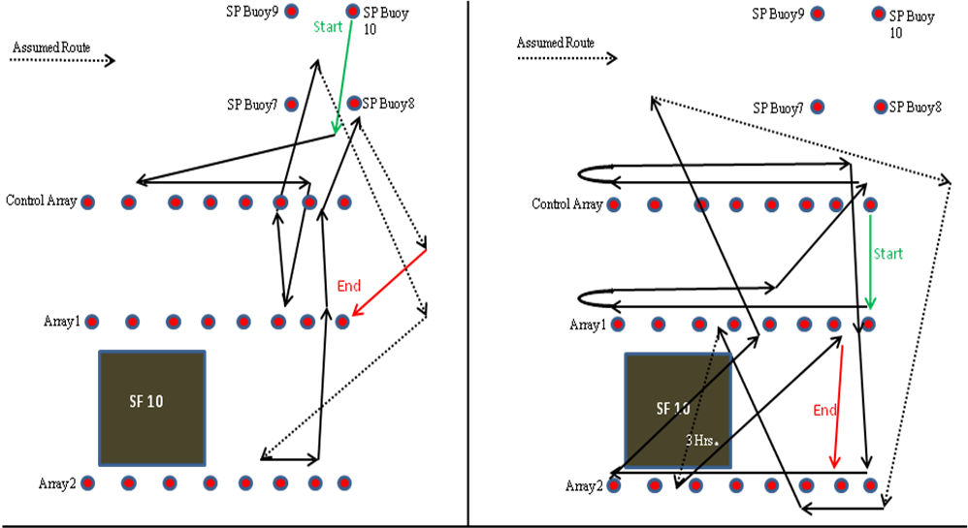

Figure 43. Movements of two green sturgeon around SF 10 dredge placement site. The fish on the left never passes through the site whereas the fish on the right passes through multiple times.

4 Discussion

The goals of this study were to identify the migratory pathways and refine the time estimates of Chinook salmon and steelhead through the San Francisco Estuary, focusing on residency or exposure time at dredge material placement sites and sites in which dredging occurs or may potentially occur. The purpose of this information is to address potential exposure to impacts of harbor and channel maintenance activities that occur within the estuary on the outmigration of these two species of concern. As little is known about the migration routes of any of the salmon runs in the Sacramento River, these results might serve as surrogates for more vulnerable runs. Use of surrogates however, must be made with caution, and the recent advent of smaller tags may imply that studies of smaller smolts will soon be possible. The fish used in this study were of hatchery origin and may limit the ability to extrapolate effects on wild stock outmigration behavior. The differences in morphology and behavior in hatchery and wild fish vary depending upon species and somewhat on location. For Atlantic salmon there tends to be no difference in outmigration survival for both wild and hatchery fish (Lacroix et al. 2005) but sea survival is twice as high in wild fish (Jonsson et al. 1991). There also tend to be higher rates of straying in hatchery fish as returning adults (Jonsson et al. 1991). For brown trout released in Norway, hatchery-reared fish grew slower and had shorter lifespans than their wild counterparts (Hesthagen et al. 1999), while in Sweden, brown trout hatchery fish, wild stock and their hybrids showed no significant differences in survival, growth and morphology within streams and only small differences in growth in lab experiments (Dahl et al. 2006). . Wild Chinook salmon tend to have higher in-stream survival rates compared to hatchery Chinook (Fritts et al. 2007). Steelhead grow faster in captivity (Hayes et al. 2004), migrate out to sea faster (Hayes et al. 2004; Daugherty et al. 2003), and mature earlier than wild stocks (Daugherty et al. 2003). Predation by cormorants and terns on steelhead smolts is higher than other species (Chinook and Coho) on the Columbia River, especially hatchery steelhead by terns (Antolos et al. 2005; Collis et al. 2001; Ryan et al. 2003). In experiments, wild fry survived predation at higher rates than hatchery origin (Berejikian 1995; Berejikian et al. 1996). Significant changes in brain development due to hatchery environments may be a potential explanation for changes in behavior, as demonstrated by Marchetti and Nevitt (Marchetti and Nevitt 2003) using rainbow trout (O. mykiss). As can be seen in Appendix 5, only one wild steelhead was detected at a study site (Alcatraz Control).

There is a growing body of literature concerning the effects of tagging on fish growth, swimming performance and predator avoidance. Surgical implantation of transmitters has little effect on growth of Chinook salmon (Adams et al. 1998; Brown et al. 2006) regardless of size. Gastric and surgical implantation of transmitters did have variable effects on swimming performance and predator avoidance but this may be more related to size. Chinook salmon smaller than 120 mm FL swam significantly slower than controls for both gastric and surgical implantation at 1 and 23 days (Adams et al. 1998). Over 120 mm FL fish were affected differently in swimming performance depending upon implantation: gastric implantation showed no difference at 1 day but significant differences from controls at 19-23 days while the opposite was the case for surgical implantations. In this study, both gastric and surgical implantations were more vulnerable to smallmouth bass predation than controls, while (Anglea et al. 2004) found that surgical implantation had no effect on Chinook salmon swimming performance or predation. While the surgery may be invasive and require a recovery period, it may be preferred over gastric implantation since gastric implantation does have an effect on Chinook salmon growth, while surgically implanted fish don’t have significantly different growth than controls after 54 days (Adams et al. 1998). Recent experimental work (Ammann, 2006) found no difference in growth or swimming speed between three groups of hatchery-reared juvenile steelhead – those with tags, those which had surgery, and those which were not manipulated. (Welch et al. 2007) found that although mortality due to surgical implantation of tags was higher in smaller steelhead (<12 cm) growth was not significantly affected compared to controls. Mortality and shedding decreased as fish size increased to 15 cm.

The overall survival rates of steelhead (12.8%) and Chinook salmon (17.8%) were determined by the percentage of animals that reached the array in front of the Golden Gate Bridge, and modified by adding those fish detected at the Point Reyes array that were not detected as they went through the Golden Gate. These rates therefore refer to minimum survival rates – some fish may still be in the system, and are yet to enter the open ocean, whereas some fish may miss detection as they swim past the array – the Golden Gate array does not cover the entire cross section of the entry to the Bay. It is difficult to limit all the bias in these estimates, such as assuming mortality when a fish is not detected at an array, but incorporating the detection probabilities for each terminal array of each reach reduces bias. The survival rates experienced by the current study animals are higher than in previous years. It is not possible to statistically test those differences due to a number of variables that had changed each year such as the release point, timing of releases, and numbers released. In 2006 and 2007, releases took place at Rio Vista, about 112 km downstream from the current release site. Fish therefore had less time to acclimatize to river conditions.

There were differential survival rates in different reaches. Steelhead had lower survival overall but experienced slightly higher survival rates than salmon in the Carquinez reach and 30 % higher survival at the Richmond reach. (Melnychuk et al. 2007) found mortality rates of juvenile steelhead on the Cheakamus River in British Columbia were correlated with river segment distances. While steelhead had very low survival from Richmond to the Golden Gate Bridge, Chinook salmon had almost 80% survival in that reach. Steelhead appear to hit two bottlenecks on their outmigration: from the release site to Benicia and Richmond to the Golden Gate Bridge where survival is reduced by more than 50%. Chinook salmon hit a bottleneck in the Carquinez to Richmond reach. These differences could be due to different predation pressures for each species. Steelhead have been found to be more susceptible to avian predation in shallower areas on the Columbia River (Collis et al., 2001). Other piscivorous predators in the river system and the delta include: striped bass, largemouth bass, and pike minnow (Ptychocheilus oregonensis, formerly northern squawfish). Ptychocheilus oregonensis was found to be the major fish predator of salmon and steelhead smolts in the John Day Reservoir on the Columbia River. Salmon and steelhead smolts comprised 67% of the pike minnows’ diet (Poe et al. 1991).

Although transit rates varied considerably by species and by reach, these differences did not have a significant effect on survival through the estuary. However, two groups of fish were evident in each species – those which transited rapidly through river reaches, at overall speeds often greater than 1 ms⁻¹, and those which transited at a slower overall rate. Analysis of transit rates of the same fish in different river reaches showed that individuals did not necessarily maintain the same strategy throughout the river system. “Slow” rates of transit might also correspond to those individuals which moved around within a river reach before passing through the next bridge array – either making upstream and downstream movements, or making lateral movements onto shoals. Overall, transit rates for Chinook salmon and steelhead calculated for San Pablo Bay ranged from 0.06-1.60 ms⁻¹ for all fish. Adams et al. (1998) found that juvenile Chinook salmon between 120-160mm FL that had been surgically implanted with acoustic tags swam 2.20 – 4.49 BLsec⁻¹., which roughly calculates, to a range of .264-.718 ms⁻¹. Melnychuk et al. (2007) measured travel speeds for steelhead migrating to the Strait of Georgia to be 0.7-0.9 BLsec⁻¹ and a maximum of 3-5 BLsec⁻¹ in river currents of 1 ms⁻¹. For Chinook salmon there was no correlation with transit rates and tidal flows but steelhead seemed to have a small relationship with transit rates and ebbing tidal flows. Other studies have found that flow (either tidal or discharge) has very low explanatory value with respect to transit rates (Tiffan, 2009). By using cross-section velocities at different river stretches Tiffan et al. (2009) found a strong relationship between water velocity and transit rates. They also found that fish spent more time actively swimming and meandering in deeper areas with lower water velocities suggesting that they may be cuing their downstream movement based upon water velocity. If this is the case, it may explain the behaviors found in this study such as individuals moving back upstream on flood tides (following high water velocity) or individuals that pass through the Bay Bridge receivers into the south bay (meandering/searching during low water velocity/slack tide periods).

The transit time through the Bay for salmonid smolts in this study were comparable to those found in 2007 and 2008 (Klimley et al., 2009) although those studies present results as means rather than medians. In all three years, overall transit rates were considerably faster than those obtained by MacFarlane and Norton (2002) – from 5 to 38 days. Given the velocities attained by some of the fish, it is likely that transit rates will vary greatly depending on inter-annual variations in the physical condition of the Bay. Many fish of both species were seen to display repeated upstream-downstream movements, and this appeared to be related to the tidal state – upstream movements generally corresponded with flood tides. This results in repeated visits to particular sites, especially the San Pablo Arrays, which concern the dredge material placement site. Since dredging did not occur during the study period we are unable to determine if active dredging and dredged material placement would affect transit rates and exposure times. However, despite these rapid transit rates through the bay, a study by Varanasi et al. (1993) suggested that outmigrating juvenile Chinook salmon are significantly affected by chemical contaminants in San Francisco Bay, while juvenile steelhead and coho are more likely to actively avoid bodies of water with high concentrations of suspended sediment (NMFS, 1998).

Of the 213 steelhead and 265 Chinook salmon that entered San Pablo Bay, 124 and 149 respectively were detected at the two San Pablo Arrays (1 and 2), and of these, 52% and 63% were detected at receivers related to the placement site. There did not appear to be any differences between detections at the control or placement sites, suggesting that there was no active avoidance or preference by the fish. Instantaneous rates of transit through the site were rapid, and probably in large part due to current velocities. However, repeated upstream-downstream movements resulted in multiple exposure times at these sites. As with previous studies (Klimley et al., 2009), total exposure time at the placement site could be measured in minutes rather than hours or days, and there was no evidence of residency- rather, fish transited back and forth through the site. In contrast, the results of this study differed from previous years in the time spent at other sites, notably Mare Island, where steelhead in particular appeared to reside for several hours during 2008, whereas in 2009, exposure of both Chinook salmon and steelhead at all dredged sites was limited to a few individuals and short periods of time. When analyzing the presence of salmonid smolts over a larger area of the bay, it will be necessary to scale up the exposure time around the receiver, in order to cover the entire area in question.

A significant number of smolts were detected at the Bay Bridge, and presumably entered the South Bay, perhaps transported by currents. However, many of these fish were eventually detected at the Golden Gate. Whether the presence of smolts from the Sacramento River in the South Bay and their subsequent success in reaching the ocean is a result of passive transport or rather an active strategy, is a topic that requires further study.

Overall, there did not seem to be any relationship between depth and migratory pathways for salmon or steelhead smolts. Looking at different cross-channel arrays for each species there seemed to be small relationships at specific sites along the upper estuary but not enough to have any explanatory power. There was also no significant difference between the number of fish detected in the shoals versus the channels. There may be other abiotic conditions at these sites that explain migratory pathways.

Green sturgeon were found at sites throughout the Bay during the study, although their exposure time at dredged or dredged material placement sites was in the order of minutes rather than hours or days. However, the green sturgeon currently tagged in the system are all migratory adults, which tend to transit through the Bay fairly rapidly as they move upstream to their spawning grounds or back out to sea again. Future work on the distribution and abundance of green sturgeon will focus on the juvenile and sub-adult life stages, which are likely utilizing the Bay to a far greater extent.

All three years of this study have occurred during droughts. The Sacramento River region was classified as “dry” in 2006/7, “critical” in 2007/8 and “dry” once more in this year. The migratory behavior described in this report and Klimley et al. (2009) should be supplemented and compared with that displayed by the salmonid smolts during wetter years in the future.

Future work and recommendations

In order to improve detection efficiencies at the Benicia and Carquinez bridges we recommend that more receivers be deployed to fill in the gaps. There are large gaps in between the bridge abutments at the Carquinez Bridge where no receivers are currently in place. Two receivers, deployed in the center of the channels on acoustical releases, would improve the coverage at the bridge if they were deployed on either side of the center bridge abutment. At Benicia three receivers would cover the margins where there are currently no receivers.

The presence of fish in the South Bay might justify the placement of receivers in this area. There are currently receivers at the Port of Oakland and at the Port of San Francisco but they are scheduled to be removed before the 2009-2010 study.

The use of an Acoustic Doppler Current Profiler (ADCP) at the SF 10 placement site would allow us to determine a cross section of flow velocities in situ, which would help us to understand the tidal influence on the outmigration suggested by the results in the current study.

The recent improvement of VEMCO technology now permits the use of a structured array of VR2W receivers to plot actual pathways of fish through an area. This would be particularly useful to look at fish behavior at key dredge and placement sites, especially in combination with in situ physical data. Green sturgeon are detected many times at and near the SF10 dredge placement site. This system would allow us to better determine the amount of time these fish spend within the area.

The presence of other species at dredge and placement sites, particularly sevengill sharks and green sturgeon, highlights the need to consider an array of species and their interactions, and how these might be affected by human activities in the Bay.

Acknowledgements

The authors would like to thank Mike McGill and Christina Slager at the Aquarium of the Bay for providing the boat time to deploy and maintain the receivers deployed on acoustical releases. Thanks to Dave Vogel for allowing us to present data on three green sturgeon tagged by his project. We would also like to thank Chuck Morton for scheduling boat time and assisting on the Caltrans vessel with the maintenance of the receivers deployed on the Bay Bridge and Richmond San Rafael Bridge. We greatly appreciate the help from everyone in the UC Davis Biotelemetry Laboratory (Mike Thomas, Denise Tu, Anna Stephenson, Taylor Chapple, Phil Sandstrom, Dennis Cocherell) for volunteering their time to assist with the surgical implantation of the tags. We would also like to thank Arnold Ammann and Cyril Michele at the Santa Cruz office of the NMFS for maintaining the database which made it possible to assemble detections from many different studies. Finally, we would like to acknowledge David Woodbury at the Santa Rosa office of the NMFS for his input into the design of the study.

References

Adams, N.S., Rondorf, D.W., Evans, S.D., Kelly, J.E., and Perry, R.W., 1998. Effects of surgically and gastrically implanted radio transmitters on swimming behavior of juvenile Chinook salmon. Transactions of the American Fisheries Society, 127: 128-136.
Adams P, Grimes C, Lindley S, Moser M. 2002. Status Review for North American Green Sturgeon, Acipenser medirostris. National Marine Fisheries Service, 50p.
Ammann, A. 2006. Effect of dummy ultrasonic tags on swimming performance and growth of juvenile steelhead trout. Abstract Only. Proceedings of the 4th Biennial CALFED Science Conference 2006, p267.
Anglea, S.M., Geist, D.R., Brown, R.S., Deters, K.A., and McDonald, R.D., 2004. Effects of acoustic transmitters on swimming performance and predator avoidance of juvenile Chinook salmon. North American Journal of Fisheries Management, 24: 162-170.
Brown, R.S., Cooke, S.J., Anderson, W.G., and McKinley, R.S., 1999. Evidence to challenge the “2% Rule” for Biotelemetry. North American Journal of Fisheries Management, 19: 867-871.
Brown RS, Geist DR, Deters KA, Grassell A. 2006. Effects of surgically implanted acoustic transmitters > 2% of body mass on the swimming performance, survival and growth of juvenile sockeye and Chinook salmon. Journal of Fish Biology 69:1626-1638.
Busby, P.J., Wainwright, T.C., Bryant, G.J., Lierheimer, L.J., Waples, R.S., Waknitz, F.W., and Logomarsino, I.V. 1996. Status Review of West Coast Seelhead from Washington, Idaho, Oregon, and California, NOAA Technical Memorandum NMFS-NWFSC-27.
Chin, J.L., Wong, F.L., and Carlson P.R. 2004. Shifting Shoals and Shattered Rocks-How Man has Transformed the Floor of West-Central San Francisco Bay, USGS Circular 1259 30pp.
Colgan, P. 1978. Quantitative Ichthyology. New York: John Wily and Sons.
Collis K, Roby DD, Craig DP, Ryan BA, Ledgerwood RD. 2001. Colonial waterbird predation on juvenile salmonids tagged with passive integrated transponders in the Columbia river estuary: Vulnerability of different salmonid species, stocks, and rearing types. Transactions of the American Fisheries Society 130:385-396
Collis, K., Roby D. D., Craig, D.P., Adamany, S., Adkins, J.Y., and Lyons, D.E. 2002. Colony Size and Diet Composition of Piscivorous Waterbirds on the Lower Columbia River: Implications for Losses of Juvenile Salmonids to Avian Predation. Transactions of the American Fisheries Society; 13: 385-396
Dahl J, Pettersson E, Dannewitz J, Jarvi T, Lof AC 2006. No difference in survival, growth and morphology between offspring of wild-born, hatchery and hybrid brown trout (Salmo trutta). Ecology of Freshwater Fish 15:388-397.
Daugherty DJ, Sutton TM, Greil RW. 2003. Life-history characteristics, population structure, and contribution of hatchery and wild steelhead in a Lake Huron tributary. Journal of Great Lakes Research 29:511-520.
Dwinell, D., Delorey, and J., Lawrence, F. 2003. The History, Development and Implementation of the Long Term Management Strategy for the Placement of Dredged Material in the San Francisco Bay Region, Dredging ’02: Key Technologies for Global Prosperity. American Society of Civil Engineers.
Fagan R.M., and Young D.Y., 1978. Temporal patterns of behavior: durations, intervals, latencies and sequences. In: Colgan P.W., (ed) Quantitative Ethology. John Wiley & Sons, New York, NY, pp78-114
Fisher, F.W., 1994. Past and Present Status of Central Valley Chinook Salmon. Conservation Biology , 8: 870-873.
Friesen T.A., Vile J.S., and Pribyl A.L., 2007. Outmigration of juvenile Chinook salmon in the lower Willamette river, Oregon. Northwest Science 81:173-190.
Fritts AL, Scott JL, Pearsons TN. 2007. The effects of domestication on the relative vulnerability of hatchery and wild origin spring Chinook salmon (Oncorhynchus tshawytscha) to predation. Canadian Journal of Fisheries and Aquatic Sciences 64:813-818.
Fry, D.H., 1961. King Salmon spawning stocks of the California Central Valley, 1949-1959. California Fish and Game , 47: 55-71.
Hayes SA, Bond MH, Hanson CV, MacFarlane RB. 2004. Interactions between endangered wild and hatchery salmonids: can the pitfalls of artificial propagation be avoided in small coastal streams? Journal of Fish Biology 65:101-121.
Hesthagen T, Floystad L, Hegge O, Staurnes M, Skurdal J. 1999. Comparative life-history characteristics of native and hatchery-reared brown trout, Salmo trutta L., in a sub-Alpine reservoir. Fisheries Management and Ecology 6:47-61.
Heublein, J., Kelly J.T., Crocker C.E., Klimley A.P., and Lindley S.T., 2009. Migration of green sturgeon, Acipenser medirostris , in the Sacramento River. Env Biol Fishes 84 (3): 245–258
Johnson, S.L., Power J.H., Wilson, D.R., and Ray, J., 2008. A comparison of the survival and migratory behavior of hatchery reared and naturally reared steelhead smolts in the Alsea River and estuary (Oregon) using acoustic telemetry White paper report 49p.
Jonsson B, Jonsson N, Hansen LP. 1991 Differences in life history and migratory behavior between wild and hatchery-reared Atlantic salmon in nature. Aquaculture (1991) 98:69-78.
Klimley A.P., and Holloway, C.F. 1999. School fidelity and homing synchronicity of yellowfin tuna, Thunnus albacares. Mar Biol 133: 307–317
Klimley, A.P., Tu, D., Brostoff, W., LaCivita, P., Bremner, A., and Keegan, T., 2009. Juvenile Salmonid Outmigration and Distribution in the San Francisco Estuary: 2006-2008 Interim Draft Report 62p.
Lacroix, G.L, Knox, D., and McCurdy, P., 2004. Effects of implanted acoustic transmitters on juvenile Atlantic salmon. Transactions of the American Fisheries Society, 133: 211-220.
Lacroix GL, Knox D, Stokesbury MJW. 2005. Survival and behaviour of post-smolt Atlantic salmon in coastal habitat with extreme tides. Journal of Fish Biology 66:485-498.
LFR. 2004. Framework for assessment of potential effects of dredging on sensitive fish species in San Francisco Bay. Final Report. 105 pp. http://www.spn.usace.army.mil/ltms/rpt-USACE-SciencePlan-Final-Aug04-09170.pdf
MacFarlane, R. B., and Norton, E., 2002. Physiological ecology of juvenile chinook salmon (Oncorhynchus tshawytscha) at the southern end of their distribution, the San Francisco Estuary and Gulf of the Farallones, California. Fishery Bulletin, 100: 244-257.
Marchetti MP, Nevitt GA. 2003. Effects of hatchery rearing on brain structures of rainbow trout, Oncorhynchus mykiss. Environmental Biology of Fishes (2003) 66:9-14.
Melnychuk, M.C., Welch D.W., Walters, C.J., and Christensen, V. 2007. Riverine and early ocean migration and mortality patterns of juvenile steelhead trout (Oncorhynchus mykiss) from the Cheakamus River, British Columbia. Hydrobiologia, 582:55-65. DOI: 10.1007/s10750-006-0541-1.
Moore, A., Russell, I.C., and Potter, E.C.E., 1990. The effects of intraperitoneally implanted dummy acoustic transmitters on the behavior and physiology of juvenile Atlantic salmon, Salmo-salar L. Journal of Fish Biology, 37: 713-721.
National Marine Fisheries Service (NMFS). 1998. Endangered Species Act Section 7 Consultation - biological opinion and conference opinion. [for LTMS in San Francisco Bay] 36pp. National Marine Fisheries Service [no location given] September 18. [Att. D to ROD for LTMS]
Needham, P.R., Smith, O.R., and Hanson, H.A., 1941. Salmon salvage problems in relation to Shasta Dam, California, and notes on the biology of the Sacramento River salmon. Abstract, Transactions of the American Fisheries Society, 17th annual meeting.
Peake, S., McKinley, R.S., Scrutin, D.A., and Moccia, R.,. 1997. Influence of transmitter attachment procedures on swimming performance of wild and hatchery-reared Atlantic salmon smolts. Transactions of the American Fisheries Society, 126: 707-714.
Poe TP, Hansel HC, Vigg S, Palmer DE, Prendergast LA. 1991. Feeding of Predaceous Fishes on out-Migrating Juvenile Salmonids on John Day Reservoir Columbia River USA. Transactions of the American Fisheries Society 120:405-420.
Robertson, M.J., Scrutson, D.A., and Brown, J.A., 2003. Effects of surgically implanted transmitters on swimming performance, food consumption and growth on wild Atlantic salmon. Journal of Fish Biology, 62: 673-678.
Ryan BA, Smith SG, Butzerin JM, Ferguson JW. 2003. Relative vulnerability to avian predation of juvenile salmonids tagged with passive integrated transponders in the Columbia River estuary, 1998-2000. Transactions of the American Fisheries Society (2003) 132:275-288
Stone, L. 1874. Report of operations during 1872 at the United States salmon hatching establishment on the McCloud River. Pp. 168-215 in U.S. Commission on Fish and Fisheries, Report for 1872 and 1873, Part II, Washington, D.C.
Tiffan K.F., Kock T.J., Haskell C.A., Connor W.P., and Steinhorst R.K. (2009) Water Velocity, Turbulence, and Migration Rate of Subyearling Fall Chinook Salmon in the Free-Flowing and Impounded Snake River. Transactions of the American Fisheries Society 138:373-384. DOI: 10.1577/t08-051.1.
U.S. Army Corps of Engineers (USACE), USEPA, BCDC, SFBRWQCB, and SWRCB. 1998. Long-term management strategy [LTMS] for the placement of dredged material in the San Francisco Bay Region. Final policy environmental impact statement/ programmatic environmental impact report. Vol. 1 (incl. App. A, H, J, K and M). October.
U.S. Environmental Protection Agency, 1996, Long-term management strategy (LTMS) for the placement of dredged materials in the San Grancisco Bay Rdgion, Draft, April 1996 [final October 1996]: vol 1, 500 p. [URL http://www.spn.usace.army.mil/ltmsl]
Varanasi, U., Casillas, E., and Stein, J. 1993. Contaminant levels in juvenile Chinook salmon. Final Rpt. Year 1. Tech. Rpt. Ser., LTMS San Francisco Bay Region. 29pp.+app. NOAA NMFS, Long Beach, CA. April.
Welch DW, Batten SD, Ward BR. Growth, survival, and tag retention of steelhead trout (O. mykiss) surgically implanted with dummy acoustic tags. Hydrobiologia (2007) 582:289-299
Whitlock, J. 1999. [letter to L. Hamilton of NMFS] 1p. USEPA, San Francisco, CA. January 16.

Appendices

Appendix 1. Repeated upstream-downstream behavior displayed by Chinook salmon in San Pablo Bay

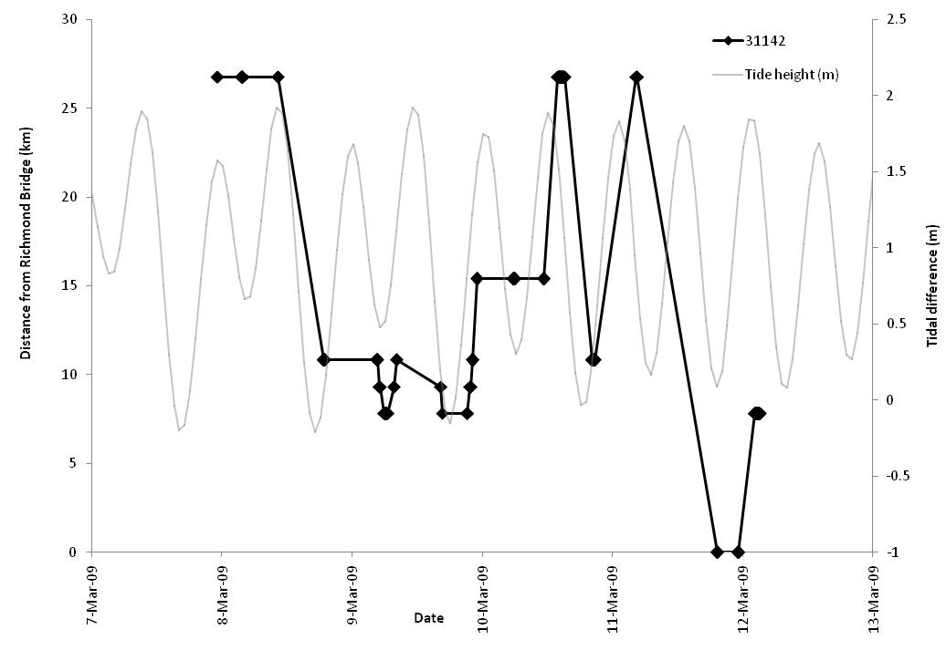

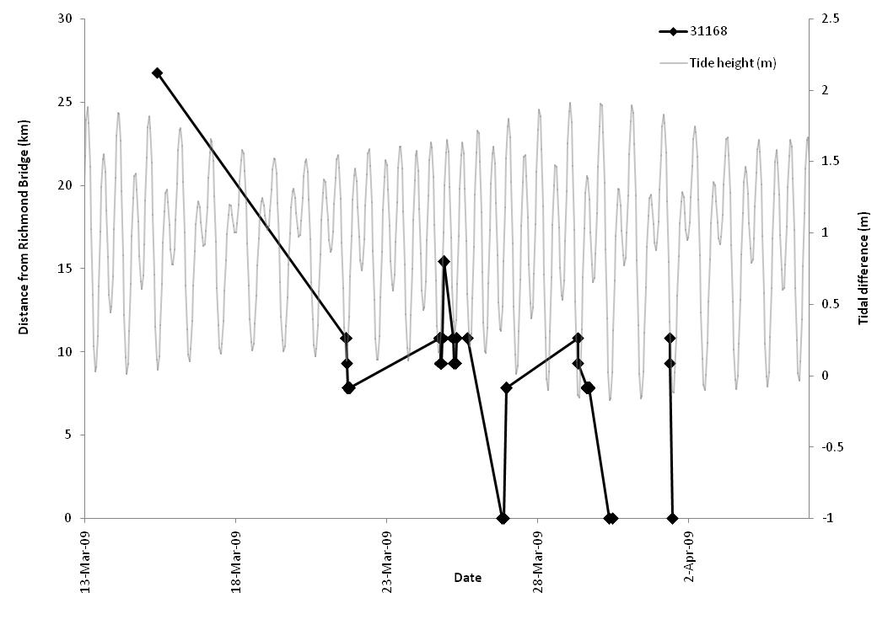
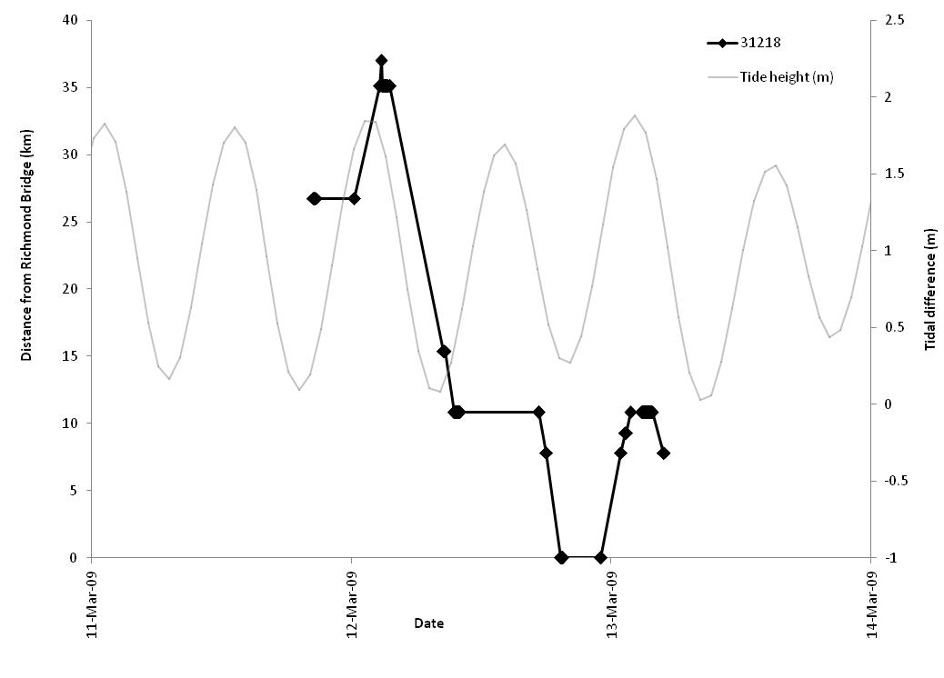

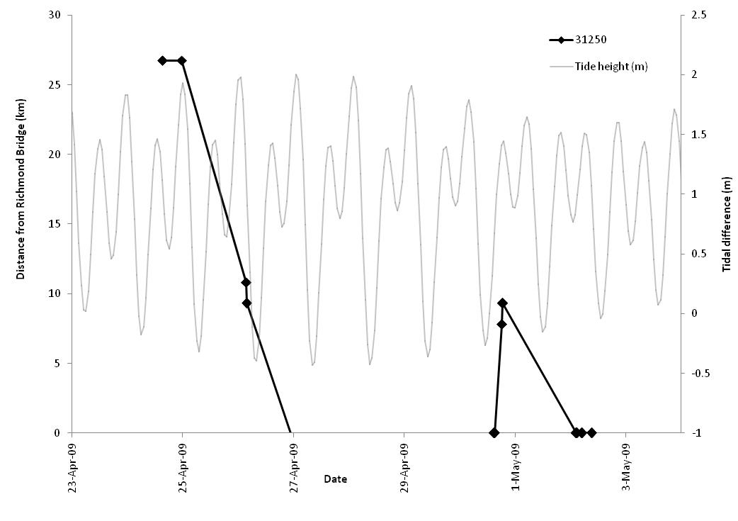
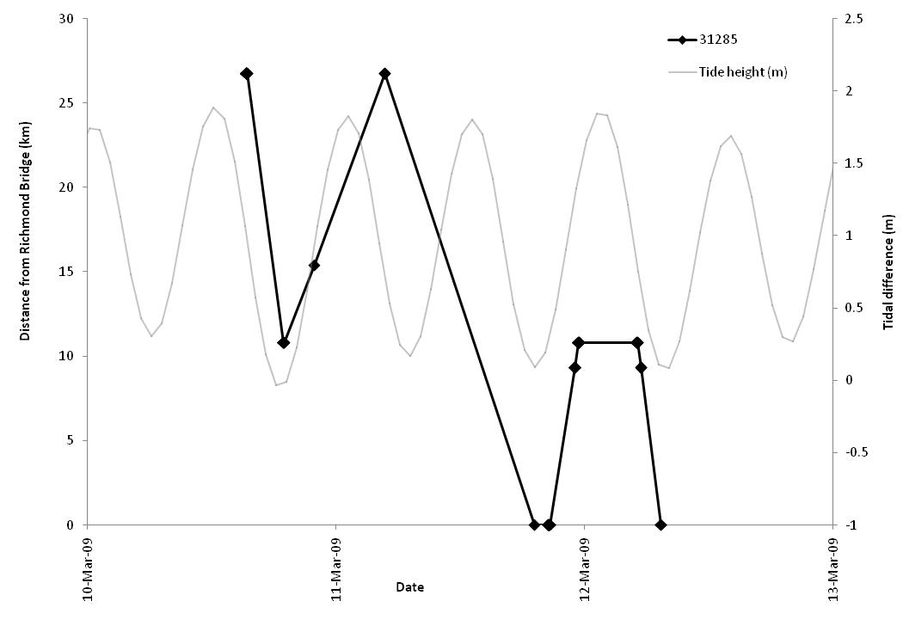

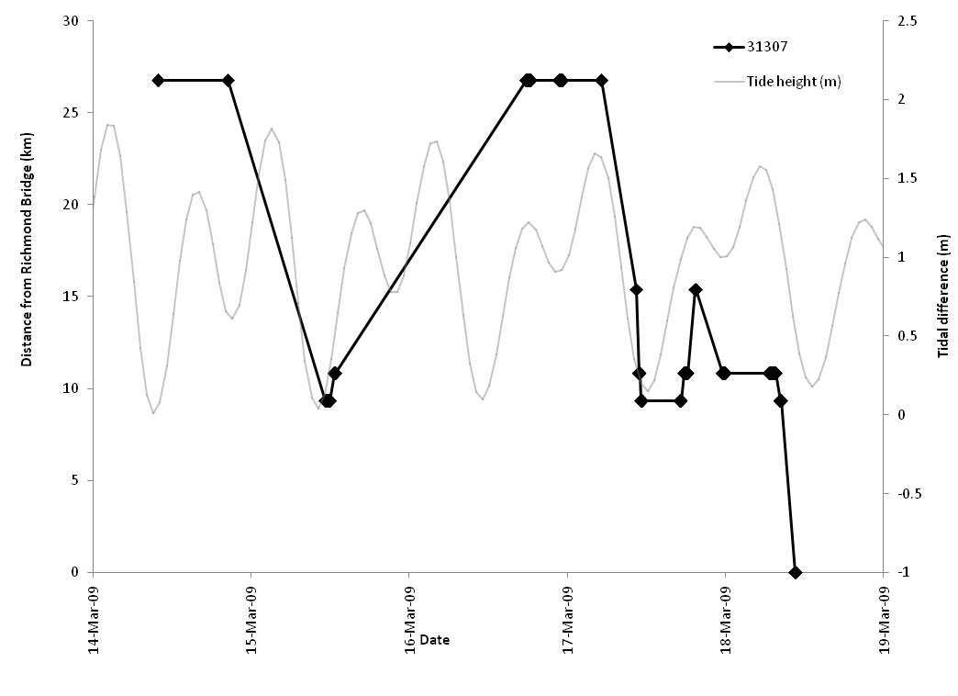
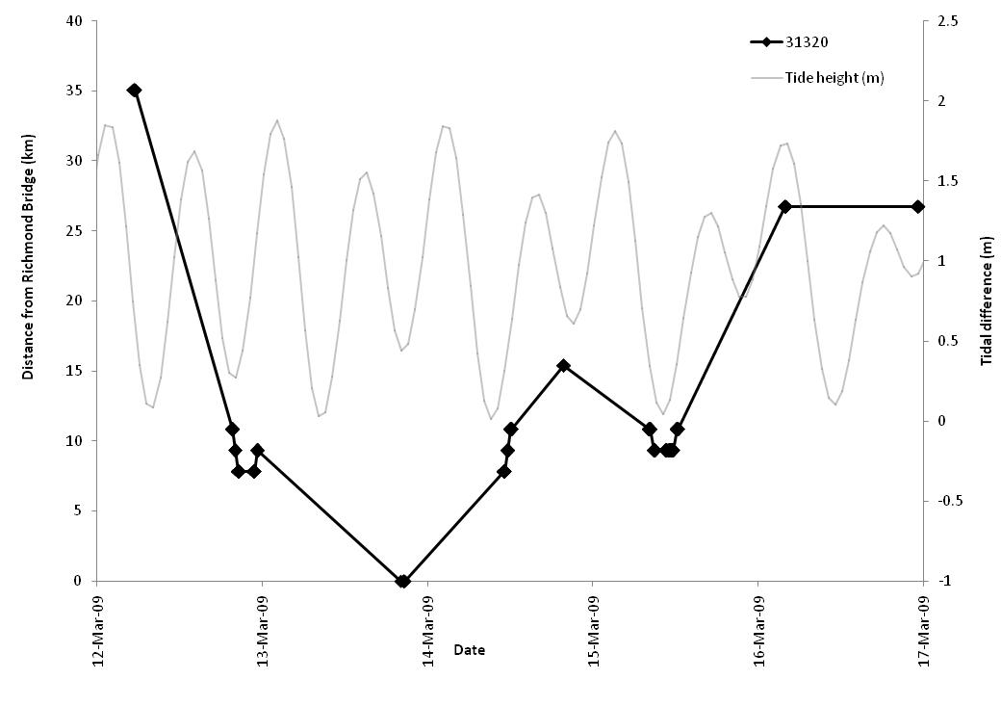

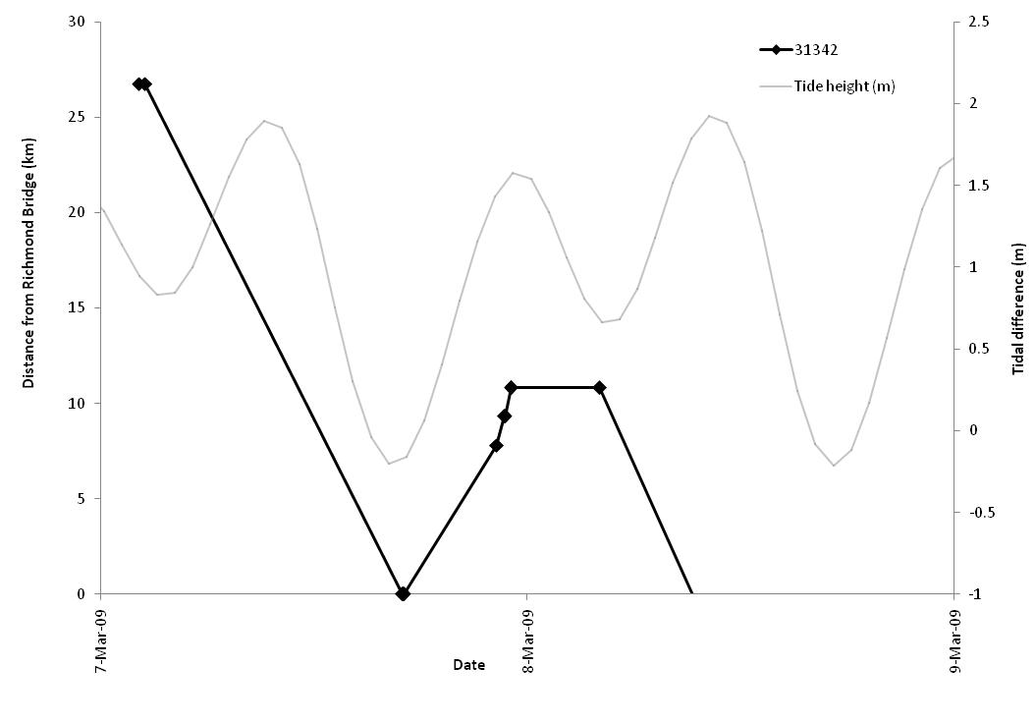

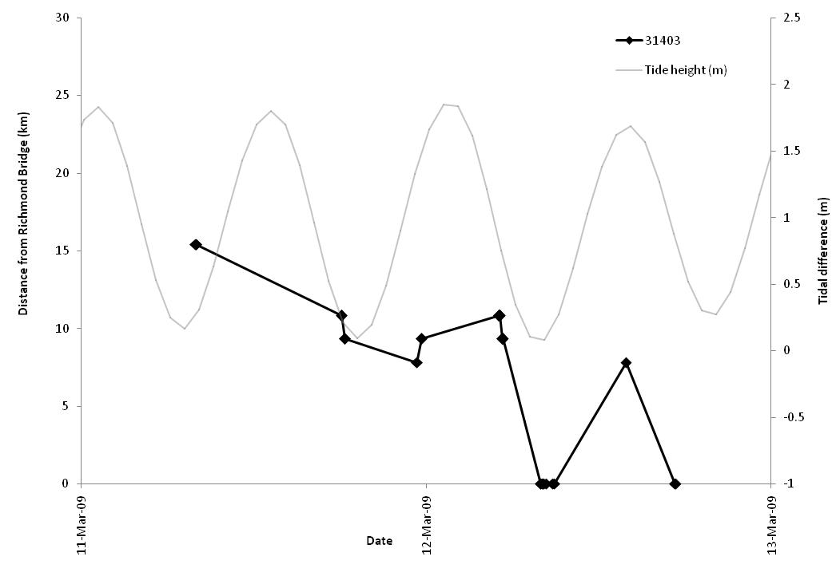

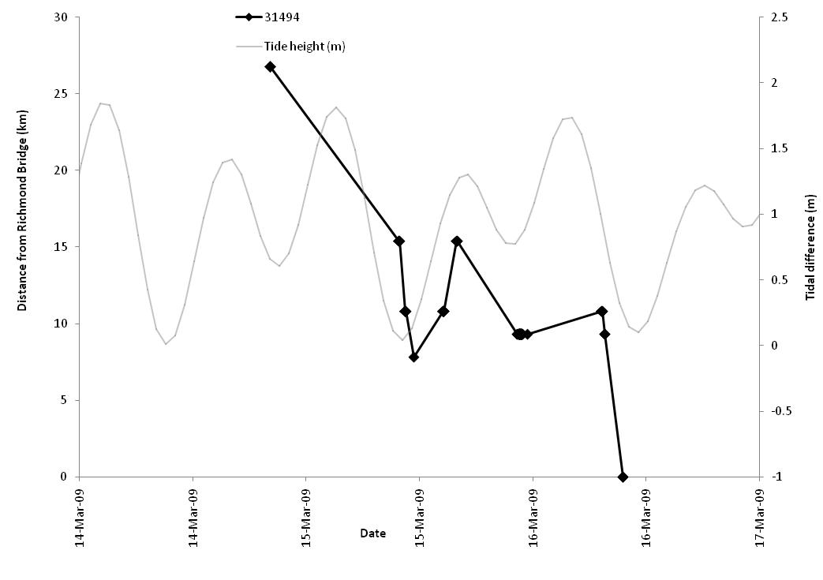
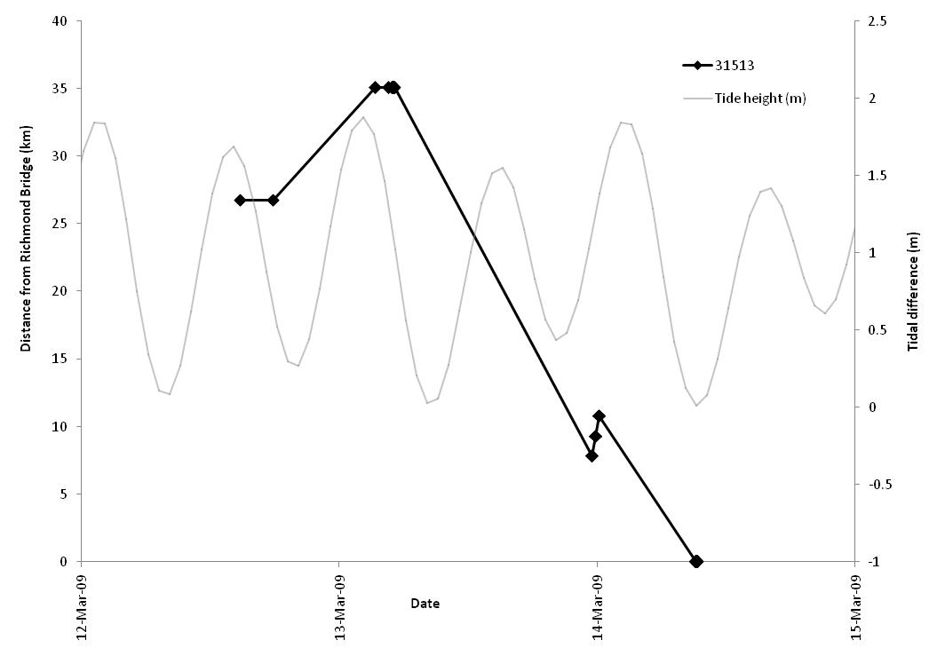

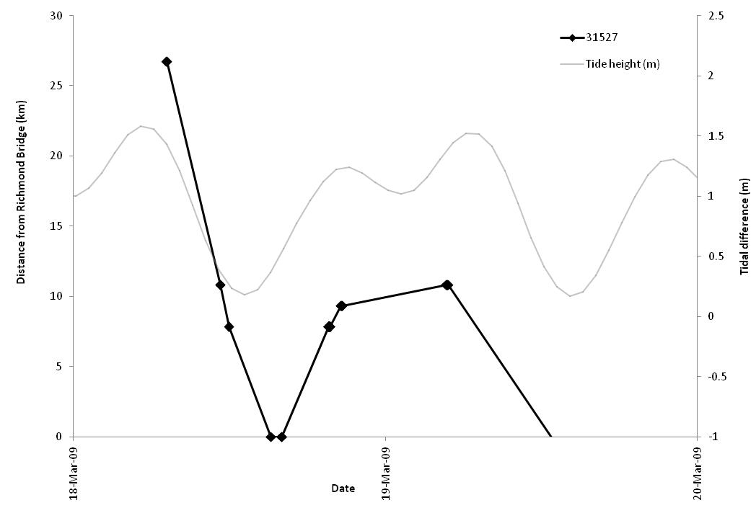

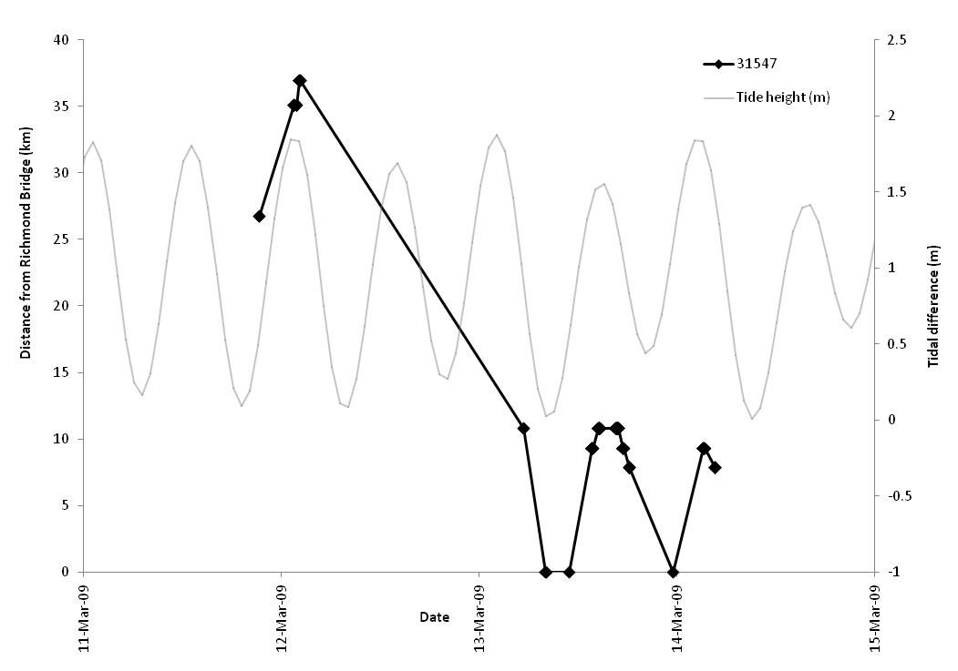

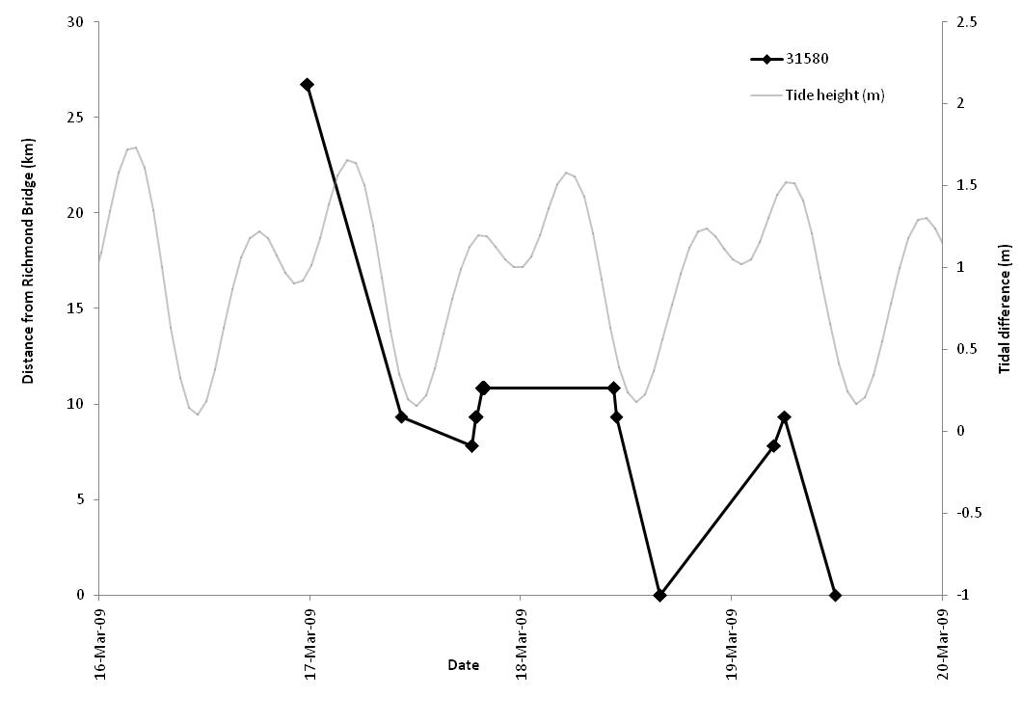

Appendix 2. Repeated upstream-downstream behavior displayed by selected steelhead in San Pablo Bay.

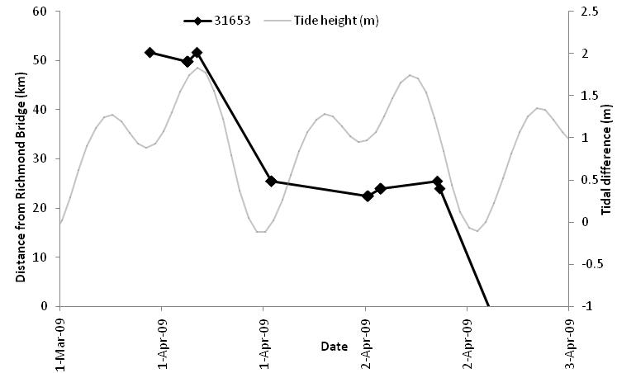

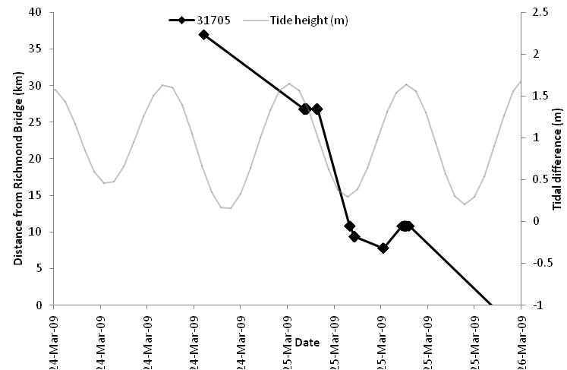

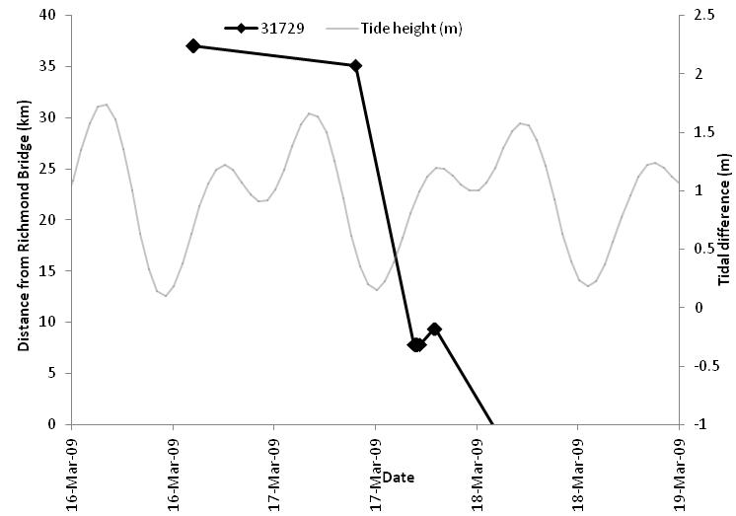

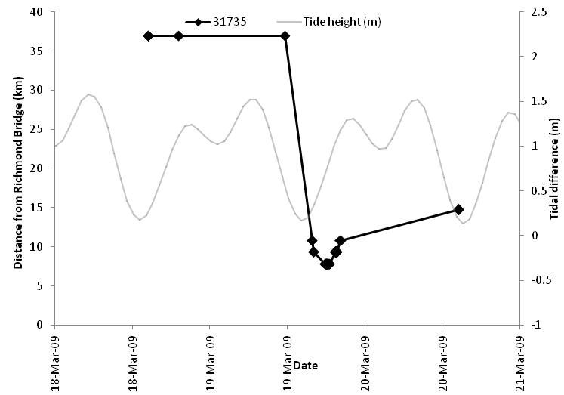
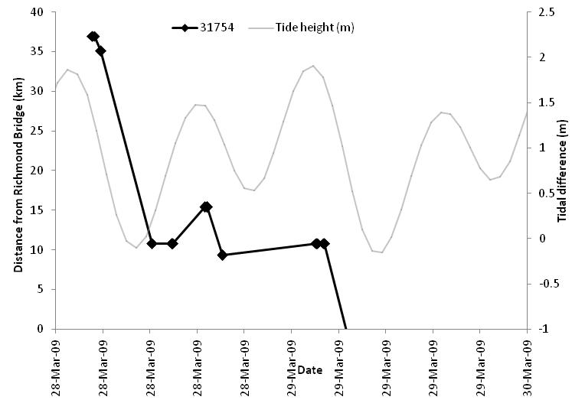

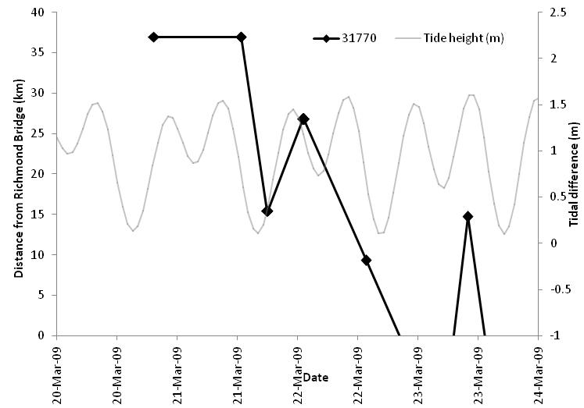

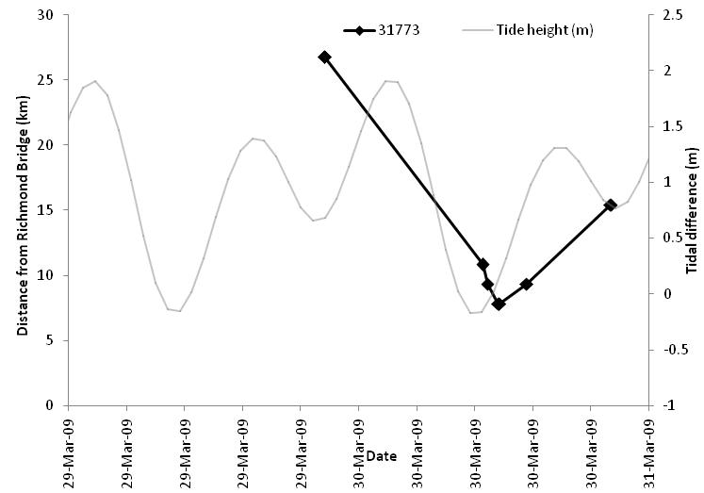

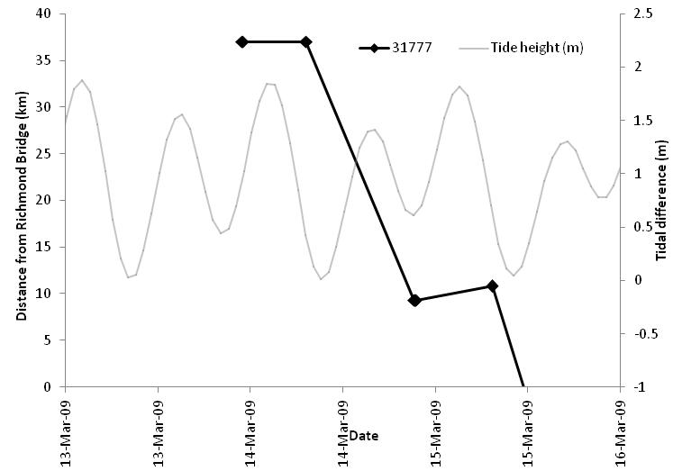

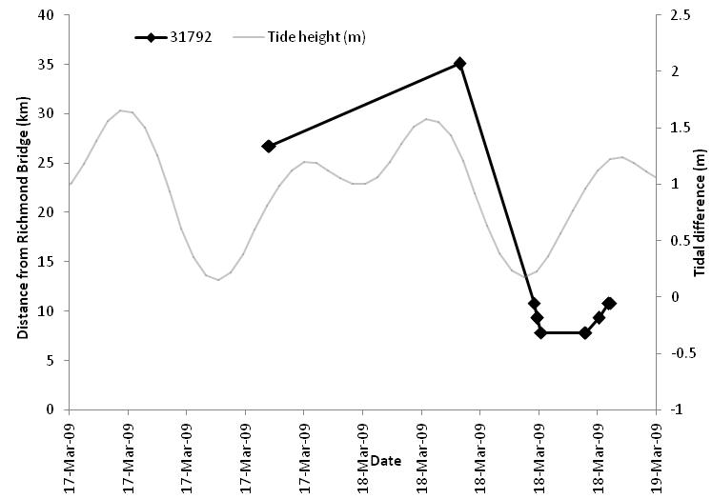

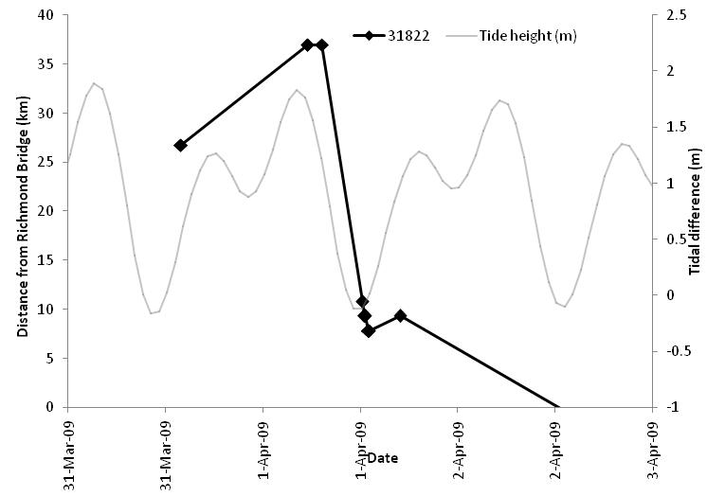

Appendix 3. Exposure time of Steelhead at Dredge Sites

Tag ID |  | G3 |  | G5 |  | Larkspur Ferry 15 |  | MartinezMarina |  | MontezumaEast |  | MontezumaWest |  | PetalumaRRBridge |  | Point Richmond |  | PortSonomaMarina |  | SPBuoy10 |  | SPBuoy7 |  | SPBuoy8 |  | Grand Total
31653 |  |  |  |  |  |  | 6.48 |  |  |  |  |  |  |  |  |  |  |  |  |  |  |  |  |  | 6.48
31662 |  |  |  |  |  |  |  |  | 1.00 |  |  |  |  |  |  |  |  |  |  |  |  |  |  |  | 1.00
31688 |  |  |  |  |  |  | 1.00 |  |  |  |  |  |  |  |  |  |  |  |  |  |  |  |  |  | 1.00
31691 |  |  |  |  |  |  | 3.18 |  |  |  |  |  |  |  |  |  |  |  |  |  |  |  |  |  | 3.18
31698 |  |  |  |  |  |  |  |  |  |  |  |  | 3.28 |  |  |  |  |  |  |  |  |  |  |  | 3.28
31701 |  |  |  |  |  |  |  |  |  |  |  |  |  |  |  |  |  |  |  |  |  |  | 6.15 |  | 6.15
31703 |  |  |  |  |  |  |  |  |  |  |  |  |  |  |  |  |  |  |  |  |  |  | 1.00 |  | 1.00
31704 |  |  |  |  |  |  |  |  |  |  |  |  |  |  |  |  |  |  |  |  |  |  | 18.62 |  | 18.62
31709 |  |  |  |  |  |  | 0.60 |  |  |  |  |  |  |  |  |  |  |  |  |  |  |  |  |  | 0.60
31711 |  |  |  |  |  |  | 1.00 |  |  |  |  |  |  |  |  |  |  |  |  |  |  |  |  |  | 1.00
31718 |  |  |  |  |  |  |  |  |  |  |  |  |  |  |  |  |  |  |  |  |  |  | 1.00 |  | 1.00
31722 |  |  |  |  |  |  | 2.55 |  |  |  |  |  |  |  |  |  |  |  |  |  |  |  |  |  | 2.55
31732 |  |  |  |  |  |  | 1.00 |  |  |  |  |  |  |  |  |  |  |  |  |  |  |  |  |  | 1.00
31741 |  |  |  |  |  |  |  |  |  |  |  |  |  |  |  |  |  |  |  |  |  |  | 1.35 |  | 1.35
31746 |  |  |  |  |  |  |  |  |  |  |  |  |  |  |  |  |  |  |  |  |  |  | 18.53 |  | 18.53
31747 |  |  |  |  |  |  | 1.00 |  |  |  |  |  |  |  |  |  |  |  | 3.05 |  |  |  |  |  | 4.05
31749 |  |  |  |  |  |  | 18.92 |  |  |  |  |  |  |  |  |  |  |  |  |  |  |  |  |  | 18.92
31754 |  |  |  |  |  |  |  |  |  |  |  |  |  |  |  |  |  |  |  |  |  |  | 2.10 |  | 2.10
31762 |  |  |  |  |  |  |  |  |  |  |  |  |  |  |  |  |  |  |  |  |  |  | 1.00 |  | 1.00
31770 |  |  |  |  |  |  |  |  |  |  |  |  |  |  |  |  |  |  |  |  |  |  | 6.72 |  | 6.72
31773 |  |  |  |  |  |  |  |  |  |  |  |  |  |  |  |  |  |  |  |  |  |  | 2.88 |  | 2.88
31782 |  |  |  |  |  |  | 1.00 |  |  |  |  |  |  |  |  |  |  |  |  |  |  |  |  |  | 1.00
31788 |  |  |  |  |  |  |  |  |  |  |  |  |  |  |  |  |  |  |  |  |  |  | 2.18 |  | 2.18
31792 |  |  |  |  |  |  | 1.00 |  |  |  |  |  |  |  |  |  |  |  |  |  |  |  |  |  | 1.00
31795 |  |  |  |  | 12.20 |  |  |  |  |  |  |  |  |  |  |  |  |  |  |  |  |  |  |  | 12.20
31801 |  |  |  |  |  |  |  |  | 133.33 |  |  |  |  |  |  |  |  |  |  |  |  |  |  |  | 133.33
31827 |  |  |  |  |  |  | 1.18 |  |  |  |  |  |  |  |  |  |  |  |  |  |  |  |  |  | 1.18
31838 |  |  |  |  |  |  | 3.18 |  |  |  |  |  |  |  |  |  |  |  |  |  |  |  | 0.00 |  | 3.18
31840 |  |  |  |  |  |  | 5.03 |  |  |  |  |  |  |  |  |  |  |  |  |  |  |  |  |  | 5.03
31856 |  |  |  |  |  |  | 1.00 |  |  |  |  |  |  |  |  |  |  |  |  |  |  |  |  |  | 1.00
31864 |  |  |  |  |  |  | 1.80 |  |  |  |  |  |  |  |  |  |  |  |  |  |  |  |  |  | 1.80
31866 |  |  |  |  |  |  |  |  |  |  |  |  |  |  |  |  |  |  |  |  |  |  | 0.93 |  | 0.93
31867 |  |  |  |  |  |  | 1.00 |  |  |  |  |  |  |  |  |  |  |  |  |  |  |  |  |  | 1.00
31886 |  |  |  |  |  |  |  |  |  |  |  |  |  |  |  |  |  |  |  |  |  |  | 2.00 |  | 2.00
 |  |  |  |  |  |  |  |  |  |  |  |  |  |  |  |  |  |  |  |  |  |  | Appendix 3 cont.
31892 |  |  |  |  |  |  | 1.00 |  |  |  |  |  |  |  |  |  |  |  |  |  |  |  |  |  | 1.00
31898 |  |  |  |  |  |  | 12.95 |  |  |  |  |  |  |  |  |  |  |  |  |  |  |  |  |  | 12.95
31901 |  |  |  |  |  |  | 1.00 |  |  |  |  |  |  |  |  |  |  |  |  |  |  |  |  |  | 1.00
31909 |  |  |  |  |  |  | 2.53 |  |  |  |  |  |  |  |  |  |  |  |  |  |  |  |  |  | 2.53
31913 |  |  |  |  |  |  |  |  |  |  |  |  |  |  |  |  |  |  |  |  |  |  | 0.78 |  | 0.78
31918 |  |  |  |  |  |  |  |  |  |  |  |  |  |  |  |  |  |  |  |  |  |  | 3.38 |  | 3.38
31920 |  |  |  |  |  |  | 4.58 |  |  |  |  |  |  |  |  |  |  |  |  |  |  |  | 2.98 |  | 7.57
31936 |  |  |  |  |  |  |  |  |  |  |  |  |  |  |  |  |  |  |  |  |  |  | 1.00 |  | 1.00
31939 |  |  |  |  |  |  | 1.27 |  |  |  |  |  |  |  |  |  |  |  |  |  |  |  |  |  | 1.27
31977 |  |  |  |  |  |  | 1.00 |  |  |  |  |  |  |  |  |  |  |  |  |  |  |  |  |  | 1.00
31983 |  |  |  |  |  |  | 1.00 |  |  |  |  |  |  |  |  |  |  |  |  |  |  |  | 7.58 |  | 8.58
31985 |  |  |  |  |  |  |  |  | 46.83 |  |  |  |  |  |  |  |  |  |  |  |  |  |  |  | 46.83
31987 |  |  |  |  |  |  |  |  |  |  |  |  |  |  |  |  |  |  |  |  |  |  | 1.00 |  | 1.00
31995 |  |  |  |  |  |  |  |  |  |  |  |  |  |  |  |  |  |  |  |  |  |  | 1.00 |  | 1.00
31999 |  |  |  |  |  |  | 3.98 |  |  |  |  |  |  |  |  |  |  |  |  |  |  |  | 2.50 |  | 6.48
32004 |  |  |  |  |  |  |  |  |  |  |  |  |  |  |  |  |  |  |  |  |  |  | 1.00 |  | 1.00
32005 |  |  |  |  |  |  | 3.00 |  |  |  |  |  |  |  |  |  |  |  |  |  |  |  | 1.00 |  | 4.00
32012 |  |  |  |  | 1.12 |  |  |  |  |  |  |  | 46.70 |  |  |  |  |  |  |  |  |  |  |  | 47.82
32032 |  |  |  |  |  |  | 4.88 |  |  |  |  |  |  |  |  |  |  |  |  |  |  |  |  |  | 4.88
32036 |  |  |  |  |  |  |  |  |  |  | 19.15 |  |  |  | 35.50 |  |  |  |  |  |  |  | 7.72 |  | 62.37
32039 |  |  |  |  |  |  | 1.00 |  |  |  |  |  |  |  |  |  |  |  |  |  |  |  | 1.00 |  | 2.00
32040 |  |  |  |  |  |  |  |  |  |  |  |  | 15.03 |  |  |  | 3.07 |  |  |  |  |  |  |  | 18.10
32041 |  |  |  |  |  |  | 1.00 |  |  |  |  |  |  |  |  |  |  |  |  |  |  |  |  |  | 1.00
32046 | 25.70 |  |  |  |  |  |  |  |  |  |  |  |  |  |  |  |  |  |  |  |  |  |  |  | 25.70
32047 |  |  |  |  |  |  | 1.00 |  |  |  |  |  |  |  |  |  |  |  |  |  |  |  | 4.68 |  | 5.68
32052 |  |  |  |  |  |  | 1.00 |  |  |  |  |  |  |  |  |  |  |  |  |  |  |  |  |  | 1.00
32053 |  |  |  |  |  |  |  |  |  |  |  |  |  |  |  |  |  |  |  |  |  |  | 4.35 |  | 4.35
32057 |  |  |  |  |  |  | 4.12 |  |  |  |  |  |  |  |  |  |  |  |  |  |  |  |  |  | 4.12
32063 |  |  |  |  |  |  | 0.00 |  |  |  |  |  |  |  |  |  |  |  |  |  |  |  | 1.55 |  | 1.55
32069 |  |  |  |  |  |  | 6.05 |  |  |  |  |  |  |  |  |  |  |  |  |  |  |  |  |  | 6.05
32072 |  |  |  |  |  |  | 12.65 |  |  |  |  |  |  |  |  |  |  |  |  |  |  |  |  |  | 12.65
32075 |  |  |  |  |  |  | 4.35 |  |  |  |  |  |  |  |  |  |  |  |  |  |  |  |  |  | 4.35
32086 |  |  |  |  |  |  | 2.93 |  |  |  |  |  |  |  |  |  |  |  |  |  |  |  |  |  | 2.93
32096 |  |  |  |  |  |  |  |  |  |  |  |  |  |  |  |  |  |  |  |  |  |  | 8.62 |  | 8.62
32098 | 1.00 |  | 1.00 |  |  |  |  |  |  |  |  |  |  |  |  |  |  |  | 1.00 |  | 1.00 |  | 1.00 |  | 5.00
32099 |  |  |  |  |  |  |  |  |  |  |  |  |  |  |  |  |  |  |  |  |  |  | 1.00 |  | 1.00
32104 |  |  |  |  | 67.28 |  | 1.97 |  |  |  |  |  |  |  |  |  |  |  |  |  |  |  | 1.00 |  | 70.25
32106 |  |  |  |  |  |  |  |  |  |  |  |  |  |  |  |  |  |  |  |  |  |  | 1.00 |  | 1.00
32113 |  |  |  |  |  |  | 1.00 |  |  |  |  |  | 61.93 |  |  |  | 2.00 |  |  |  |  |  |  |  | 64.93
32114 |  |  |  |  | 6.13 |  | 1.32 |  |  |  |  |  |  |  |  |  |  |  |  |  |  |  |  |  | 7.45
32115 |  |  |  |  |  |  |  |  | 13.17 |  |  |  |  |  |  |  |  |  |  |  |  |  |  |  | 13.17
32118 |  |  |  |  |  |  |  |  |  |  |  |  | 127.78 |  |  |  | 1.00 |  |  |  |  |  |  |  | 128.78
 |  |  |  |  |  |  |  |  |  |  |  |  |  |  |  |  |  |  |  |  |  |  | Appendix 3 cont.
32119 |  |  |  |  |  |  | 1.00 |  |  |  |  |  |  |  | 0.83 |  |  |  |  |  |  |  |  |  | 1.83
32125 |  |  |  |  |  |  |  |  |  |  |  |  |  |  |  |  |  |  |  |  |  |  | 1.00 |  | 1.00
32126 |  |  |  |  |  |  | 0.00 |  |  |  |  |  |  |  |  |  |  |  |  |  |  |  | 0.88 |  | 0.88
32129 |  |  |  |  |  |  | 1.00 |  |  |  |  |  |  |  |  |  |  |  |  |  |  |  | 6.33 |  | 7.33
32131 |  |  |  |  |  |  | 1.00 |  |  |  |  |  |  |  |  |  |  |  |  |  |  |  |  |  | 1.00
32133 |  |  |  |  | 38.35 |  |  |  |  |  |  |  |  |  |  |  |  |  |  |  |  |  |  |  | 38.35
32140 |  |  |  |  |  |  | 23.12 |  |  |  |  |  |  |  |  |  |  |  |  |  |  |  |  |  | 23.12
32141 |  |  |  |  |  |  |  |  |  |  |  |  |  |  |  |  |  |  |  |  |  |  | 48.53 |  | 48.53
32658 |  |  |  |  |  |  | 3.72 |  |  |  |  |  |  |  |  |  |  |  |  |  |  |  |  |  | 3.72
32659 |  |  |  |  |  |  | 2.53 |  |  |  |  |  |  |  |  |  |  |  |  |  |  |  |  |  | 2.53
Total | 26.70 |  | 1.00 |  | 125.08 |  | 158.88 |  | 194.33 |  | 19.15 |  | 254.73 |  | 36.33 |  | 6.07 |  | 4.05 |  | 1.00 |  | 175.37 |  | 1002.70

Appendix 4. Exposure time of Chinook salmon at Dredge Sites

Tag ID | EmeryvilleB | G3 | MartinezMarina | MontezumaEast | MontezumaWest | PetalumaRRBridge | PortSonomaMarina | SPBuoy10 | SPBuoy10b | SPBuoy8 | Vallejo Marina C | Grand Total
31142 |  |  | 2.73 |  |  |  |  | 5.27 |  | 21.30 |  | 29.30
31143 |  |  | 0.50 |  |  |  |  |  |  |  |  | 0.50
31146 |  |  | 48.57 |  |  |  |  |  |  |  |  | 48.57
31151 |  |  |  |  |  |  |  | 4.45 |  |  |  | 4.45
31152 |  |  | 0.55 |  |  |  |  |  |  |  |  | 0.55
31157 |  |  | 0.00 |  |  |  |  |  |  |  | 1.57 | 1.57
31159 |  |  |  |  |  |  |  |  |  | 10.10 |  | 10.10
31164 |  |  | 3.60 |  |  |  |  |  |  |  |  | 3.60
31167 |  |  | 0.50 |  |  |  |  |  |  |  |  | 0.50
31168 |  | 1.47 | 6.45 |  |  |  |  |  |  | 8.35 |  | 16.27
31172 |  |  |  |  |  |  |  | 4.15 |  |  |  | 4.15
31173 |  |  | 21.38 |  |  |  |  |  |  |  |  | 21.38
31175 |  |  |  |  |  |  |  | 0.50 |  | 6.50 |  | 7.00
31178 |  |  |  |  |  |  |  |  |  |  | 3.58 | 3.58
31179 |  |  | 9.45 |  |  |  |  |  |  |  |  | 9.45
31182 |  |  |  |  |  |  |  |  |  |  | 1.90 | 1.90
31194 |  |  | 10.85 |  |  |  |  | 0.50 |  | 4.52 |  | 15.87
31195 |  |  |  |  |  |  |  | 0.50 |  |  |  | 0.50
31201 |  |  | 1.13 |  |  |  |  |  |  |  |  | 1.13
31203 |  |  | 3.25 |  |  |  |  | 0.50 |  |  |  | 3.75
31214 |  |  |  |  |  |  |  |  |  | 0.43 |  | 0.43
31218 |  |  | 48.45 |  |  |  |  |  |  | 7.98 |  | 56.43
31220 |  |  | 49.53 |  |  |  |  |  |  |  |  | 49.53
31224 |  |  | 3.28 |  |  |  |  |  |  |  |  | 3.28
31228 |  |  | 2.73 |  |  |  |  |  |  |  |  | 2.73
31230 |  |  | 10.88 |  |  |  |  |  |  |  |  | 10.88
31232 |  |  | 8.83 |  |  |  |  |  |  | 24.03 |  | 32.87
31237 |  |  |  |  |  |  |  |  |  | 15.25 |  | 15.25
31239 |  |  |  |  |  |  |  |  | 2.92 | 3.40 |  | 6.32
31240 |  |  | 20.37 |  |  |  |  |  |  |  |  | 20.37
31244 |  |  | 4.42 |  |  |  |  | 5.07 |  |  |  | 9.48
31245 |  |  | 7.68 |  | 20.15 |  |  | 14.77 |  |  |  | 42.60
31247 |  |  | 1.15 |  |  |  |  | 0.38 |  |  |  | 1.53
31250 | 1.00 |  | 8.03 |  |  |  |  |  |  |  |  | 9.03
31251 |  |  | 8.35 |  |  |  |  |  |  |  |  | 8.35
 |  |  |  |  |  |  |  |  |  | Appendix 4 cont.
31255 |  |  | 0.00 |  |  |  |  | 3.35 |  |  |  | 3.35
31258 |  |  | 0.77 |  |  |  |  | 3.55 |  |  |  | 4.32
31260 |  |  |  |  |  |  |  | 6.72 |  |  |  | 6.72
31266 |  |  | 7.80 |  |  |  |  |  |  |  |  | 7.80
31267 |  |  | 2.40 |  |  |  |  | 6.42 |  |  |  | 8.82
31272 |  |  | 8.65 |  |  |  |  |  |  |  |  | 8.65
31275 |  |  | 21.33 |  |  | 75.62 | 14.77 |  |  |  |  | 111.72
31278 |  |  | 1.45 |  | 2.70 |  |  |  |  |  |  | 4.15
31280 |  |  | 1.08 |  |  |  |  |  |  |  |  | 1.08
31284 |  |  |  |  |  |  |  |  |  | 1.03 |  | 1.03
31285 |  |  | 19.85 |  |  |  |  |  |  | 0.50 |  | 20.35
31287 |  |  | 0.50 |  |  |  |  | 0.97 |  |  |  | 1.47
31293 |  |  | 9.25 |  |  |  |  |  |  |  |  | 9.25
31295 |  |  | 93.97 |  |  |  |  |  |  |  |  | 93.97
31299 |  |  | 0.50 |  |  |  |  |  |  | 1.25 | 2.05 | 3.80
31302 |  |  |  |  |  |  |  |  |  |  | 0.50 | 0.50
31303 |  |  | 5.57 |  |  |  |  |  |  |  |  | 5.57
31306 |  |  |  |  |  |  |  | 18.63 |  | 11.07 |  | 29.70
31307 |  |  | 3.57 |  |  |  |  |  |  | 7.25 |  | 10.82
31316 |  |  | 1.37 |  |  | 4.45 |  | 0.50 |  |  |  | 6.32
31319 |  |  | 0.50 |  |  |  |  |  |  | 7.33 |  | 7.83
31320 |  |  | 15.63 |  |  |  |  |  |  | 5.42 |  | 21.05
31321 |  |  |  |  |  |  |  | 4.55 |  |  |  | 4.55
31322 |  |  | 5.30 |  |  |  |  |  |  |  |  | 5.30
31324 |  |  | 3.50 |  |  |  |  |  |  |  |  | 3.50
31326 |  |  | 2.88 |  |  |  |  |  |  |  |  | 2.88
31328 |  |  | 9.90 |  |  |  |  |  |  |  |  | 9.90
31329 |  |  | 30.32 |  |  |  |  | 52.43 |  | 26.33 |  | 109.08
31331 |  |  | 74.55 |  |  |  |  | 0.50 |  | 0.50 | 6.53 | 82.08
31336 |  |  | 0.50 |  |  |  |  |  |  | 2.53 |  | 3.03
31338 |  |  | 6.13 | 69.83 |  |  |  |  |  |  |  | 75.97
31339 |  |  | 5.42 |  |  |  |  |  |  | 0.55 |  | 5.97
31341 |  |  |  |  |  |  |  | 5.83 |  |  |  | 5.83
31342 |  |  | 0.50 |  |  |  |  |  |  |  |  | 0.50
31343 |  |  | 11.72 |  |  |  |  |  |  |  |  | 11.72
31344 |  |  | 16.77 |  |  |  |  |  |  |  |  | 16.77
31353 |  |  | 5.65 |  |  |  |  |  |  |  |  | 5.65
31354 |  |  | 1.55 |  |  |  |  | 6.00 |  |  |  | 7.55
31361 |  |  | 0.50 |  |  |  |  |  |  | 2.17 |  | 2.67
31367 |  |  | 0.50 |  |  |  |  | 2.67 |  | 2.40 |  | 5.57
31372 |  | 4.07 |  |  |  |  |  |  |  |  |  | 4.07
31375 |  | 4.78 |  |  |  |  |  | 2.48 |  |  |  | 7.27
 |  |  |  |  |  |  |  |  |  |  | Appendix 4 cont.
31376 |  |  | 21.87 |  |  |  |  | 0.73 |  | 0.50 |  | 23.10
31378 |  |  | 4.38 |  |  |  |  |  |  |  |  | 4.38
31381 |  |  | 0.00 |  |  |  |  | 0.50 |  |  |  | 0.50
31389 |  |  | 2.82 |  |  |  |  |  |  | 0.50 |  | 3.32
31392 |  |  | 0.50 |  |  |  |  |  |  |  |  | 0.50
31393 |  | 25.37 | 0.50 |  |  |  |  |  |  | 1.37 |  | 27.23
31396 |  |  |  |  |  |  |  |  |  | 0.50 |  | 0.50
31397 |  |  | 0.50 |  |  |  |  |  |  |  |  | 0.50
31400 |  |  | 1.48 |  |  |  |  |  |  |  |  | 1.48
31401 |  |  | 1.02 |  |  |  |  |  |  |  |  | 1.02
31403 |  |  |  |  |  |  |  | 3.40 |  |  | 0.80 | 4.20
31409 |  |  | 4.97 |  |  |  |  |  |  |  |  | 4.97
31413 |  |  | 0.00 |  |  |  |  |  |  | 1.08 |  | 1.08
31414 |  |  |  |  |  |  |  |  |  | 2.58 |  | 2.58
31415 |  |  | 0.50 |  |  |  |  |  |  |  | 0.50 | 1.00
31416 |  |  |  |  |  |  |  |  |  | 4.33 |  | 4.33
31417 |  |  |  |  |  |  |  |  |  | 7.58 |  | 7.58
31422 |  |  | 14.70 |  |  |  |  |  |  | 0.50 |  | 15.20
31424 |  |  | 0.50 |  |  |  |  |  |  |  |  | 0.50
31426 |  |  | 5.82 |  |  |  |  |  |  |  |  | 5.82
31428 |  |  | 0.50 |  |  |  |  |  |  |  |  | 0.50
31430 |  |  |  |  |  |  |  |  |  |  | 2.40 | 2.40
31439 |  |  | 0.50 |  |  | 16.27 | 10.90 |  |  |  |  | 27.67
31441 |  |  | 3.97 |  |  |  |  |  |  |  |  | 3.97
31443 |  |  | 7.28 |  |  |  |  |  |  |  |  | 7.28
31445 |  |  | 6.77 |  |  |  |  |  |  |  |  | 6.77
31448 |  |  | 8.35 |  |  |  |  |  |  |  |  | 8.35
31450 |  |  | 0.00 |  |  |  |  |  |  | 2.07 |  | 2.07
31452 |  |  | 17.82 |  |  |  |  |  |  |  |  | 17.82
31454 |  |  | 1.15 |  |  |  |  |  |  |  |  | 1.15
31455 |  |  | 3.50 |  |  |  |  |  |  |  |  | 3.50
31464 |  |  | 0.50 |  |  |  |  |  |  |  |  | 0.50
31465 |  |  | 0.50 |  |  |  |  |  |  |  |  | 0.50
31468 |  |  |  |  |  |  |  |  |  | 0.62 |  | 0.62
31471 |  |  | 1.62 |  |  |  |  |  |  |  |  | 1.62
31474 |  |  |  |  |  |  |  |  |  |  | 0.50 | 0.50
31475 |  |  | 5.23 |  |  |  |  |  |  |  |  | 5.23
31480 |  |  | 12.72 |  |  |  |  |  |  |  |  | 12.72
31481 |  |  |  |  |  |  |  |  |  | 5.03 |  | 5.03
31482 |  |  | 0.00 |  |  |  |  | 15.73 |  |  |  | 15.73
31489 |  |  | 0.50 |  |  |  |  |  |  |  |  | 0.50
31491 |  |  | 4.77 |  |  |  |  | 0.95 |  |  |  | 5.72
 |  |  |  |  |  |  |  |  |  |  | Appendix 4 cont.
31492 |  |  |  |  |  |  |  |  | 4.07 | 2.87 |  | 6.93
31494 |  |  | 2.03 |  |  |  |  |  |  | 4.22 |  | 6.25
31496 |  |  | 0.50 |  |  |  |  |  |  | 0.50 |  | 1.00
31497 |  |  | 2.77 |  |  |  |  |  |  |  | 0.80 | 3.57
31498 |  |  | 3.07 |  |  |  |  |  |  |  |  | 3.07
31500 |  |  | 1.68 |  |  |  |  |  |  | 1.48 |  | 3.17
31504 |  |  | 2.85 |  |  |  |  |  |  |  |  | 2.85
31505 |  |  | 0.00 |  |  | 0.50 | 0.50 |  |  |  |  | 1.00
31509 |  |  | 0.50 |  |  |  |  |  |  |  |  | 0.50
31511 |  |  |  |  |  |  |  |  |  |  | 3.22 | 3.22
31513 |  |  | 45.17 |  |  |  |  |  |  |  |  | 45.17
31515 |  |  | 30.20 |  |  |  |  |  |  |  |  | 30.20
31516 |  |  |  |  |  |  |  |  |  | 0.75 |  | 0.75
31517 |  |  |  |  |  |  |  | 1.02 |  |  |  | 1.02
31518 |  |  |  |  | 22.27 |  |  |  |  |  |  | 22.27
31519 |  |  |  |  |  |  |  | 1.23 |  |  |  | 1.23
31521 |  |  | 2.02 |  |  |  |  |  |  |  |  | 2.02
31528 |  |  | 0.50 |  |  |  |  |  |  |  |  | 0.50
31531 |  |  | 0.00 |  |  |  |  |  |  | 1.38 |  | 1.38
31532 |  |  | 5.38 |  |  |  |  |  |  |  |  | 5.38
31535 |  |  | 2.40 |  |  |  |  |  |  |  |  | 2.40
31536 |  |  |  | 2.70 |  |  |  |  |  |  |  | 2.70
31537 |  |  |  |  |  |  |  |  |  | 0.50 |  | 0.50
31541 |  |  | 4.58 |  |  |  |  |  |  |  |  | 4.58
31546 |  |  | 0.00 |  |  |  |  |  |  | 0.50 |  | 0.50
31547 |  |  | 2.20 |  |  |  |  |  |  |  |  | 2.20
31550 |  |  | 2.67 |  |  |  |  |  |  |  |  | 2.67
31552 |  |  |  |  |  |  |  |  |  | 0.50 |  | 0.50
31553 |  |  | 1.05 |  |  |  |  |  |  |  |  | 1.05
31554 |  |  | 0.00 |  |  | 42.30 | 6.48 |  |  |  |  | 48.78
31557 |  |  | 14.90 |  |  |  |  |  |  |  |  | 14.90
31559 |  |  | 1.40 |  |  |  |  |  |  |  |  | 1.40
31562 |  |  |  |  |  |  |  | 0.98 |  |  |  | 0.98
31564 |  |  | 0.50 |  |  |  |  |  |  |  |  | 0.50
31565 |  |  |  | 0.75 |  |  |  |  |  |  |  | 0.75
31566 |  |  | 0.37 |  |  |  |  |  |  |  |  | 0.37
31567 |  |  | 2.83 |  |  |  |  |  |  |  |  | 2.83
31570 |  |  | 0.50 |  |  |  |  | 0.72 |  |  |  | 1.22
31571 |  |  | 0.50 |  |  |  |  |  | 0.72 | 6.27 |  | 7.48
31579 |  |  | 4.27 |  |  |  |  |  |  |  |  | 4.27
31580 |  |  | 25.30 |  |  |  |  |  |  |  |  | 25.30
31582 |  |  |  |  |  |  |  | 0.45 |  |  |  | 0.45
 |  |  |  |  |  |  |  |  |  |  | Appendix 4 cont.
31585 |  |  | 2.17 |  |  |  |  |  |  |  |  | 2.17
31589 |  |  | 0.55 |  |  |  |  |  |  | 2.75 |  | 3.30
31593 |  |  | 4.25 |  |  |  |  |  |  |  |  | 4.25
31595 |  |  | 3.77 |  |  |  |  |  |  |  |  | 3.77
31598 |  |  | 13.97 |  |  |  |  |  |  |  |  | 13.97
31606 |  |  | 4.75 |  |  |  |  |  |  | 0.50 |  | 5.25
31612 |  |  | 0.50 |  |  |  |  |  |  |  |  | 0.50
31619 |  |  | 15.52 |  |  |  |  | 8.22 |  |  |  | 23.73
31620 |  | 140.38 | 0.50 |  | 42.38 |  |  |  |  |  |  | 183.27
31626 |  |  | 0.33 |  |  |  |  |  |  | 0.70 |  | 1.03
31627 |  |  | 0.77 |  |  |  |  | 0.50 |  |  |  | 1.27
31628 |  |  | 6.07 |  |  |  |  |  |  |  |  | 6.07
31631 |  |  | 12.15 |  |  |  |  |  |  | 0.67 |  | 12.82
31635 |  |  | 8.67 | 288.83 |  |  |  |  |  |  |  | 297.50
31636 |  |  |  |  |  |  |  |  |  | 0.50 |  | 0.50
31639 |  |  | 0.50 |  |  |  |  | 3.62 |  |  |  | 4.12
31640 |  |  | 6.48 |  |  |  |  |  |  |  |  | 6.48
Grand Total | 1.00 | 176.07 | 1028.83 | 362.12 | 87.50 | 139.13 | 32.65 | 188.73 | 7.70 | 220.95 | 24.35 | 2269.03

Appendix 5. Other Steelhead detected on ACE receivers
 |  |  |  |  |  |  | Receiver Stations
Study | Tag ID | Alcatraz Control | Alcatraz Disposal | Emeryville Marina | Martinez Marina | Montezuma Slough | Petaluma (Railroad Bridge) | Port Sonoma Marina | Petaluma Channel | Pt. Richmond(Rich Harbor) | Raccoon Straits | SP Array 1 (SF10) | SP Array 2 (SF10) | SP Channel (Buoy 7,8,9, &10) | SP CONTROL | Vallejo Marina | Grand Total
Wild | 16248 | 2 |  |  |  |  |  |  |  |  |  |  |  |  |  |  | 2
Calfed/ | 30195 |  |  |  | 10 |  |  |  |  |  |  |  |  |  |  |  | 10
USFWS | 30203 |  |  |  | 2 |  |  |  |  |  |  | 18 | 1 |  | 2 |  | 23
 | 30224 |  |  |  |  |  |  |  |  |  | 4 |  |  |  |  |  | 4
 | 30228 |  |  |  |  |  |  |  |  |  | 9 |  |  |  | 3 |  | 12
 | 30239 |  |  |  | 3 |  |  |  |  |  |  |  |  |  | 1 |  | 4
 | 30244 |  |  |  | 1 |  |  |  |  |  |  | 4 |  | 2 | 6 |  | 13
 | 30254 | 1 |  |  | 1 |  |  |  |  |  |  |  |  |  |  |  | 2
 | 30256 |  |  |  |  |  |  |  |  |  |  |  |  | 7 |  |  | 7
 | 30267 |  |  |  | 1 |  |  |  |  |  |  |  |  |  | 2 |  | 3
 | 30287 |  |  |  | 2 |  |  |  |  |  |  |  |  |  |  |  | 2
 | 30292 |  |  |  |  |  |  |  |  |  |  |  |  |  | 7 |  | 7
 | 30294 |  |  |  | 2 |  |  |  |  |  |  |  |  | 42 | 5 |  | 49
 | 30303 |  |  |  | 3 |  |  |  |  |  |  | 12 |  | 7 | 1 |  | 23
 | 30308 |  |  |  |  |  |  |  |  |  |  |  |  | 4 | 12 |  | 16
 | 30316 |  |  |  |  |  |  |  |  |  | 2 | 6 | 2 |  | 8 |  | 18
 | 30321 |  |  |  | 1 |  |  |  |  |  |  |  |  |  |  | 4 | 5
 | 32347 |  |  |  | 1 |  |  |  |  |  | 12 |  | 3 |  | 1 |  | 17
 | 32358 |  |  |  |  |  |  |  |  |  |  | 1 |  |  | 2 | 5 | 8
 | 32360 |  |  |  | 14 |  |  |  |  |  |  |  |  | 5 |  |  | 19
 | 32365 |  |  |  |  |  |  |  |  |  |  | 18 |  |  | 9 |  | 27
 | 32371 |  |  |  | 1 |  |  |  |  |  |  |  |  |  |  |  | 1
 | 32382 |  |  |  | 1 |  |  |  |  |  |  | 19 | 30 | 11 | 44 |  | 105
 | 32386 |  |  |  | 10 |  |  |  |  |  |  |  |  |  |  |  | 10
 | 32394 | 10 |  |  | 18 |  |  |  |  |  |  | 5 | 5 | 7 | 11 |  | 56
 | 32396 |  |  |  | 6 |  |  |  |  |  |  | 4 | 8 |  |  |  | 18
 | 32409 |  |  |  |  |  |  |  |  |  |  |  |  |  | 1 |  | 1
 | 32414 |  | 3 |  |  |  |  |  |  |  |  |  |  |  |  |  | 3
 | 32422 |  |  |  | 7 |  |  |  |  |  |  | 14 |  | 1 | 14 |  | 36
 | 32426 |  |  |  |  |  |  |  |  |  |  |  |  | 1 |  |  | 1
 | 32439 |  |  |  | 15 |  |  |  |  |  |  | 2 | 1 |  |  |  | 18
 |  |  |  |  |  |  |  |  |  |  |  |  | Appendix 5 cont.
 | 32440 |  |  |  |  |  |  |  |  |  |  | 1 |  |  | 1 |  | 2
 | 32441 |  |  |  | 2 |  |  |  |  |  |  |  |  |  |  |  | 2
 | 32443 |  |  |  | 1 |  |  |  |  |  |  | 6 | 12 |  | 6 |  | 25
 | 32445 |  |  |  | 1 |  |  |  |  |  |  | 2 | 1 |  | 2 |  | 6
 | 32447 |  |  |  | 3 |  |  |  |  |  |  | 1 | 19 | 2 | 5 |  | 30
 | 32449 |  |  |  | 5 |  |  |  |  |  |  | 5 | 6 |  | 5 |  | 21
 | 32481 |  |  |  | 9 |  |  |  |  |  |  |  |  |  |  |  | 9
 | 32494 |  |  |  | 25 |  |  |  |  |  | 1 | 6 | 10 | 1 | 12 |  | 55
 | 32495 |  |  |  | 12 |  |  |  |  |  |  | 8 | 13 |  | 4 |  | 37
 | 32496 |  |  |  |  |  |  |  |  |  |  | 1 |  |  | 1 |  | 2
 | 32498 |  |  |  |  |  |  |  |  |  |  | 2 |  |  | 3 |  | 5
DWR | 4281 |  |  |  |  |  |  |  |  |  |  | 45 | 7 | 1 | 6 | 3 | 62
EBMUD | 52112 |  |  |  |  |  |  |  |  |  |  |  |  | 1 |  |  | 1
 | 52113 |  |  |  |  |  |  |  |  |  |  |  |  | 2 |  |  | 2
 | 52117 |  |  |  |  |  |  |  |  |  |  |  |  | 2 |  |  | 2
 | 52118 |  |  |  | 75 |  |  |  |  |  |  |  |  |  |  |  | 75
 | 52122 |  |  |  | 11 |  |  |  |  |  |  | 1 |  | 1 | 4 |  | 17
 | 52135 |  |  |  |  |  | 19 | 5 | 8 |  |  | 1 | 9 |  | 2 |  | 44
EBMUD | 54990 |  | 9 |  |  |  |  |  |  |  |  |  |  |  |  |  | 9
 | 55021 | 1 |  |  | 3 |  |  |  |  |  |  | 15 | 2 |  | 16 |  | 37
 | 55026 |  |  |  | 30 |  |  |  |  |  |  | 205 | 258 | 6 | 21 |  | 520
EBMUD | 54910 | 1 |  |  | 45 |  |  |  | 2 |  |  |  |  | 20 |  |  | 68
 | 54921 |  |  |  | 1 |  |  |  |  |  |  |  |  |  |  | 61 | 62
 | 54926 |  |  |  | 185 |  |  |  |  |  |  |  |  |  | 12 |  | 197
 | 54930 |  |  |  |  |  |  |  |  | 21 |  | 78 | 5 |  | 50 |  | 154
 | 54932 |  |  |  | 36 |  |  |  |  |  |  |  |  |  |  |  | 36
 | 54933 |  |  |  | 26 | 252 |  |  |  |  |  |  |  |  |  |  | 278
 | 54937 |  |  |  | 4 |  |  |  |  |  |  | 85 | 110 |  | 65 |  | 264
 | 54940 |  |  |  | 17 |  |  |  |  |  |  | 19 | 16 | 43 | 93 |  | 188
 | 54950 |  |  |  | 131 |  |  |  |  |  |  |  |  |  | 14 |  | 145
 | 54978 | 1 |  |  | 6 |  |  |  |  |  | 2 |  |  | 10 |  |  | 19
 | 54983 |  |  |  |  | 46 |  |  |  |  |  |  |  |  |  |  | 46
 | 54990 | 2 |  |  | 4 |  |  |  | 69 |  |  |  |  |  |  |  | 75
 | 54997 |  |  |  | 20 |  |  |  |  | 20 | 39 | 6 | 5 |  | 5 |  | 95
 | 55006 | 26 |  |  | 23 |  |  |  |  |  |  |  |  | 4 |  |  | 53
 | 55013 |  |  |  | 19 |  |  |  |  |  |  |  |  |  |  |  | 19
 | 55015 |  |  |  |  | 2 |  |  |  |  |  |  |  |  |  |  | 2
EBMUD | 10028 |  |  |  |  |  |  |  |  |  |  | 1 |  |  | 1 |  | 2
 | 10029 |  |  |  |  |  |  |  |  |  |  | 7 | 10 |  | 5 |  | 22

Appendix 6. Other Chinook salmon detected on ACE receivers

 |  |  |  |  |  |  | Receiver Stations
Study | Tag ID | Alcatraz Control | Alcatraz Disposal | Emeryville Marina | Martinez Marina | Montezuma Slough | Petaluma (Railroad Bridge) | Port Sonoma Marina | Petaluma Channel | Pt. Richmond(Rich Harbor) | Raccoon Straits | SP Array 1 (SF10) | SP Array 2 (SF10) | SP Channel (Buoy 7,8,9, &10) | SP CONTROL | Vallejo Marina | Grand Total
Calfed/ | 30502 |  |  |  |  |  |  |  |  |  |  | 19 |  |  |  |  | 19
USFWS | 30509 |  |  |  |  |  |  |  |  |  |  |  | 192 |  | 4 |  | 196
 | 30512 |  |  |  | 1 |  |  |  |  |  |  | 3 | 3 |  | 1 | 2 | 10
 | 30516 |  |  |  | 37 |  |  |  |  |  |  | 10 | 5 |  |  |  | 52
 | 30517 |  |  |  |  |  |  |  |  |  |  | 7 | 4 | 4 |  |  | 15
 | 30519 |  |  |  |  |  |  |  | 4 |  | 40 | 28 | 25 |  | 11 |  | 108
 | 30521 |  |  |  | 1 |  |  |  |  |  |  |  |  |  |  |  | 1
 | 30523 |  | 11 |  | 1 |  |  |  |  |  |  |  |  |  | 65 |  | 77
 | 30528 |  |  |  | 15 |  |  |  |  |  | 20 | 4 |  |  | 17 |  | 56
 | 30529 |  |  |  |  |  |  |  | 3 |  |  | 7 | 18 |  | 12 |  | 40
 | 30531 | 20 |  |  |  |  |  |  | 4 |  |  |  |  |  | 44 |  | 68
 | 30533 |  |  |  |  | 9 |  |  |  |  |  |  |  |  |  |  | 9
 | 30541 |  |  |  | 6 |  |  |  |  |  |  | 7 | 3 |  | 3 |  | 19
 | 30542 |  |  |  | 7 |  |  |  |  |  |  | 3 | 1 |  | 118 |  | 129
 | 30543 |  | 10 |  | 1 |  |  |  |  |  |  | 56 | 3 |  | 12 |  | 82
 | 30544 |  |  |  |  |  |  |  |  |  |  | 45 |  | 14 | 11 | 2 | 72
 | 30547 |  |  |  | 3 |  |  |  |  |  |  |  |  |  | 3 |  | 6
 | 30551 |  |  |  |  |  |  |  |  |  |  | 7 | 17 |  |  |  | 24
 | 30554 |  |  |  |  | 52 |  |  |  |  |  |  |  |  |  |  | 52
 | 30555 |  |  |  |  |  |  |  |  |  |  |  |  |  |  | 3 | 3
 | 30557 |  |  |  |  |  |  |  |  |  |  |  |  |  | 1 |  | 1
 | 30580 |  |  |  | 8 | 160 |  |  |  |  |  |  |  |  |  |  | 168
 | 30588 |  |  |  | 8 |  |  |  |  |  |  |  |  |  |  |  | 8
 | 30590 |  |  |  | 224 |  |  |  |  |  |  |  |  |  |  |  | 224
 | 30594 |  | 3 |  |  |  |  |  |  |  |  | 10 | 10 |  |  |  | 23
 | 30596 |  |  |  | 4 |  |  |  |  |  |  |  |  |  |  |  | 4
 | 30603 |  |  |  |  |  |  |  |  |  |  |  |  |  | 5 |  | 5
 | 30604 |  |  |  | 17 |  |  |  |  |  |  | 2 |  |  | 6 |  | 25
 | 30608 | 54 | 41 |  |  |  |  |  |  |  | 10 |  |  |  |  |  | 105
 | 30613 |  |  |  | 2 |  |  |  | 2 |  |  |  |  |  |  |  | 4
 | 30622 | 1 |  |  | 2 |  |  |  |  |  |  | 3 |  |  | 9 |  | 15
 |  |  |  |  |  |  |  |  |  |  |  |  |  | Appendix 6 cont.
 | 30670 |  |  |  | 4 |  |  |  |  |  | 60 |  |  |  |  |  | 64
 | 30672 |  |  |  | 1 |  |  |  |  |  |  | 1 | 1 |  | 7 |  | 10
 | 30674 |  |  |  |  |  |  |  |  |  |  | 40 | 65 |  | 56 |  | 161
 | 30676 |  |  |  |  |  |  |  |  |  |  | 4 | 4 |  | 1 |  | 9
 | 30696 |  |  |  |  | 215 |  |  |  |  |  |  |  |  |  |  | 215
 | 30697 |  |  |  | 2 |  |  |  |  |  |  | 7 |  |  | 4 |  | 13
 | 30712 |  |  |  | 1 |  |  |  |  |  |  |  |  |  |  |  | 1
 | 30715 |  |  |  | 2 |  |  |  |  |  |  |  |  |  |  |  | 2
 | 30720 |  |  |  | 2 |  |  |  |  |  |  | 1 | 2 |  |  |  | 5
 | 30721 |  |  |  | 11 |  |  |  |  |  |  | 1 | 1 |  | 1 |  | 14
 | 30722 |  |  |  | 12 |  |  |  |  |  |  |  |  |  |  |  | 12
 | 30724 |  |  |  | 4 |  |  |  |  |  |  |  |  |  |  |  | 4
 | 30726 |  |  |  |  |  |  |  |  |  |  | 1 |  |  | 38 |  | 39
 | 30731 |  |  |  | 1 |  |  |  |  |  |  |  |  |  |  |  | 1
 | 30732 |  |  |  | 4 |  |  |  |  |  |  | 1 |  |  |  |  | 5
 | 30740 |  |  |  | 3 |  |  |  |  |  |  |  |  |  |  |  | 3
 | 30742 |  |  |  |  |  |  |  |  |  |  | 17 | 3 |  | 9 |  | 29
 | 30744 |  |  |  |  |  |  |  |  |  |  | 1 |  |  |  |  | 1
 | 30748 | 5 | 1 |  | 3 |  |  |  |  |  |  | 7 | 20 |  | 19 |  | 55
 | 30751 |  |  |  |  |  |  |  |  |  |  |  | 8 |  | 4 |  | 12
 | 30752 |  |  |  | 6 |  |  |  |  |  | 16 |  |  |  |  |  | 22
 | 30760 |  |  |  | 4 |  |  |  |  |  |  | 2 |  |  |  |  | 6
 | 30766 |  |  |  | 3 |  |  |  |  |  |  | 2 |  |  |  |  | 5
 | 30777 |  |  |  | 16 |  |  |  |  |  |  |  |  |  |  |  | 16
 | 30786 |  |  |  |  |  |  |  |  |  | 19 | 4 | 24 |  | 37 |  | 84
 | 30793 |  |  |  | 11 |  |  |  |  |  |  |  |  |  |  |  | 11
 | 30794 |  |  |  | 2 |  |  |  |  |  |  |  |  |  | 3 |  | 5
 | 30808 |  |  |  | 227 |  |  |  |  |  |  |  |  |  |  |  | 227
 | 30810 | 9 |  |  | 13 |  |  |  |  |  |  | 5 | 6 |  | 32 |  | 65
 | 30818 |  |  |  | 3 |  |  |  |  |  |  |  |  |  |  |  | 3
 | 30819 |  |  |  | 1 |  |  |  |  |  |  | 46 | 22 | 9 | 32 |  | 110
 | 30823 |  |  |  | 11 |  |  |  |  |  |  |  |  |  |  |  | 11
 | 30824 |  |  |  |  |  |  |  |  |  | 1 |  | 14 | 9 |  |  | 24
 | 30831 |  |  |  | 4 |  |  |  |  |  |  |  |  |  |  | 9 | 13
 | 30833 |  |  |  | 3 |  |  |  |  |  |  | 10 | 58 | 1 | 29 |  | 101
 | 30837 |  |  |  | 45 |  |  |  |  |  |  | 20 | 26 | 7 | 19 |  | 117
 | 30839 | 9 |  |  | 10 |  |  |  |  |  |  |  |  | 25 | 2 |  | 46
 | 30844 |  |  |  |  |  |  |  | 1 |  |  | 14 | 5 | 31 | 16 |  | 67
 | 30846 |  |  |  | 3 |  |  |  |  |  |  | 19 | 116 | 41 | 93 |  | 272
 | 30858 | 20 |  |  |  |  |  |  |  |  |  | 26 | 14 | 33 | 55 |  | 148
 | 30859 | 2 |  |  | 4 |  |  |  |  |  |  | 3 |  | 2 | 3 |  | 14
 | 30860 |  |  |  |  |  |  |  |  |  |  |  |  |  | 2 |  | 2
 |  |  |  |  |  |  |  |  |  |  |  |  |  | Appendix 6 cont.
 | 30864 |  |  |  | 1 |  |  |  |  |  |  | 4 |  | 6 | 2 |  | 13
 | 30876 |  |  |  | 3 |  |  |  |  |  |  | 4 |  | 5 | 8 |  | 20
 | 30881 |  |  |  | 10 |  |  |  |  |  |  | 16 | 16 | 12 | 9 |  | 63
 | 30883 | 1 |  |  | 1 |  |  |  |  |  | 26 | 42 |  | 70 | 57 |  | 197
 | 30884 |  |  |  | 3 | 20 |  |  |  |  |  | 17 | 28 |  |  |  | 68
 | 30888 |  |  |  | 20 | 37 |  |  |  |  |  |  |  |  |  |  | 57
 | 30893 |  |  |  | 1 |  |  |  |  |  |  | 5 | 18 | 2 | 9 |  | 35
 | 30895 |  |  |  | 4 |  |  |  |  |  |  | 18 |  |  | 9 |  | 31
 | 30900 |  |  |  |  |  |  |  |  |  |  | 25 | 6 | 15 | 17 |  | 63
 | 30907 |  |  |  |  |  |  |  |  |  | 22 | 5 | 6 | 7 | 6 |  | 46
 | 30908 |  |  |  | 3 |  |  |  |  |  |  |  |  |  |  |  | 3
 | 30911 |  |  |  | 47 |  |  |  |  |  |  |  |  |  |  |  | 47
 | 30916 |  |  |  | 5 |  |  |  |  |  |  | 1 | 6 | 73 | 267 |  | 352
 | 30918 |  |  |  | 6 |  |  |  |  |  |  |  |  | 1 |  |  | 7
 | 30927 |  |  |  | 4 |  |  |  |  |  |  | 1 | 1 | 3 | 2 |  | 11
 | 30929 |  |  |  | 2 |  |  |  |  |  |  | 1 |  |  | 4 |  | 7
 | 30933 |  |  |  |  |  |  |  |  |  | 30 | 24 |  | 27 | 43 |  | 124
 | 30936 | 2 |  |  | 5 |  |  |  |  |  |  | 3 |  | 26 | 2 | 3 | 41
 | 30937 |  |  |  | 2 |  |  |  |  |  | 27 | 13 | 5 | 11 | 15 |  | 73
 | 30940 |  |  |  | 9 |  |  |  |  |  | 1 |  |  | 4 |  | 1 | 15
 | 30949 |  |  |  | 1 |  |  |  |  |  |  | 11 |  |  | 10 |  | 22
 | 30952 |  |  |  | 47 |  |  |  |  |  |  | 10 | 12 |  | 39 |  | 108
 | 30970 |  |  |  | 3 |  |  |  | 13 |  |  | 8 |  | 19 | 11 |  | 54
 | 30983 | 1 |  |  |  |  |  |  |  |  |  | 8 | 7 | 14 | 10 |  | 40
 | 30984 |  |  |  | 12 |  |  |  |  |  |  |  |  | 7 |  |  | 19
 | 30988 |  |  |  |  |  |  |  |  |  |  | 1 |  |  | 1 |  | 2
 | 30994 |  |  |  | 1 |  |  |  |  |  |  |  |  |  |  |  | 1
 | 30996 |  |  |  | 5 |  |  |  |  |  |  | 1 |  | 1 | 11 |  | 18
 | 30997 |  |  |  |  |  |  |  |  |  |  |  | 5 |  | 2 |  | 7
 | 31004 |  |  |  | 99 |  |  |  |  |  |  | 1 |  | 11 | 7 |  | 118
 | 31007 |  |  |  |  |  |  |  |  |  |  | 11 | 16 | 3 | 61 |  | 91
 | 31009 |  |  |  |  |  |  |  |  |  |  | 24 | 8 | 3 | 6 |  | 41
 | 31014 |  |  |  | 3 |  |  |  |  |  |  | 8 |  | 2 | 1 |  | 14
 | 31017 |  |  |  |  | 39 |  |  |  |  |  |  |  |  |  |  | 39
 | 31026 |  |  |  |  |  |  |  |  |  |  |  |  |  | 26 |  | 26
 | 31037 | 11 |  |  | 2 | 34 |  |  |  |  |  |  |  | 3 |  |  | 50
 | 31038 |  |  |  | 12 |  |  |  |  |  |  | 1 |  | 7 | 2 |  | 22
 | 31040 |  |  |  | 9 |  |  |  |  |  |  | 6 | 17 | 43 | 28 |  | 103
 | 31047 |  |  |  | 1 |  |  |  |  |  |  |  |  |  |  |  | 1
 | 31051 |  |  |  |  |  |  |  |  |  |  | 9 |  | 6 | 22 |  | 37
 | 31054 |  |  |  |  | 161 |  |  |  |  |  |  |  |  |  |  | 161
 | 31056 |  |  |  | 3 |  |  |  |  |  |  |  |  |  |  |  | 3
 |  |  |  |  |  |  |  |  |  |  |  |  |  | Appendix 6 cont.
 | 31077 |  |  |  |  |  |  |  |  |  |  |  |  | 4 | 9 | 3 | 16
 | 31079 |  |  |  | 3 |  |  |  |  |  |  |  |  |  |  |  | 3
 | 31106 |  |  |  | 44 |  |  |  |  |  |  |  |  | 8 |  |  | 52
 | 31115 |  |  |  | 4 |  |  |  |  |  |  |  |  |  |  |  | 4
 | 31126 |  |  |  |  |  |  |  |  |  |  |  |  |  | 5 |  | 5
 | 31127 |  |  |  | 9 |  |  |  | 1 |  | 81 | 35 | 8 |  | 98 |  | 232
 | 31128 |  |  |  | 1 |  |  |  |  |  |  | 1 |  |  |  |  | 2
 | 31133 |  |  |  | 10 |  |  |  |  |  |  |  |  |  | 6 |  | 16
 | 32162 | 13 |  |  |  |  |  |  |  |  |  |  | 13 |  |  |  | 26
 | 32165 |  |  |  | 20 | 38 |  |  |  |  |  |  |  | 18 |  |  | 76
 | 32170 |  |  |  |  |  |  |  |  |  |  | 5 | 3 |  | 2 |  | 10
 | 32174 |  |  |  | 20 |  |  |  |  |  |  | 39 |  |  | 191 |  | 250
 | 32176 |  |  |  |  |  |  |  |  |  |  | 14 | 3 |  | 11 |  | 28
 | 32180 |  | 27 |  | 1 |  |  |  |  |  |  | 4 | 1 | 10 | 9 |  | 52
 | 32184 |  |  |  |  |  |  |  |  |  |  | 1 |  |  | 3 |  | 4
 | 32193 |  |  |  | 1 | 16 |  |  |  |  |  |  |  |  |  |  | 17
 | 32197 |  |  |  |  |  |  |  | 1 |  |  | 17 | 3 |  | 10 |  | 31
 | 32200 |  |  |  | 35 |  |  |  |  |  | 24 | 26 | 146 |  | 27 |  | 258
 | 32214 |  |  |  | 3 |  |  |  |  |  | 1 | 32 | 1 | 9 | 55 |  | 101
 | 32219 |  |  |  | 6 |  |  |  |  |  |  |  |  |  |  |  | 6
 | 32221 |  | 10 |  | 16 |  |  |  |  |  |  | 14 | 1 |  | 78 |  | 119
 | 32225 |  |  |  | 8 |  |  |  |  |  |  | 18 |  |  | 93 |  | 119
 | 32228 |  |  |  | 3 |  |  |  |  |  |  | 20 | 10 |  | 1 |  | 34
 | 32232 |  |  |  | 7 |  |  |  |  |  |  | 4 |  | 30 | 1 |  | 42
 | 32233 |  |  |  | 1 |  |  |  |  |  | 7 | 2 | 27 |  | 5 |  | 42
 | 32236 |  |  |  |  |  |  |  |  |  | 8 | 3 |  |  | 8 |  | 19
 | 32237 |  |  |  |  |  |  |  |  |  |  | 16 | 50 |  | 12 |  | 78
 | 32238 |  |  |  |  |  |  |  |  |  |  |  | 1 |  |  | 2 | 3
 | 32240 | 6 |  |  | 2 |  |  |  |  |  | 24 | 8 | 3 |  | 13 |  | 56
 | 32242 |  | 63 |  | 6 |  |  |  |  |  | 15 |  |  |  |  |  | 84
 | 32243 |  |  |  | 12 |  |  |  |  |  |  | 119 | 81 |  | 133 |  | 345
 | 32254 |  |  |  | 17 |  |  |  |  |  |  |  |  |  |  |  | 17
 | 32257 |  |  |  | 69 |  |  |  |  |  |  |  |  |  |  |  | 69
 | 32275 | 7 |  |  | 1 |  |  |  |  |  | 25 | 14 |  |  | 23 |  | 70
 | 32276 |  |  |  |  |  |  |  |  |  |  | 3 | 8 |  | 4 |  | 15
 | 32277 |  |  |  | 11 |  |  |  |  |  |  | 23 | 26 | 10 | 1 |  | 71
 | 32288 |  |  |  |  |  |  |  |  |  | 85 | 57 | 53 |  | 203 |  | 398
 | 32289 |  |  |  | 59 |  |  |  | 145 |  |  | 56 | 217 | 3 | 57 |  | 537
 | 32291 |  | 19 |  | 9 |  |  |  |  |  |  | 25 | 13 |  | 7 |  | 73
 | 32292 |  |  |  | 1 |  |  |  |  |  |  |  |  |  |  |  | 1
 | 32306 |  |  |  |  |  |  |  |  |  |  | 50 | 49 | 25 | 25 |  | 149
 | 32313 |  |  |  | 7 |  |  |  |  |  |  | 18 | 14 | 6 | 26 |  | 71
 |  |  |  |  |  |  |  |  |  |  |  |  |  | Appendix 6 cont.
 | 32320 |  |  |  | 9 |  |  |  |  |  |  |  |  |  |  |  | 9
 | 32329 |  |  |  | 45 |  |  |  |  |  |  |  |  |  |  |  | 45
 | 32331 |  |  |  |  |  |  |  |  |  |  |  |  | 7 | 50 |  | 57
 | 32332 |  |  |  | 10 |  |  |  |  |  |  | 4 |  |  | 1 |  | 15
 | 32338 |  |  |  |  |  |  |  |  |  |  | 4 | 17 | 3 | 1 |  | 25
 | 32517 |  |  |  |  | 23 |  |  |  |  |  |  |  |  |  |  | 23
 | 32540 |  |  |  |  |  |  |  |  |  |  | 4 | 29 |  | 8 |  | 41
 | 32546 |  |  |  |  |  |  |  |  |  |  |  |  |  | 8 |  | 8
 | 32557 |  |  |  | 2 |  |  |  |  |  |  |  |  |  |  |  | 2
 | 32559 |  |  |  | 5 |  |  |  |  |  | 1 | 9 |  | 34 | 14 |  | 63
 | 32564 |  | 4 |  | 1 |  |  |  |  |  |  |  |  |  |  |  | 5
 | 32566 |  |  |  | 2 |  |  |  |  |  |  |  | 6 |  |  |  | 8
 | 32571 |  |  |  |  |  |  |  |  |  |  |  | 7 |  |  |  | 7
 | 32587 |  |  |  | 4 |  |  |  |  |  |  |  |  |  |  |  | 4
 | 32589 |  |  |  | 4 |  |  |  |  |  |  |  | 7 | 2 |  |  | 13

Lacroix GL, Knox D, Stokesbury MJW. 2005. Survival and behaviour of post-smolt Atlantic salmon in coastal habitat with extreme tides. Journal of Fish Biology 66(2): 485-498.
Jonsson B, Jonsson N, Hansen LP. 1991. DIFFERENCES IN LIFE-HISTORY AND MIGRATORY BEHAVIOR BETWEEN WILD AND HATCHERY-REARED ATLANTIC SALMON IN NATURE. Aquaculture 98(1-3): 69-78.
Hesthagen T, Floystad L, Hegge O, Staurnes M, Skurdal J. 1999. Comparative life-history characteristics of native and hatchery-reared brown trout, Salmo trutta L., in a sub-Alpine reservoir. Fisheries Management and Ecology 6(1): 47-61.
Dahl J, Pettersson E, Dannewitz J, Jarvi T, Lof AC. 2006. No difference in survival, growth and morphology between offspring of wild-born, hatchery and hybrid brown trout (Salmo trutta). Ecology of Freshwater Fish 15(4): 388-397.
Fritts AL, Scott JL, Pearsons TN. 2007. The effects of domestication on the relative vulnerability of hatchery and wild origin spring Chinook salmon (Oncorhynchus tshawytscha) to predation. Canadian Journal of Fisheries and Aquatic Sciences 64(5): 813-818.
Hayes SA, Bond MH, Hanson CV, MacFarlane RB. 2004. Interactions between endangered wild and hatchery salmonids: can the pitfalls of artificial propagation be avoided in small coastal streams? Journal of Fish Biology 65: 101-121.
Daugherty DJ, Sutton TM, Greil RW. 2003. Life-history characteristics, population structure, and contribution of hatchery and wild steelhead in a Lake Huron tributary. Journal of Great Lakes Research 29(3): 511-520.
Antolos M, Roby DD, Lyons DE, Collis K, Evans AE, Hawbecker M, et al. 2005. Caspian tern predation on juvenile salmonids in the mid-Columbia River. Transactions of the American Fisheries Society 134(2): 466-480.
Collis K, Roby DD, Craig DP, Ryan BA, Ledgerwood RD. 2001. Colonial waterbird predation on juvenile salmonids tagged with passive integrated transponders in the Columbia river estuary: Vulnerability of different salmonid species, stocks, and rearing types. Transactions of the American Fisheries Society 130(3): 385-396.
Ryan BA, Smith SG, Butzerin JM, Ferguson JW. 2003. Relative vulnerability to avian predation of juvenile salmonids tagged with passive integrated transponders in the Columbia River estuary, 1998-2000. Transactions of the American Fisheries Society 132(2): 275-288.
Berejikian BA. 1995. The effects of hatchery and wild ancestry and experience on the relative ability of steelhead trout fry (Oncorhynchus mykiss) to avoid a benthic predator. Canadian Journal of Fisheries and Aquatic Sciences 52(11): 2476-2482.
Berejikian BA, Mathews SB, Quinn TP. 1996. Effects of hatchery and wild ancestry and rearing environments on the development of agonistic behavior in steelhead trout (Oncorhynchus mykiss) fry. Canadian Journal of Fisheries and Aquatic Sciences 53(9): 2004-2014.
Marchetti MP, Nevitt GA. 2003. Effects of hatchery rearing on brain structures of rainbow trout, Oncorhynchus mykiss. Environmental Biology of Fishes 66(1): 9-14.
Adams NS, Rondorf DW, Evans SD, Kelly JE, Perry RW. 1998. Effects of surgically and gastrically implanted radio transmitters on swimming performance and predator avoidance of juvenile chinook salmon (Oncorhynchus tshawytscha). Canadian Journal of Fisheries and Aquatic Sciences 55(4): 781-787.
Brown RS, Geist DR, Deters KA, Grassell A. 2006. Effects of surgically implanted acoustic transmitters > 2% of body mass on the swimming performance, survival and growth of juvenile sockeye and Chinook salmon. Journal of Fish Biology 69(6): 1626-1638.
Anglea SM, Geist DR, Brown RS, Deters KA, McDonald RD. 2004. Effects of acoustic transmitters on swimming performance and predator avoidance of juvenile Chinook salmon. North American Journal of Fisheries Management 24(1): 162-170.
Welch DW, Batten SD, Ward BR. 2007. Growth, survival, and tag retention of steelhead trout (O-mykiss) surgically implanted with dummy acoustic tags. Hydrobiologia 582: 289-299.
Melnychuk MC, Welch DW, Walters CJ, Christensen V. 2007. Riverine and early ocean migration and mortality patterns of juvenile steelhead trout (Oncorhynchus mykiss) from the Cheakamus River, British Columbia. Hydrobiologia 582: 55-65.
Poe TP, Hansel HC, Vigg S, Palmer DE, Prendergast LA. 1991. Feeding of Predaceous Fishes on out-Migrating Juvenile Salmonids on John Day Reservoir Columbia River USA. Transactions of the American Fisheries Society 120(4): 405-420.

http://mapping2.orr.noaa.gov/portal/sanfranciscobay/sfb_html/sfbenv.html
http://pubs.usgs.gov/fs/coastal-wetlands/index.html
http://www.spn.usace.army.mil/ltms/ltmsfactsheet.pdf
http://www.spn.usace.army.mil/ltms/chapter3.pdf
http://www.water.ca.gov/drought/docs/DroughtUpdate_sept30.pdf

